Success Planning Reference Guide

Overview
Use the Planner features to:
- Review past and upcoming tasks and to-dos.
- Manage assigned tasks from your school or district.
- Create and manage goals.
- Create and manage to-do list items, including those created in Naviance Curriculum.
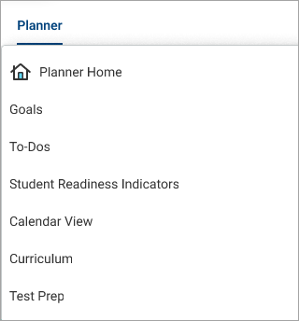
You can also access Test Prep, Curriculum, Student Readiness Indicators, and X2VOL from the Planner menu if available at your school.

From the Naviance Student homepage:
- Review Tasks from My School for those with an upcoming due date. By default, Naviance displays three upcoming tasks or to-dos. Click See All in My Planner for a complete list.
- Check Messages for reminders about an upcoming task due date if your school sends deadline reminders.

Tasks
- Select Planner and then select Tasks.
- From My Tasks, review:
  - Tasks you Need to Work On
  - Tasks you've Completed
  - Overdue
  - Tasks for Future Grades
- Select a task name to display the task details.
- Optionally, from the task details:
  - Select the link to be redirected to the task activity.
  - Click Raise Hand to ask your counselor or teacher a question about the task.
  - Enter a Comment and then click Add Comment to share a comment with your counselor, teacher, parents, and guardians.
  - Click Define your next to-do to add a to-do list item to help you stay on track and reach your goal.
  - Click Mark as Done if your school has instructed you to mark the task complete manually.
  - Download a document.
  - Attach a file related to the task. The file must be 10MB or less. Naviance supports the following file types:
    - PPTX, PPT, XLSX, XLS, DOCX, DOC
    - MP4, WMV, MOV
    - WAV, MP3
    - JPG, PNG, GIF
    - PDF
    - ZIP
  - Naviance does not support MAC documents.
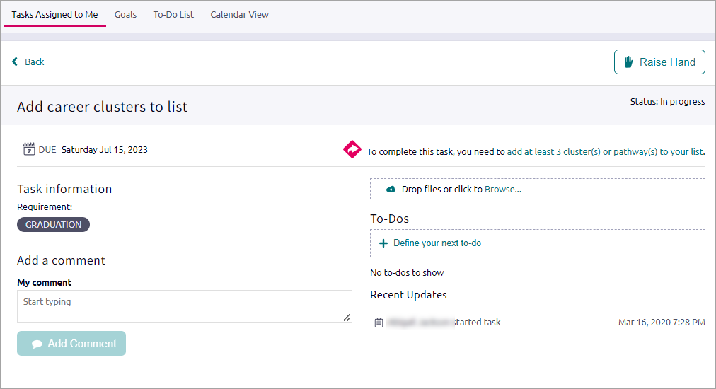

Goals
Create goals for yourself and keep track of your progress in achieving them.

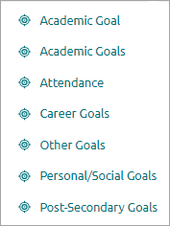
Create a Goal
- Select Planner and then select Goals.
- Click Add and select a goal category.

- Enter the information and then click Add.
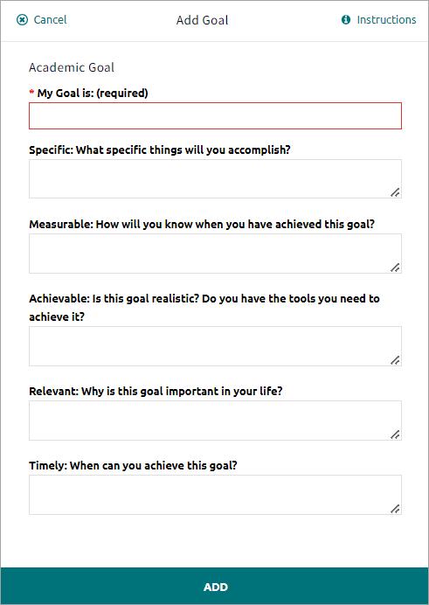
- Optionally:
  - Enter a Comment and then click Add Comment to share the comment with your counselor, teacher, parent, and guardian.
  - Click Define Your Next Step and add a to-do list item to help you stay on track and reach your goal.
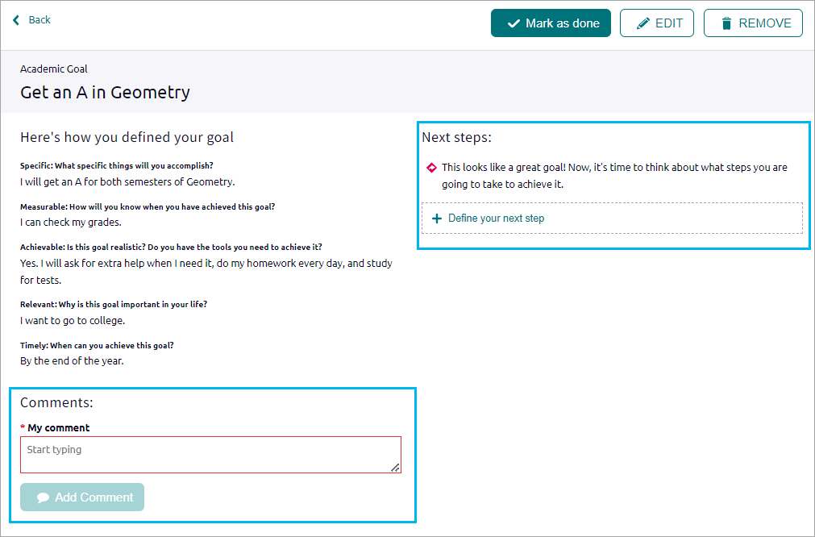

Manage a Goal
- Select Planner and then select Goals to display any goal categories.
- Optionally:
  - Click the comment icon, enter a comment, and then click Add to share it with your counselor.
  - Click the edit icon, edit the goal details, and then click Save.
  - Click the delete icon and then click Delete.
  - Click the goal name and then click Mark as Done.
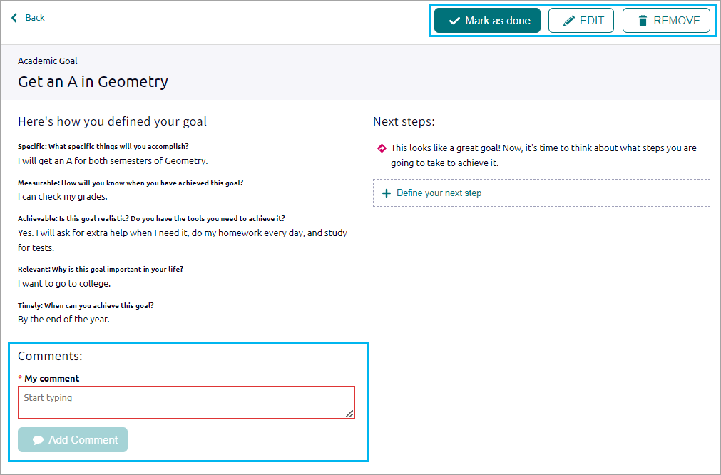

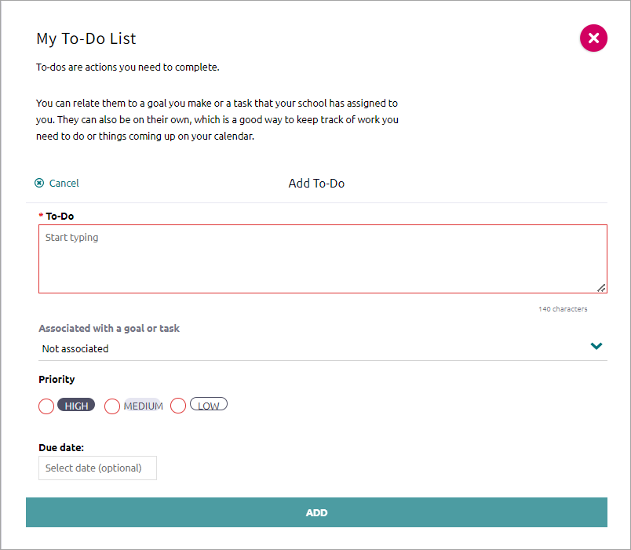
To-Dos
Use the To-Do feature to add and manage action items to complete.
- Select Planner and then select To-Dos.
- Click add.
- Enter the details and then click Add.

After creating to-dos, use the sort and filter options to organize your to-do list.
You can also review any to-do list items created in Naviance Curriculum lessons.

Calendar View
Use the calendar feature to display upcoming due dates for to-dos and tasks in a calendar.

