Parent and guardian overview
Naviance Student

Updated: July 24, 2026
Document Owner: Documentation Services
This edition applies to Naviance software and to all subsequent releases and modifications until otherwise indicated in new editions or updates.
The data and names used to illustrate the reports and screen images may include names of individuals, companies, brands, and products. All of the data and names are fictitious; any similarities to actual names are entirely coincidental.
PowerSchool is a trademark, in the U.S. and/or other countries, of PowerSchool Group LLC or its affiliate(s).
Copyright © 2005-2026 PowerSchool Group LLC and/or its affiliate(s). All rights reserved.
All trademarks are either owned or licensed by PowerSchool Group LLC and/or its affiliates.
Contents
Overview 4
Register and log in 5
Use Naviance Student 6
Utility menu 6
Main menu 6
Desktop 6
Mobile 6
Naviance Student sections 7
Parent and guardian actions in Naviance Student 8
Add a college to your student’s Colleges I’m Thinking About List 8
Access and edit account information 10
Reset your password with forgot password 10

Overview
Naviance Student is a mobile-responsive site for students, parents, and guardians that offers tools to personalize and simplify the college, career, and life planning process.
Naviance Student helps students answer the questions that will shape their future:
- Who am I?
- What do I want to be?
- How will I get there?
- How will I succeed?

As a parent or guardian, you have mostly review rights. Depending on your school’s permissions, you may be able to edit:
- Personal and demographic information.
- Email address.
- Username and password.
- Your student’s College’s I’m Thinking About list.

Register and log in
Use the registration code provided by your school to log in to Naviance for the first time. Navigate to the school’s Naviance Student page with the following URL:
Enter your school’s Naviance Student URL, typically: student.naviance.com/schoolalias
- Navigate to your school's Naviance Student web page.
- From the login page, select I'm new and need to register.
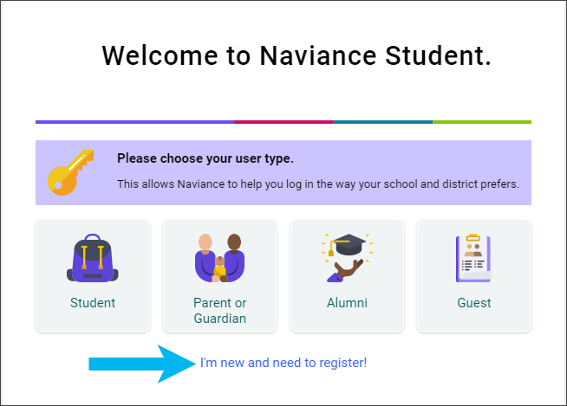
- Enter your registration code in the Registration Code field and then click Register.
- Enter a Username.
- Enter a New Password and then confirm the password.
- Click Continue.
- From the Naviance Student login page, click Student or Parent or Guardian.
- Enter the email or username and password that you just created and then click Continue to log in.

Use Naviance Student

Utility menu

- Click the heart icon to display your student’s favorite lists.
- Click the email icon to display email messages sent to you by your school.
- Click the question mark icon to display the Naviance Student Help Center.
- Click your initials to display your account information
- Click the globe icon to translate Naviance Student into over 70 languages.
- Click Log Out to end your session.

Main menu
The main menu is mobile-responsive and automatically adjusts for your device. The menu options may vary based on available sections at your school.

Desktop

Mobile
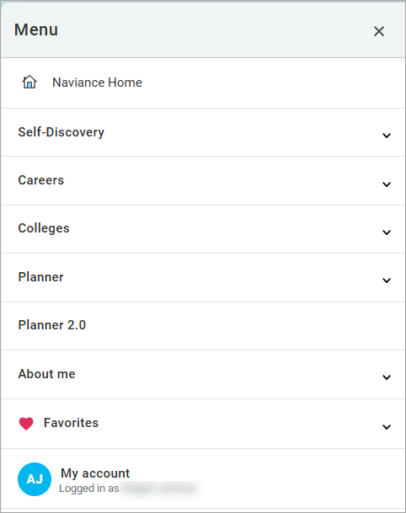

Naviance Student sections
The following sections are available in Naviance Student based on your school’s setup.
Section | Description
Home | Review your student’s Future Planning, information from your school, upcoming to-dos and tasks, and more.
Self-Discovery | Review your student’s assessment results to learn more about them and their potential career interests.
Courses | Review the school’s course catalog, course plans your student has created including required credits and other important criteria, and approve course plans, if necessary.
Careers | Explore careers, job opportunities, and work-based learning opportunities. Access the Roadtrip Nation video archive to learn how leaders have turned their passions into their life work, and review a list of your student’s favorite careers, clusters, and sub-clusters.
Colleges | Search for and discover college possibilities. Review your student’s list of colleges they are thinking about and those to which they are applying.
Planner | Review your student’s goals, to-dos, and tasks assigned by the school.
Planner 2.0 | Review your student’s goals assigned by the school.
About me | Review your student’s resume, portfolio, journal entries, documents shared by the school including the Student Readiness Report, and more.

Parent and guardian actions in Naviance Student

Add a college to your student’s Colleges I’m Thinking About List
- Select Colleges and then select Colleges I'm Thinking About.
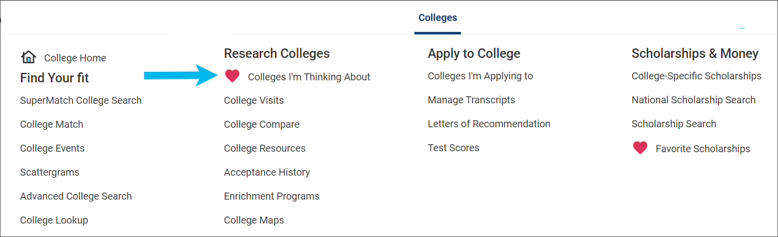
- Click Add Colleges to List.
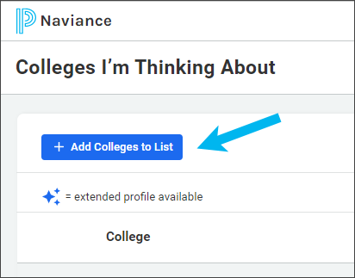
- Use the lookup tools to search for colleges.
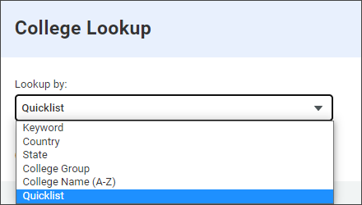

- Click the heart icon for the selected college to add it to your list. Alternatively, select multiple colleges and click Favorite.
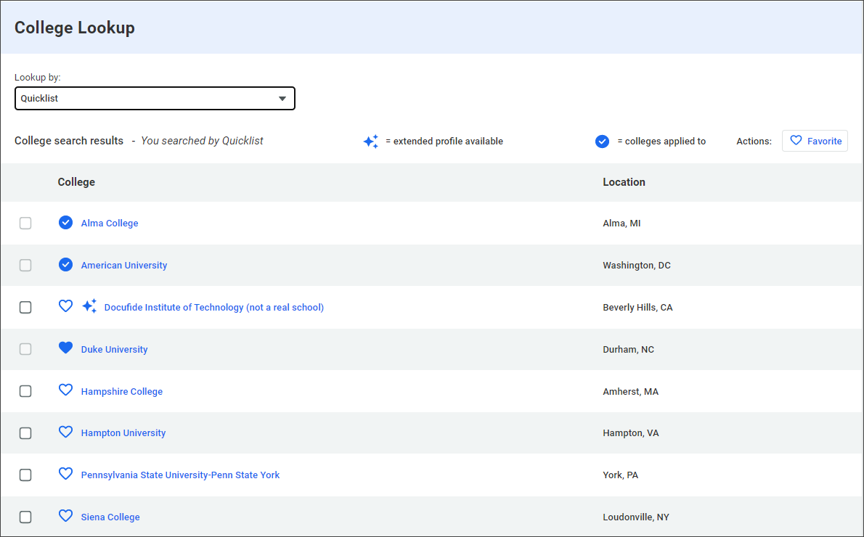
- Select Colleges and then choose Colleges I’m Thinking About to review the colleges you favorited.
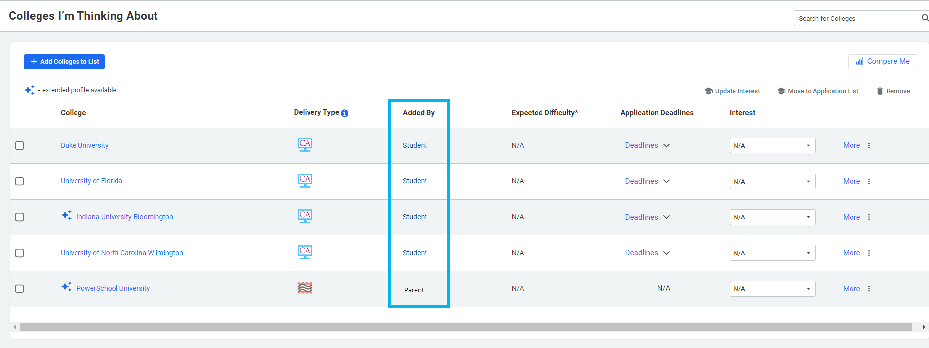

Access and edit account information
Select My Account to display General, Parent and Guardian, and Security information.
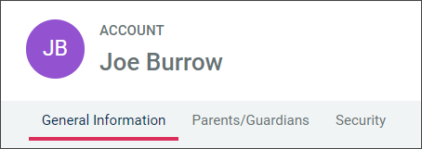
- Select General to review your student’s personal, contact, and academic information.
- Select Parent and Guardian to review your account's parent or guardian information.
- Select Security to review and update your username and password.
Click edit from any card to update the corresponding information. If the card does not display the option to edit, you cannot update the information in Naviance Student.

Reset your password with forgot password
- From the Naviance Student log-in page, click Student or Parent and Guardian.
- Select Forgot your password.
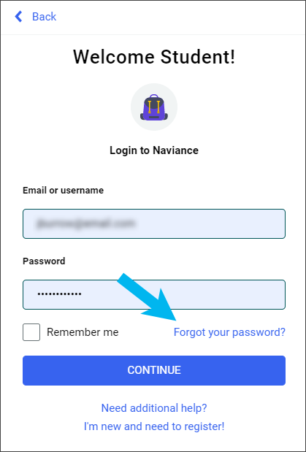

- Enter the email address on file in Naviance.
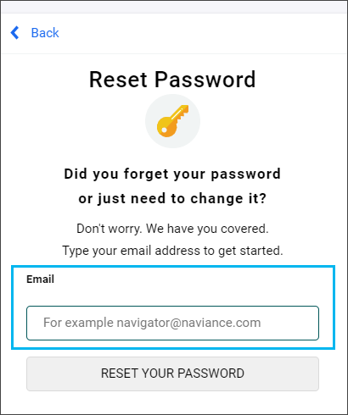
- Click Reset Your Password.
- Locate the Naviance-generated email and retrieve the temporary password from it.
- Return to the Naviance Student log-in page and click Parent and Guardian.
- Enter the Email or username and the temporary password.
- From Reset Password, enter and confirm a new password.
- Click Continue.

