Self-Discovery Reference Guide
Naviance Student

Updated: May 17, 2023
Document Owner: Documentation Services
This edition applies to Release [x.x] of the [product name] software and to all subsequent releases and modifications until otherwise indicated in new editions or updates.
The data and names used to illustrate the reports and screen images may include names of individuals, companies, brands, and products. All of the data and names are fictitious; any similarities to actual names are entirely coincidental.
PowerSchool is a trademark, in the U.S. and/or other countries, of PowerSchool Group LLC or its affiliate(s).
Copyright © 2005-2023 PowerSchool Group LLC and/or its affiliate(s). All rights reserved.
All trademarks are either owned or licensed by PowerSchool Group LLC and/or its affiliates.
Contents
Overview 4
Self-Disocvery Home 5
Assessments Overview 6
AchieveWorks® Intelligences 6
AchieveWorks® Learning and Productivity 7
AchieveWorks® Personality 8
AchieveWorks® Skills 9
Career Cluster Finder 10
Career Interest Profiler 11
Career Key 12
StrengthsExplorer® 13

Overview
Learn more about yourself and be introduced to best-fit careers using the Self-Discovery Section.
To access self-discovery tools in Naviance Student, select Self-Discovery from the main navigation bar and choose Self-Discovery Home or an assessment from the list.
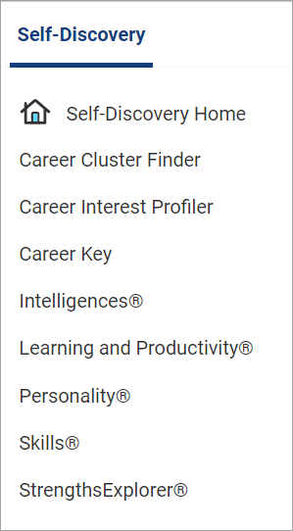

Self-Disocvery Home
From the Self-Discovery Home page, access all assessments assigned to you by your school. Depending on the assessment status, you can:
- Start an assessment.
- Continue a previously started assessment.
- View Results of a completed assessment.
- Retake all assessments except StrengthsExplorer®.
To translate all assessments except Career Key and StrengthsExplorer®, click the globe icon in the Naviance Student navigation menu, then select from over 75 languages.
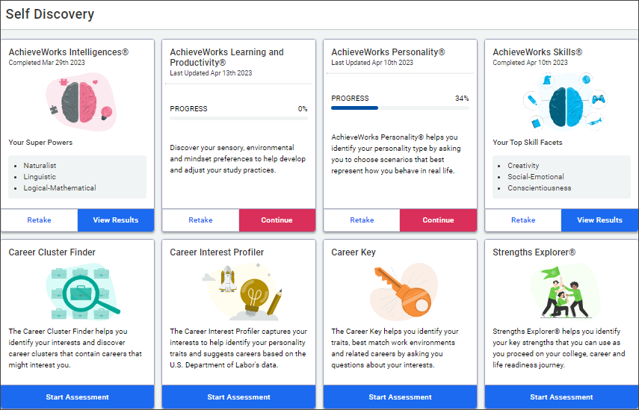

Assessments Overview

AchieveWorks® Intelligences
AchieveWorks® Intelligences helps you uncover your different intelligences and explains how to use them.
The assessment takes approximately 15 minutes and includes 54 questions.
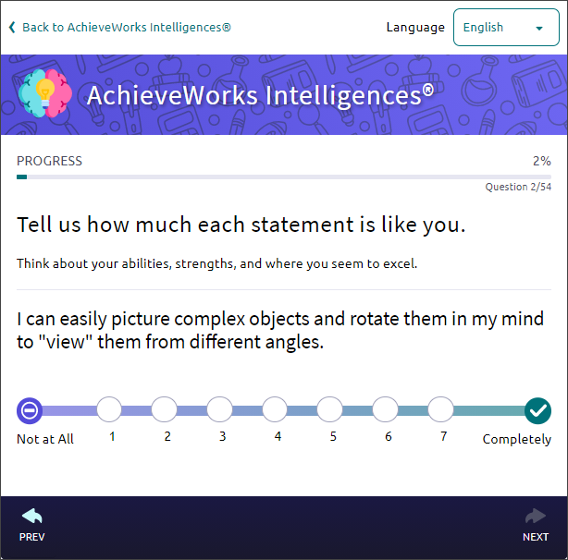
In the results, discover how you deal with information, solve problems, and create things, and learn how to use your strengths in school, work, and other activities.
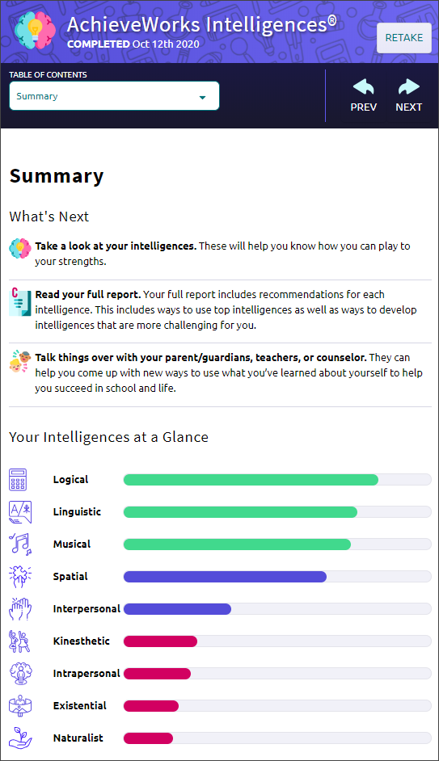

AchieveWorks® Learning and Productivity
AchieveWorks® Learning and Productivity helps you identify your sensory and mindset preferences so you can develop study practices that work for you. Find out how you learn the best and how you can be most productive.
The assessment takse approximately 20 minutes and includes 69 questions.
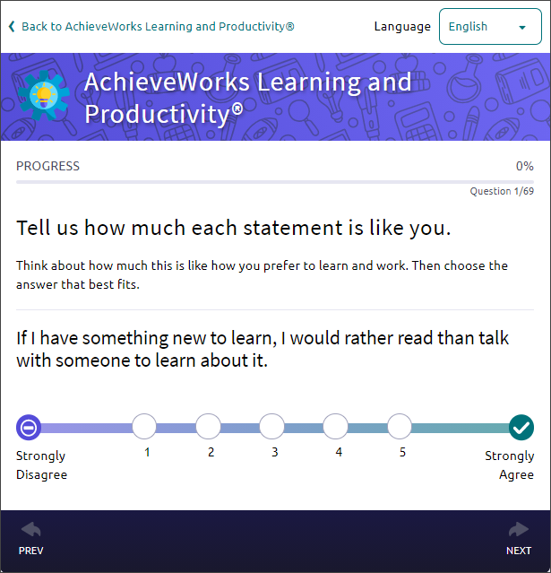
The results include tips for making studying more effective and strategies for how you can be more comfortable and successful in class.
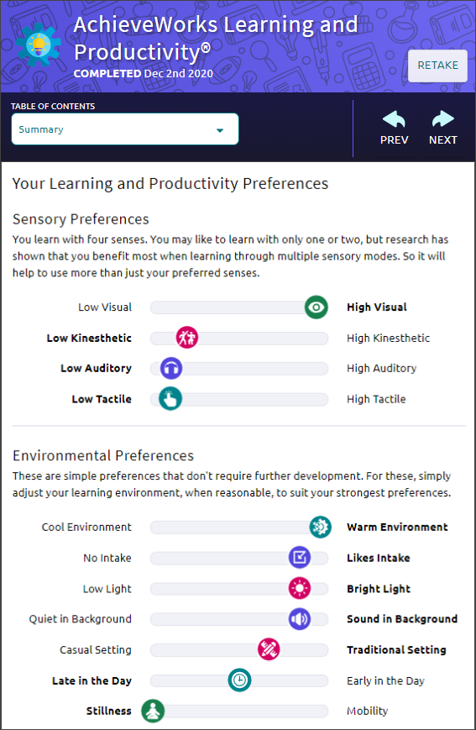

AchieveWorks® Personality
AchieveWorks® Personality helps you identify your personality type by asking you to choose scenarios that best represent how you behave in real life.
The assessment takse approximately 15 minutes and has 36 scenarios.
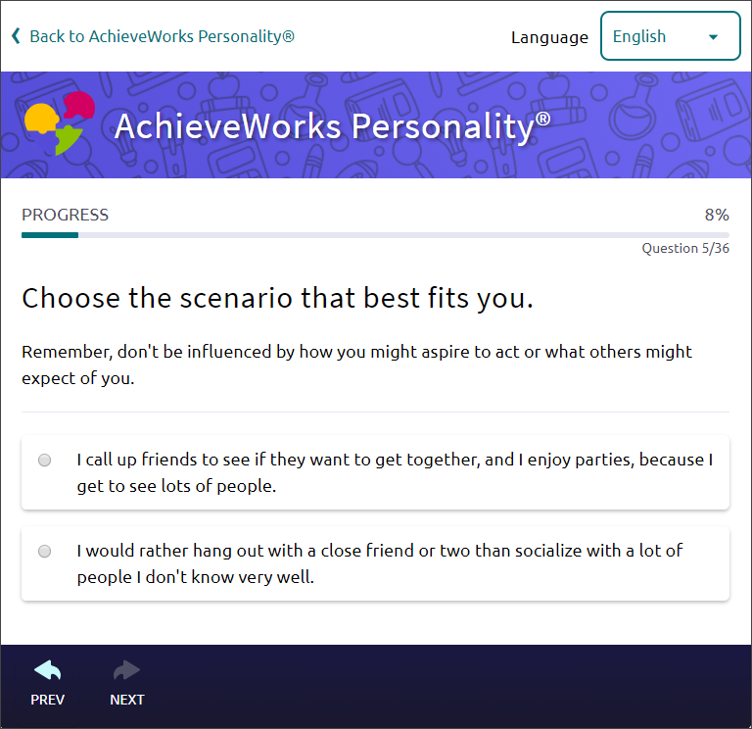
The results provide your personality type, tips to achieve success in a way that works for you, and best-fit career options.
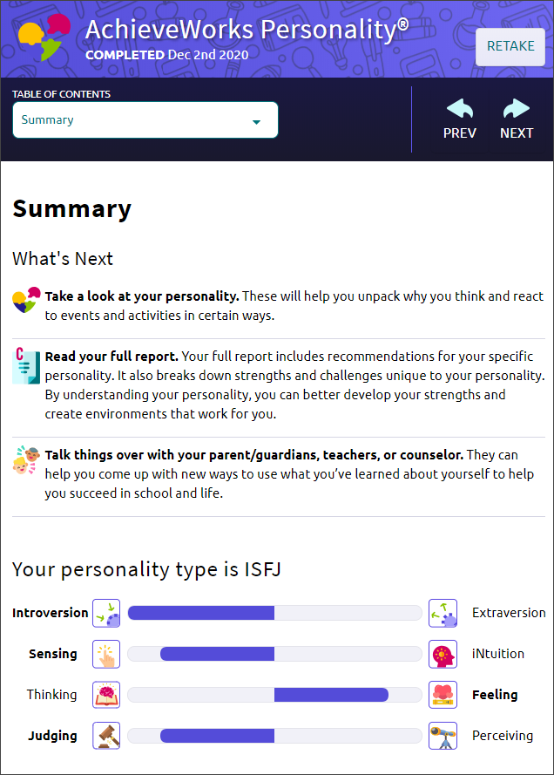

AchieveWorks® Skills
AchieveWorks® Skills helps you identify your skills and suggests ways to develop those and other skills you may need for careers.
The assessment takes approximately 20 minutes and includes 69 questions.
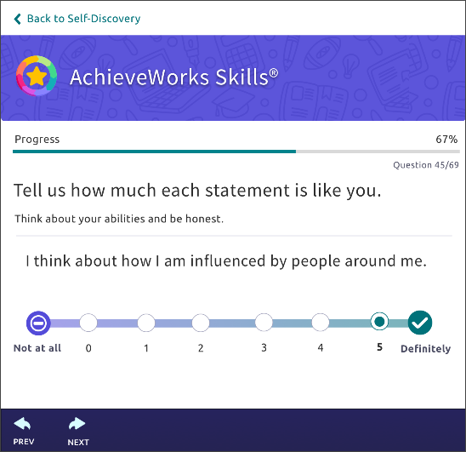
The results will include your current skill profile and recommendations for you to develop your skills.
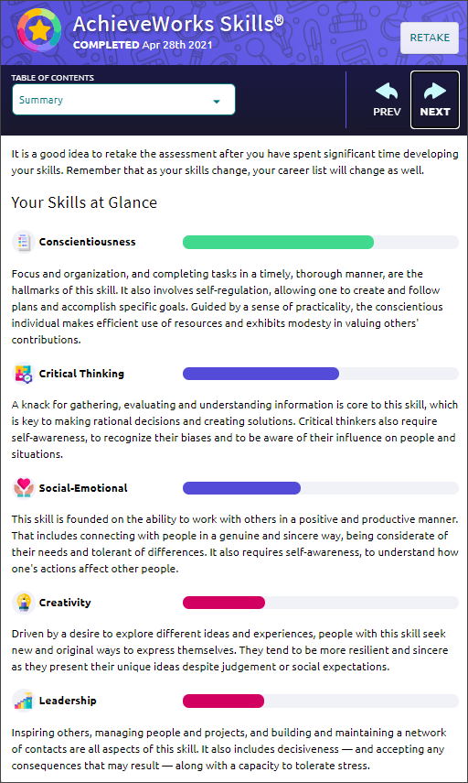
The AchieveWorks® assessments - Intelligences®, Learning and Productivity®, Personality®. and Skills® - can be taken in English, Spanish, Portuguese, Arabic, or Chinese. Choose your language when you begin the assessment. AchieveWorks® results are available are not available in languages other than English. Other assessments and results are only available in English.

Career Cluster Finder
In the Career Cluster Finder, select activities and school subjects that you like or dislike and personal qualities that you possess.
The assessment takes approximately 20 minutes and includes 108 questions.
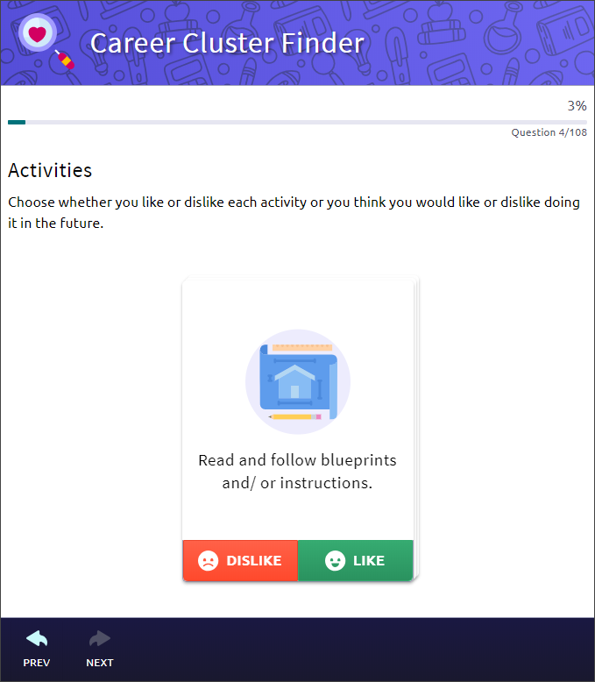
In your results, you learn how well each of the 16 National Career Clusters fits your current interests and qualities.
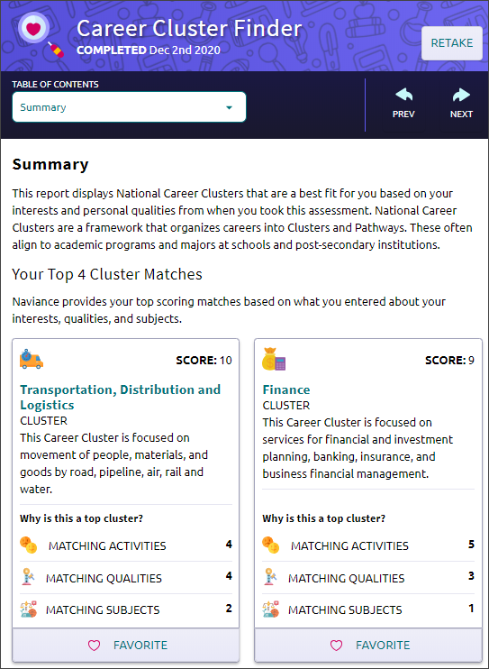

Career Interest Profiler
Career Interest Profiler captures your interests to help determine your personality traits and suggests careers based on the U.S. Department of Labor’s data.
The assessment takes approximately 15 minutes and includes 60 questions about your interests.
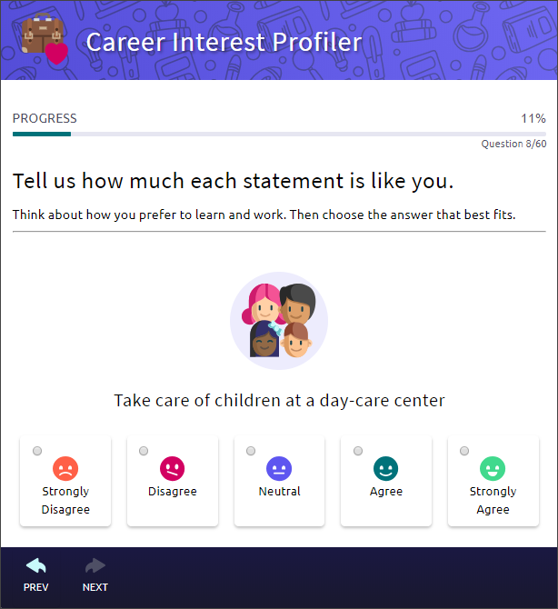
The results include your personality traits according to Holland Codes and information on how those help with career exploration and planning. The results also offer career recommendations based on your personality.
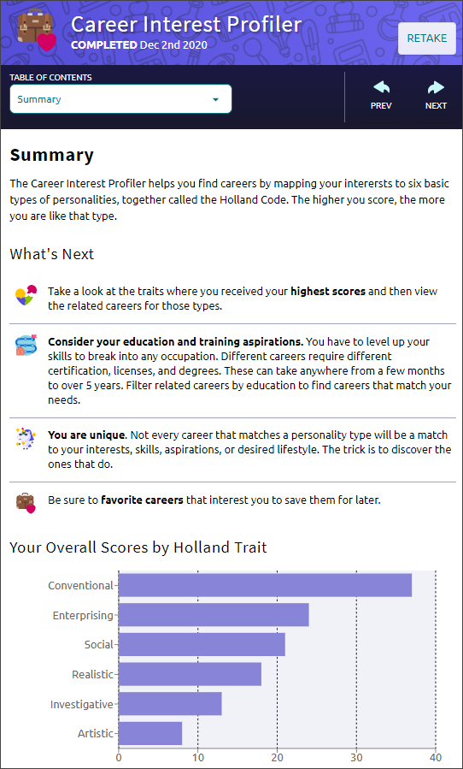

Career Key
Career Key helps you identify your traits, best match work environments, and related careers by asking questions about your interests.
The assessment takes approximately 10 minutes.
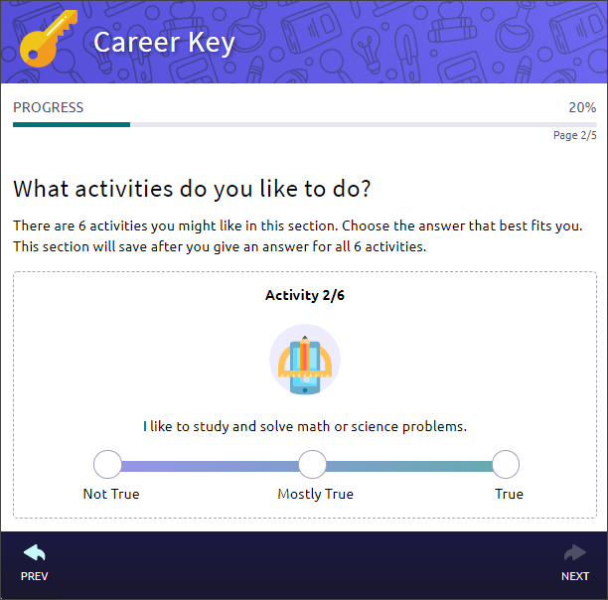
The results explain your personality traits based on Holland Codes and how those traits can help with career exploration and planning.
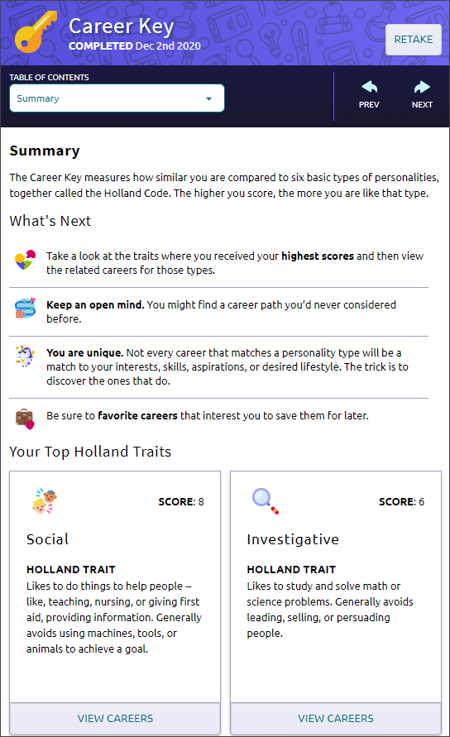

StrengthsExplorer®
StrengthsExplorer® helps uncover your talents and reveals your potential strengths to you and the people in your world.
The assessment takes approximately 20 minutes and includes 78 questions. Neither youyou’re your counselor can reset StrengthsExplorer®.
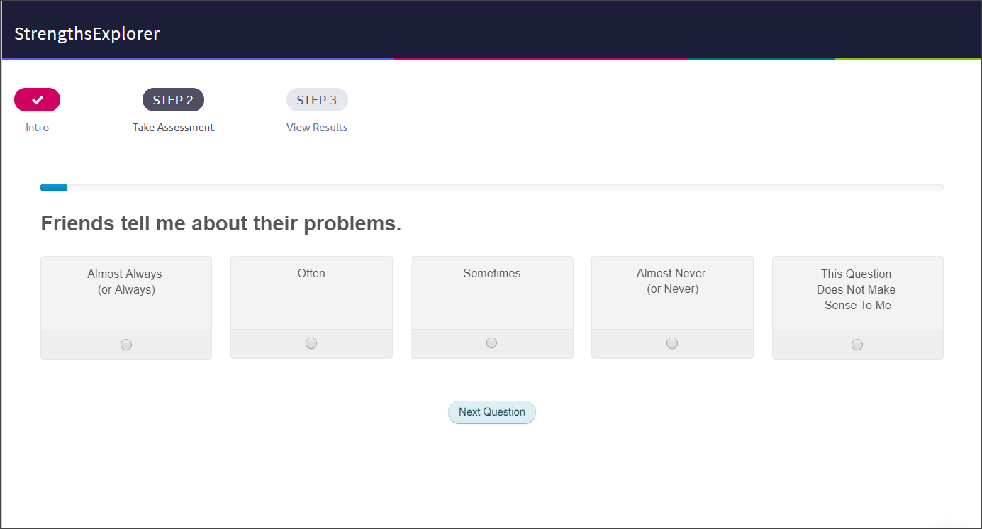
StrengthsExplorer® results include detailed explanations of your top three themes, strategies for capitalizing on your success, and a list of action items so you can continue building on your strengths. The results also include a list of best-fit career pathways.
