Approving Course Plans Quick Guide
Parents and guardians can approve their student's course plans if required by the school or district.

- Navigate to Courses, and then select Manage Course Plans.
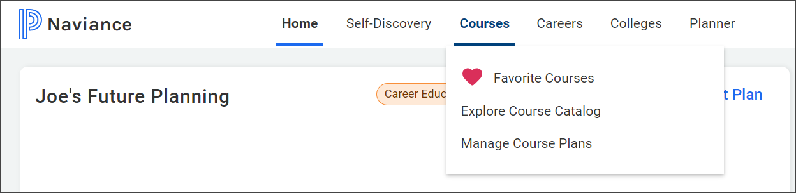
- Select the course plan that displays Awaiting Parent Approval.
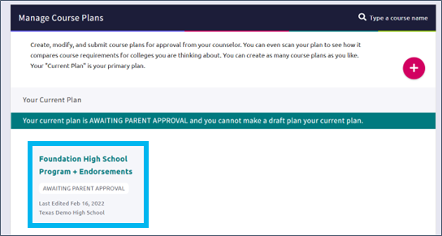
- Review the course plan.
- Enter your Full name to sign, and then click I Approve This Plan. If you do not approve the course plan, discuss your student's course selections with their counselor.
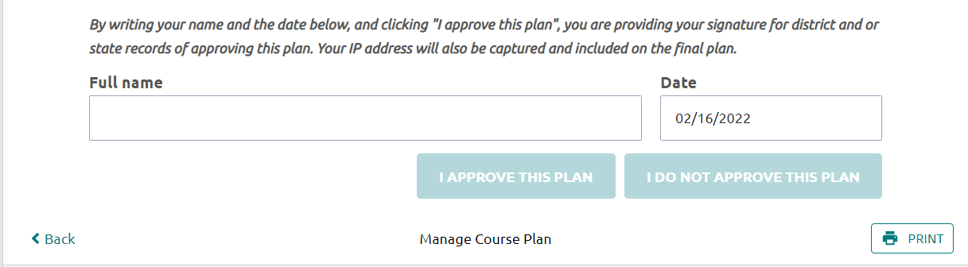
- To display a copy of the course plan, click Documents Shared With Me from the confirmation banner, select Course Plans, and then click View for the selected course plan.
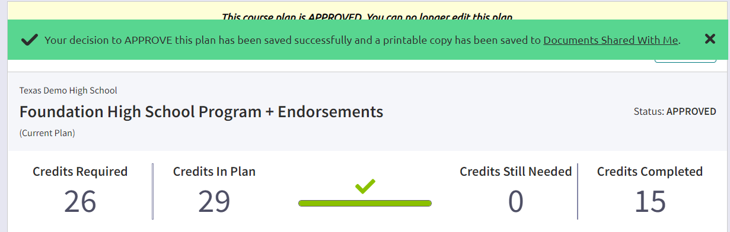
- If the confirmation banner is not available, click Print to print the course plan.


