College application process reference guide
Naviance Student

Updated: November 6, 2025
Document Owner: Documentation Services
This edition applies to Naviance software and to all subsequent releases and modifications until otherwise indicated in new editions or updates.
The data and names used to illustrate the reports and screen images may include names of individuals, companies, brands, and products. All of the data and names are fictitious; any similarities to actual names are entirely coincidental.
PowerSchool is a trademark, in the U.S. and/or other countries, of PowerSchool Group LLC or its affiliate(s).
Copyright © 2005-2025 PowerSchool Group LLC and/or its affiliate(s). All rights reserved.
All trademarks are either owned or licensed by PowerSchool Group LLC and/or its affiliates.
Contents
Overview 4
Build an application list 5
Move colleges to your Colleges I'm Applying to list 5
Add colleges to your Colleges I'm Applying to list and request transcripts 5
Request transcripts 7
Request letters of recommendation 8
Teacher recommendations 8
Outside recommendations 9
Track document submission status 10
Application materials 10
Transcripts 10
Letters of recommendation 10
Update application details 11

Overview
To get started with college applications in Naviance Student, build an application list, and request transcripts and teacher letters of recommendation. After you build an application list and request documents, track document submission status and update application details.
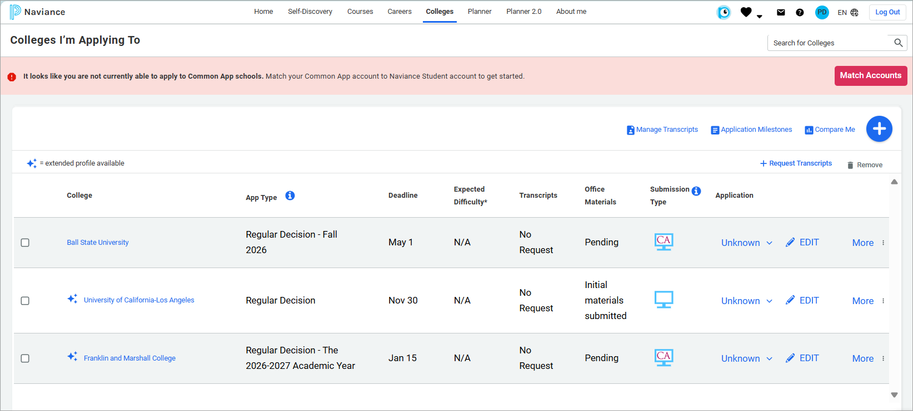

Build an application list
You can build an application list by:
- Moving colleges from your Colleges I'm Thinking About list to your Colleges I'm Applying to list.
- Add colleges to your Colleges I'm Applying to list. As you add colleges to your application list, you can also request transcripts.

Move colleges to your Colleges I'm Applying to list
- Select Colleges and then select Colleges I'm Thinking About.
- Select the colleges to move to your application list.
- Select Move to Application List.
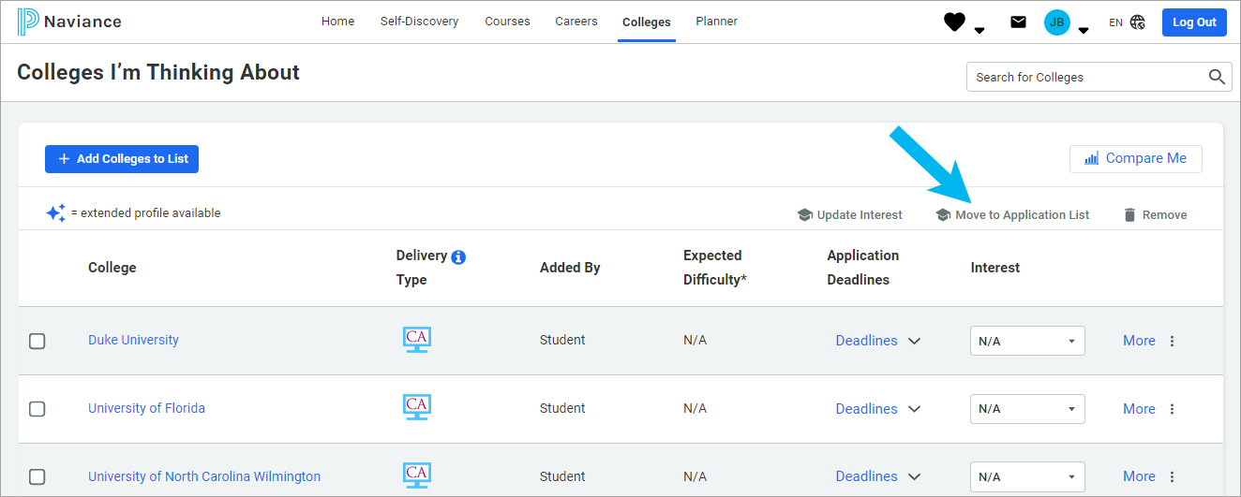
- Select an App Type from the list.
- Optionally, indicate how you'll submit your application, if you have submitted your application, and if you plan to submit SAT or ACT scores with your application.
- Click Add Applications or click Add and Request Transcripts, select the transcript type to request, and then click Request and Finish.

Add colleges to your Colleges I'm Applying to list and request transcripts
- Select Colleges and then select Colleges I'm Applying To.
- Click Add.
- Enter the name of the college to which you are applying and select it from the list.
- Select an App Type from the list.

- Optionally, indicate how you'll submit your application, if you have submitted your application, and if you plan to submit SAT or ACT scores with your application.
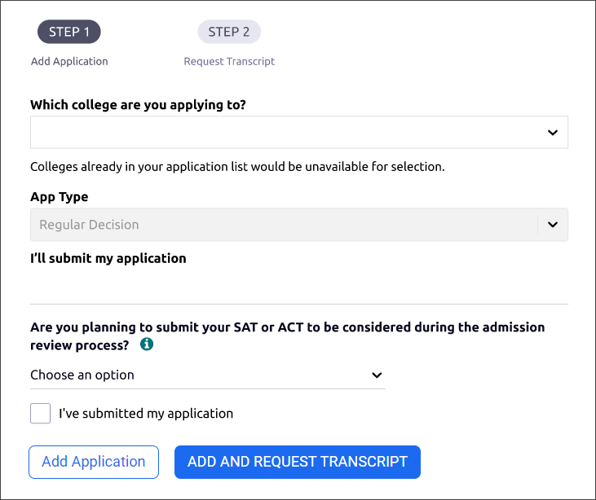
- Click Add Applications or click Add and Request Transcripts, select the transcript type to request, and then click Request and Finish.

Request transcripts
Request transcripts as you add a college to your list of Colleges I'm Applying To.
- Select Colleges and then select Colleges I'm Applying To.
- Select Request Transcripts.
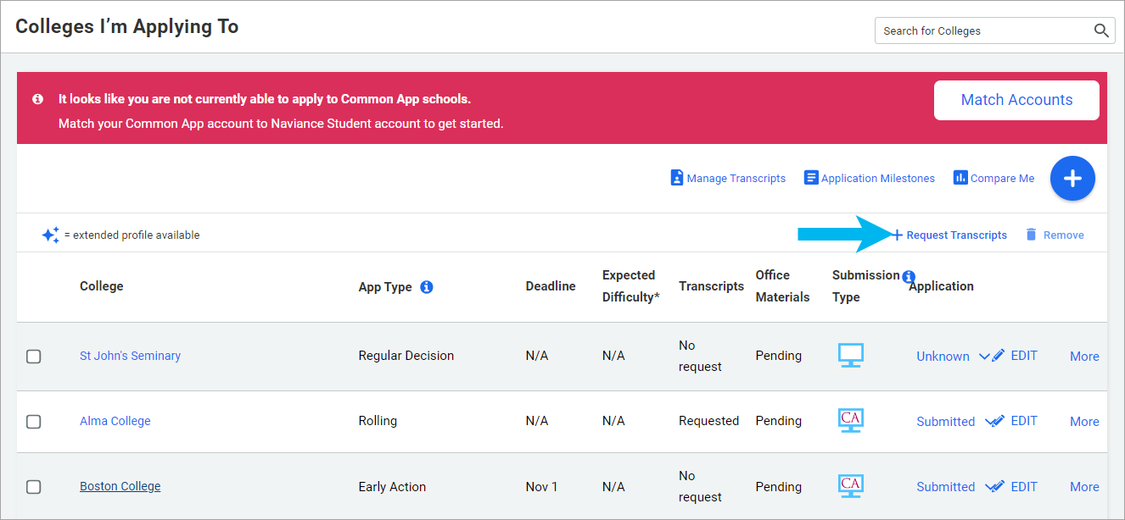
- Select the type of transcript you are requesting, select a college from your application list, or enter a college name, and then click Request and Finish.
Alternatively, use:
- Request Transcript to request transcripts for colleges to which you are applying.
- Manage Transcripts to request college, scholarship, or other transcripts.

Request letters of recommendation

Teacher recommendations
Request a recommendation letter from a teacher at your school.
- Select Colleges and then select Letters of Recommendation from Apply to College.
- If prompted, select Internal recommendation letters and click Continue.
- Click Add Request.
- Select a teacher from the list.
- Select All Colleges or specific colleges to invite a teacher to write a letter and send it to only the colleges that you have specified. You cannot request a letter of recommendation if you have already requested the maximum number allowed by the institution.
- Optionally, select General Request to invite a teacher to write a letter and send it to any college that you add to Colleges I'm Applying To list.
- Enter a personal note of up to 3000 characters. Share information that you want the teacher to highlight in their letter.
- Click Add Request.
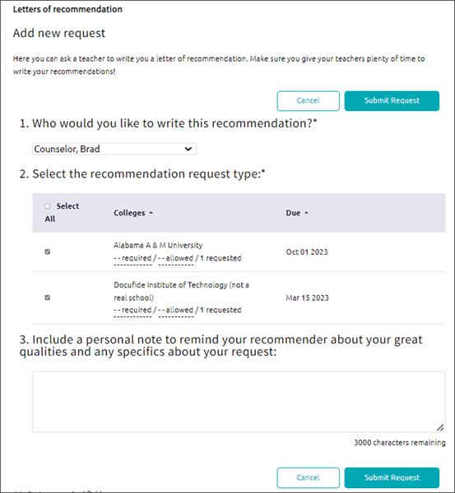

Outside recommendations
Request a recommendation letter from someone outside of your school.
- Select Colleges and then select Letters of Recommendation from Apply to College.
- Select Outside recommendation letters and click Continue.
- Click Request recommendation.
- Choose to request recommendations for Common App colleges or Non-Common App colleges and click Proceed.
For Common App colleges, you will be redirected to the Common App website to make your request. Follow Common App’s instructions.
- For Non-Common App colleges, enter the information on the Request recommendation form and click Submit. An email will be sent to the recommender with your request details.
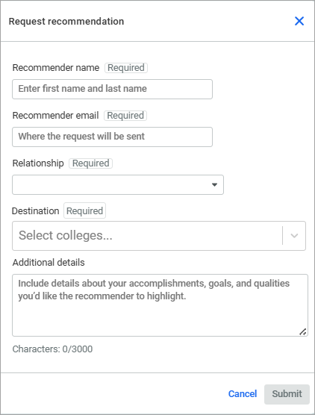

Track document submission status

Application materials
- Select Colleges and then select Colleges I'm Applying To.
- From Transcripts, review the status of your transcript request, either requested or submitted.
- From Office Materials, review the status of your initial, midyear, or final application materials, either pending or submitted.

Transcripts
- Select Colleges and then select Manage Transcripts.
- Review the status or submission date for your initial, midyear, and final transcript.

Letters of recommendation
- Select Colleges and then select Letters of Recommendation from Apply to College.
- If prompted, choose a recommendation type.
- Review the status of each request. For internal teacher recommendations, hover over the status for each request to review details such as submission date and more.

Update application details
Update your application details such as app type, interest, result, and more.
- Select Colleges and then select Colleges I'm Applying To.
- Choose Edit for the college to update.
- Update the details.
- Click Save College Application.
