Overview
Naviance Student

Updated: July 24, 2026
Document Owner: Documentation Services
This edition applies to Naviance software and to all subsequent releases and modifications until otherwise indicated in new editions or updates.
The data and names used to illustrate the reports and screen images may include names of individuals, companies, brands, and products. All of the data and names are fictitious; any similarities to actual names are entirely coincidental.
PowerSchool is a trademark, in the U.S. and/or other countries, of PowerSchool Group LLC or its affiliate(s).
Copyright © 2005-2004 2026 PowerSchool Group LLC and/or its affiliate(s). All rights reserved.
All trademarks are either owned or licensed by PowerSchool Group LLC and/or its affiliates.
Contents
Overview 4
Access Naviance Student 5
Register your account 5
Log in with a username and a temporary password 6
Use Naviance Student 8
Utility menu 8
Main menu 8
Naviance Student sections 10
Homepage 11
Self-Discovery 12
Courses 14
Careers 16
Colleges 18
My Planner 21
Planner 2.0 23
About me 24

Overview
Naviance Student helps answer the questions that will shape your future:
- Who am I?
- What do I want to be?
- How will I get there?
- How will I succeed?

Access Naviance Student
[School Name’s] Naviance Student platform can be accessed by going to the following URL: www.student.naviance.com/[schoolalias]
Replace with information for SAML or CLEVER Accessibility as needed, and then delete this sentence as well las the two sections below.
You can bookmark the site’s address on frequently used devices to return to Naviance Student.

Register your account
If you have a registration code from your school, use this code to register your account and create a username and password to use for all future logins to Naviance Student.
- Navigate to your school's Naviance Student web page.
- From the login page, select I'm new and need to register.
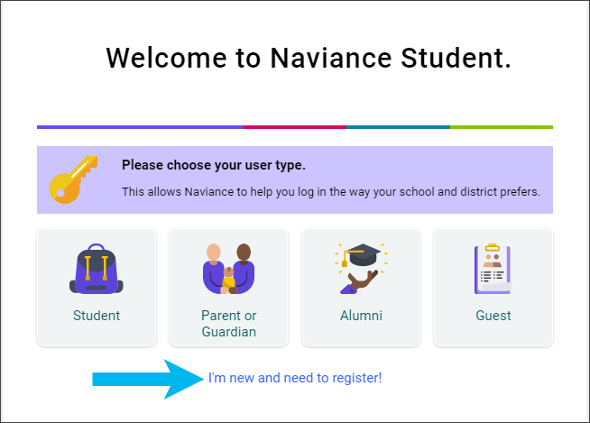
- Enter your registration code in the Registration Code field and then click Register.
- Enter a Username.
- Enter a New Password and then confirm the password.
- Click Continue.
- From the Naviance Student login page, click Student.
- Enter the email or username and password that you just created and then click Continue to log in.

Log in with a username and a temporary password
If you have a username and temporary password from this school, use these credentials for your first login.
- Navigate to your school's Naviance Student web page.
- From the log-in page, click Student.
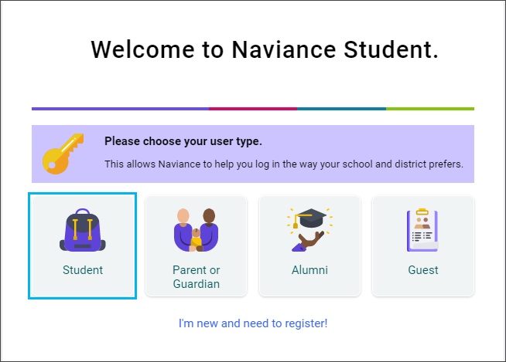
- Enter your school-provided Email or username and temporary Password and then click Continue.
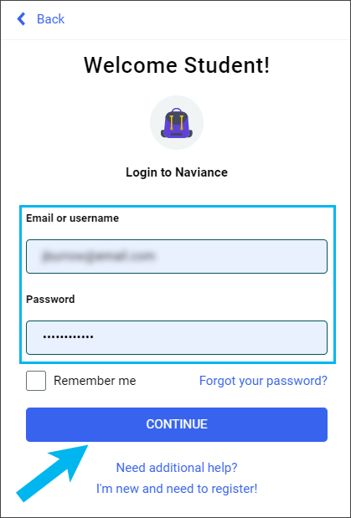
- Enter a New Password and then confirm the password.
- Click Continue.
- From the Naviance Student login page, click Student.
- Enter your email or username and the newly created password, and then click Continue.

Use Naviance Student

Utility menu

- Click PowerBuddy to ask a question or select a prompt for more information on colleges and careers.
- Click the heart icon to display your favorite lists.
- Click the email icon to display email messages sent to you by your school.
- Click the question mark icon to display the Naviance Student Help Center.
- Click your initials to display our account information.
- Click the globe icon to translate Naviance Student into over 70 languages.
- Click Log Out to end your session.

Main menu
The main menu is mobile-responsive and automatically adjusts for your device. The menu options vary based on available sections at your school.

Desktop

Mobile
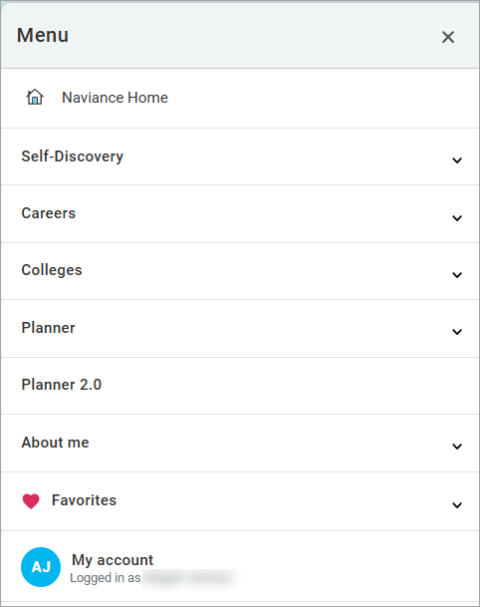

Naviance Student sections
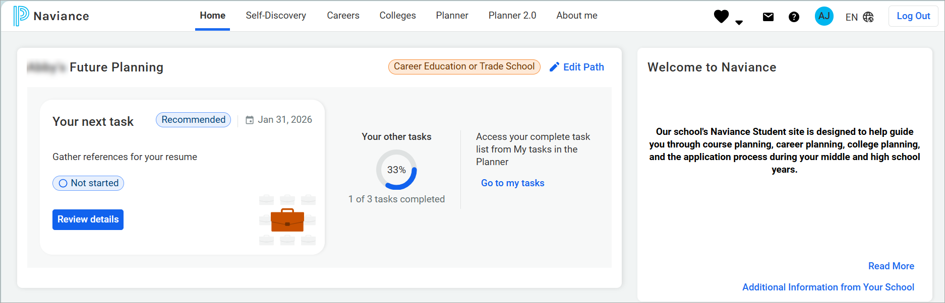
The following sections are available in Naviance Student based on your school’s setup.
Section | Description
Home | Review your Future Planning, information from your school, upcoming to-dos and tasks, and more.
Self-Discovery | Review your assessment results to learn more about yourself and your potential career interests.
Courses | Review your school’s course catalog, course plans you have created including required credits and other important criteria.
Careers | Explore careers, job opportunities, and work-based learning opportunities. Access the Roadtrip Nation video archive to learn how leaders have turned their passions into their life work, and review your list of your favorite careers, clusters, and sub-clusters.
Colleges | Search for and discover college possibilities.
Planner | Review your goals, to-dos, and tasks assigned by the school. If available at your school, access Test Prep, Curriculum, and Student Readiness Indicators.
Planner 2.0 | Review tasks assigned by the school.
About me | Share information about yourself using a resume builder, portfolio, journal, documents from your school, surveys assigned by your school, and more.

Homepage

Homepage features
Feature | Description
Future Planning | Select your path for the future to customize your homepage experience.
Path Highlights | Quickly access the features and information that are relevant for your path after high school.
Career Essentials | Reference information about your future career goals to help you plan for your future.
Information from Your School | Review a message, web links, informational pages, and new bulletins from your school.
Tasks from Your School | Review upcoming tasks and to-dos to complete, including the priority and due date.
What’s New | Find out what’s happened since your last visit including new college visits, journal entries shared by your school, and comments on course plans, tasks, or goals.

Self-Discovery
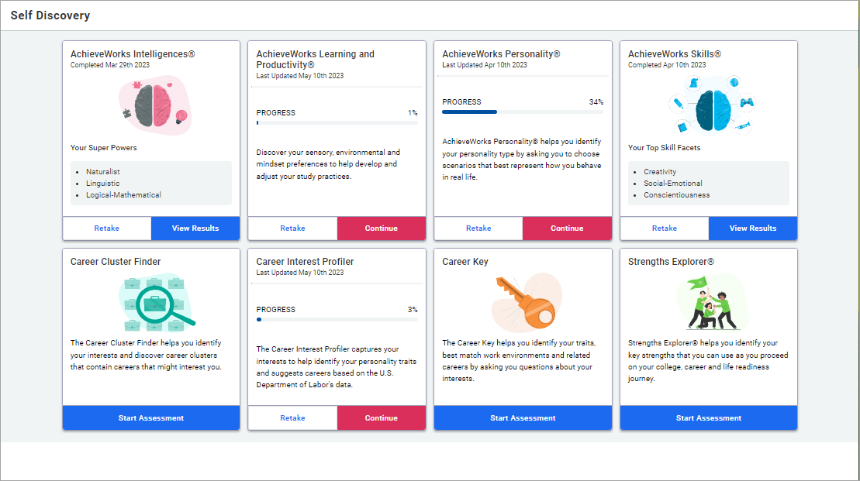
The assessments available in the Self-Discovery section vary based on your grade level and school.

Self-Discovery features

Feature | Description
AchieveWorks Intelligences® | Uncover your different intelligences and learn how to apply them.
AchieveWorks Learning and Productivity® | Identify your sensory and mindset preferences to help you develop study practices. Find out how you learn the best and are most productive.
AchieveWorks Personality® | Identify your personality type by choosing scenarios that best represent how you behave in real life.
AchieveWorks Skills® | Identify your skills and learn ways to develop them and other skills needed for careers.
Career Cluster Finder | Identify activities and school subjects that you like or dislike and personal qualities that you possess.
Career Key | Identify your traits, best-match work environments, and related careers by answering questions about your interests.
Career Interest Profiler | Captures your interests to help identify your personality traits and suggests careers based on the US Department of Labor's data.
StrengthsExplorer® | Uncover your talents and potential strengths.

Courses
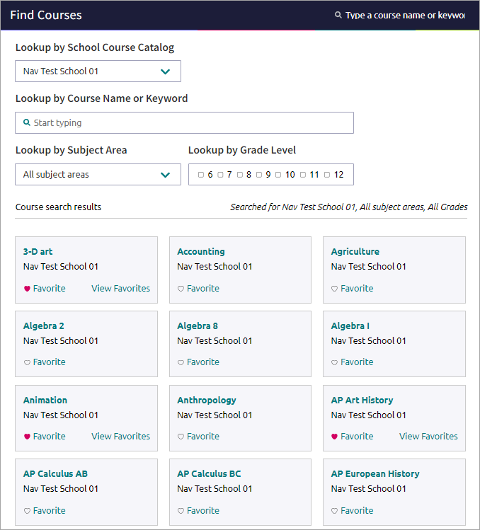
The Courses menu is only available if your school uses this feature. The Courses section does not have a homepage.

Courses features
Feature | Description
Favorite Courses | Review and manage your favorite courses.
Explore Course Catalog | Review colleges that other students who have favorited the same schools as you are interested in. Review colleges that have accepted students with a GPA and test scores like yours.
Manage Course Plans | Find and sign up for events that colleges are hosting.

Careers
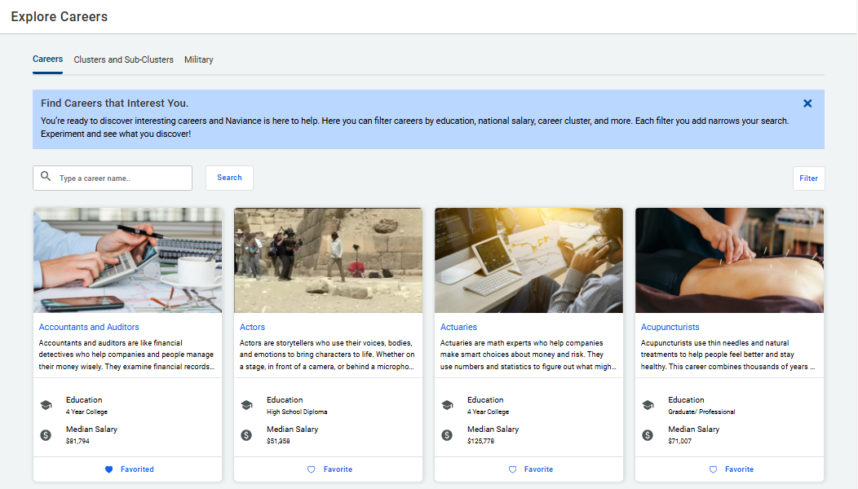
The Careers section does not have a homepage.

Career features

Career exploration
Feature | Description
Favorite Careers and Clusters | Review and manage careers, clusters, and sub-clusters that you have favorited. Find Naviance suggested clusters and sub-clusters.
Explore Careers | Search for careers and review information such as an overview, skills and experience, and wages.
Explore Clusters and Sub-clusters | Search for clusters and sub-clusters and review information such as the employment outlook, related occupations, and related majors.

Experiential exploration
Feature | Description
Search Job Opportunities | Search local job opportunities using Headed2's Job Search in Naviance.
Explore Roadtrip Nation Videos | Access over 10,000 video interviews that chronicle the diverse personal stories of leaders who have turned their interests into their life’s work.
Work-Based Learning | Find events and opportunities posted by your school.

Colleges
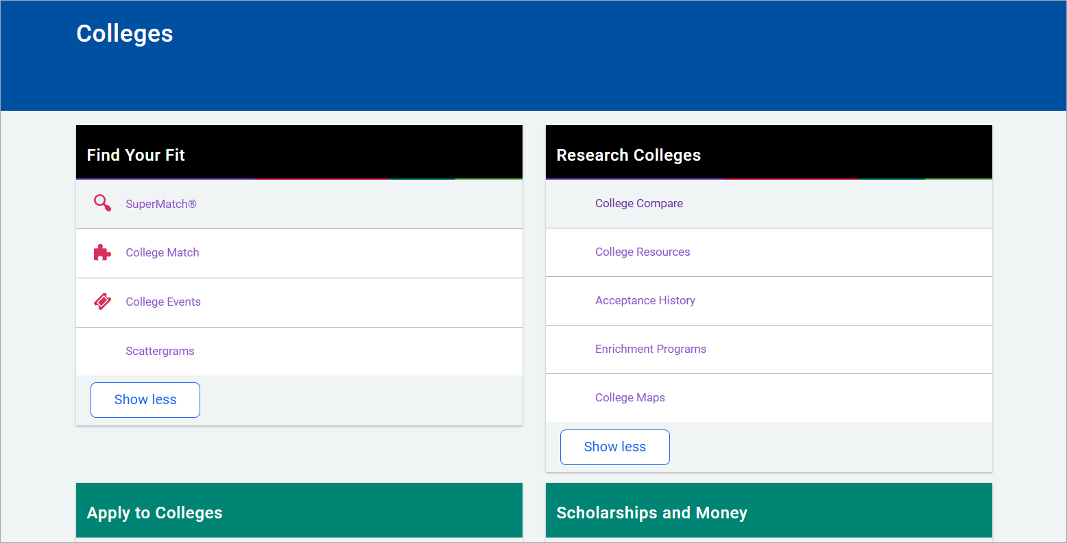

College features

Find your fit
Feature | Description
SuperMatch™ College Search | Find best-fit colleges according to criteria that is important to you.
College Match | Review colleges that other students who have favorited the same schools as you are interested in. Also, review colleges that have accepted students with a GPA and test scores like yours.
College Events | Find and sign up for events that colleges are hosting.
Scattergrams | Analyze how you compare to other students from your high school who have been accepted or denied admittance to a college based on GPA and test scores. Data is presented in a graph.
Advanced College Search | Search for colleges that match your interests and then save the search for future reference.
College Lookup | Search for a college using filters such as name, country, state, or college group. Click the heart icon to favorite a college.

Research colleges
Feature | Description
Colleges I’m Thinking About | Build and maintain a list of colleges that you are interested in.
College Compare | Compare the average GPA and test scores of students from your high school that have been accepted to colleges on your Colleges I’m Thinking About list.
College Resources | Review external web resources that may be helpful to your college search process.
Acceptance History | Review a list of colleges and the number of students from your school who were accepted and enrolled.
College Maps | Display an interactive map of schools based on a list of different pre-defined criteria, such as colleges from your Colleges I’m Thinking About list.
Enrichment Programs | Find enrichment programs shared by your school.

Apply to colleges
Feature | Description
Colleges I’m Applying To | Build and maintain a list of colleges that you are applying to.
Letters of Recommendation | Request and track teacher letters of recommendation.
Manage Transcripts | Add and review transcript requests and display associated fees.
Test Scores | Review your test scores, including SATs. Depending on your school, enter your own test scores.

Scholarships and money
Feature | Description
Scholarships I’m Applying To | Build and maintain a list of scholarships that you are applying for.
Scholarship List | Find potentially relevant scholarships to review and add to your applications list.
Scholarship Match | Review scholarships that may be a suitable match for you based on requirements such as gender, ethnicity, and GPA.
National Scholarship Search | Access an external site hosted by Sallie Mae and search for scholarship matches based on personal criteria that you provide.

College visits
Review and register for college visits that are scheduled at your school.

My Planner
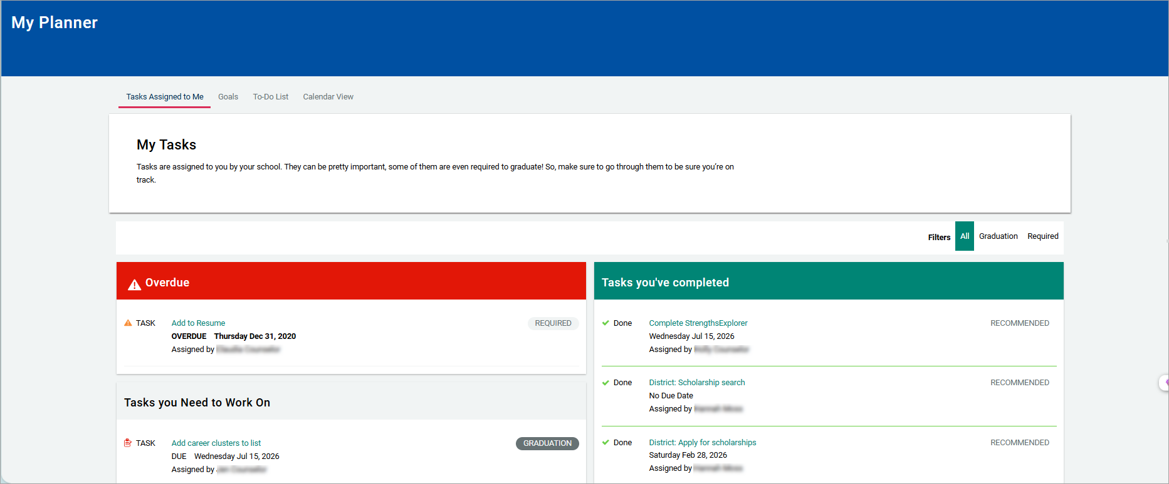

My Planner features
Features | Description
Tasks Assigned to Me | Review activities assigned by your school or district, organized by overdue, completed, and to complete. Tasks details include a due date, priority level, and link to complete the activity.
Goals | Create goals for yourself and keep track of your progress in achieving them.
To-Dos | Add and manage action items to complete.
Calendar View | Use the calendar feature to display upcoming due dates for to-dos and tasks in a calendar.
Student Readiness Indicators | Review your progress meeting state graduation requirements, if available at your school.
Curriculum | Access the Naviance College, Career, and Life Readiness Curriculum, if available at your school.
Test Prep | Access SAT, ACT, or AP Test Prep lessons, if available at your school.

Planner 2.0
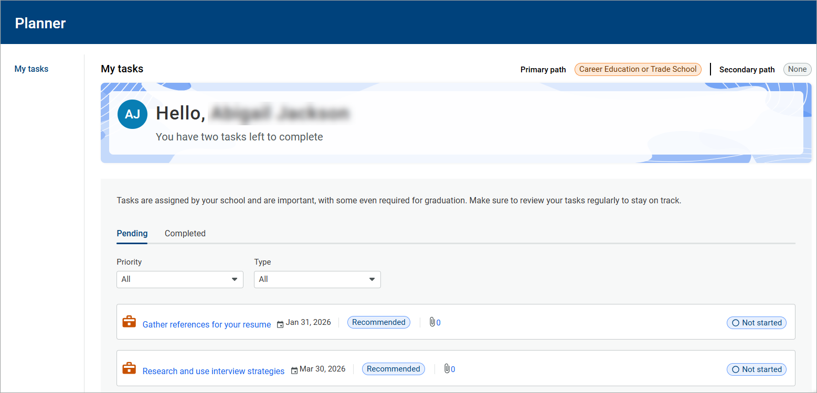

Planner 2.0 features
Features | Description
My tasks | Review activities assigned by your school or district, organized by pending and completed. Tasks details include a due date, priority level, and link to complete the activity.

About me
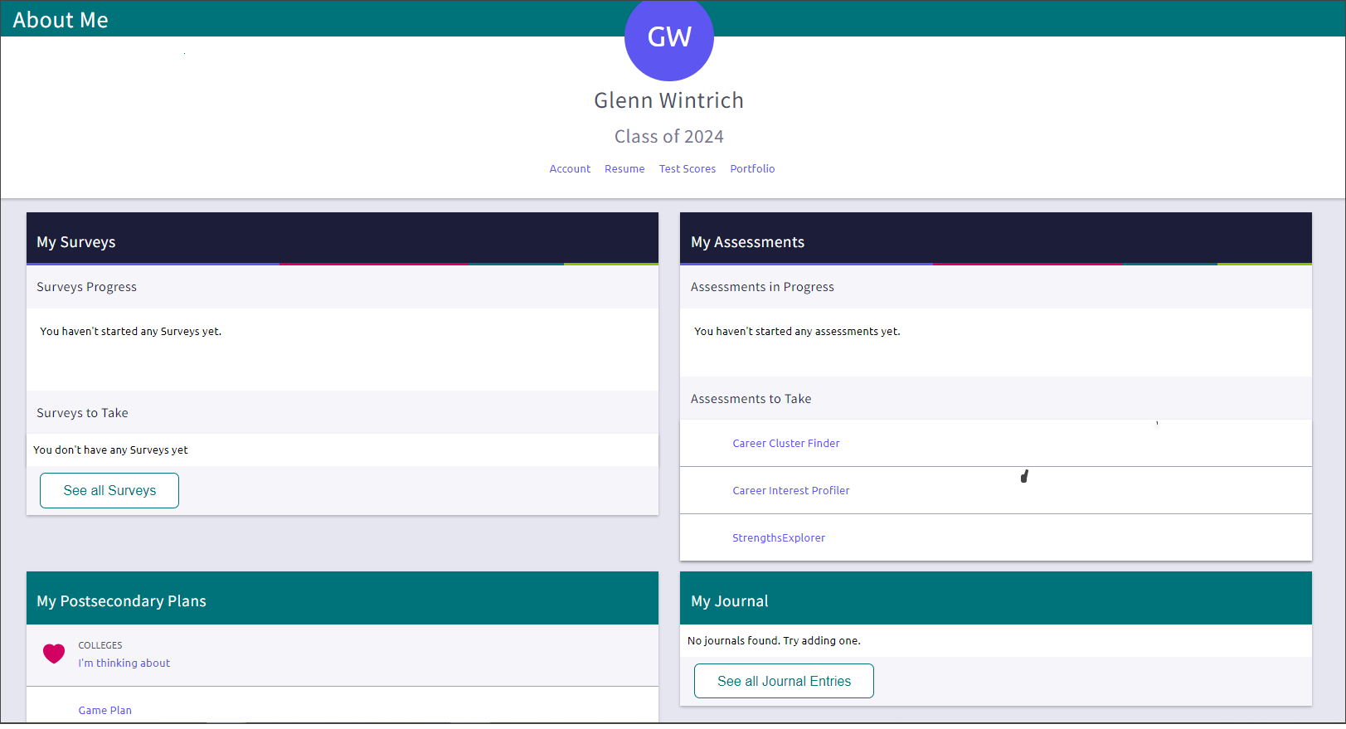

About me features
Features | Description
Resume | Keep track of your achievements from middle school to high school and share them with school staff in a resume format. Download the resume to use it for job interviews, scholarship applications, and more.
Test Scores | Review your SAT, ACT, and other key test scores added by your school. In some instances, you may also be able to add or edit key test scores in Naviance Student.
Portfolio | Document your growing skills, knowledge sets, and abilities to showcase your preparation for future careers and post-secondary goals.
My Surveys | Review surveys you are still working on and surveys that your school wants you to complete. Select a survey to start or continue it.
My Assessments | Review the assessments you are working on and assessments that your school wants you to complete. Select an assessment to start or continue it.
My Postsecondary Plans | Review your Postsecondary Plans including colleges you are interested in and careers, clusters, and sub-clusters that you have favorited. If available, complete the Game Plan survey and answer questions about your plans for after high school.
My Journal | Create journal entries for yourself or share them with counselors, teachers, parents, or guardians. Journal about things like your experiences, your plans, and essays. Attach documents to your journal entries.

