Course Planner Reference Guide
Naviance Student

Updated: June 6, 2023
Document Owner: Documentation Services
This edition applies to Naviance software and to all subsequent releases and modifications until otherwise indicated in new editions or updates.
The data and names used to illustrate the reports and screen images may include names of individuals, companies, brands, and products. All of the data and names are fictitious; any similarities to actual names are entirely coincidental.
PowerSchool is a trademark, in the U.S. and/or other countries, of PowerSchool Group LLC or its affiliate(s).
Copyright © 2005-2023 PowerSchool Group LLC and/or its affiliate(s). All rights reserved.
All trademarks are either owned or licensed by PowerSchool Group LLC and/or its affiliates.
Contents
Overview 4
Explore the Course Catalog 5
Favorite Courses 6
Manage Course Plans 7
Build a Course Plan 7
Edit a Course Plan 11
Delete a Course Plan 11

Overview
Use Course Planner features to take ownership of your middle school or high school course planning and be well-positioned for future career success.
- Search for and favorite courses you want to take.
- Build and manage course plans to ensure you meet graduation requirements.
- Plan to take courses that align with your career interests.
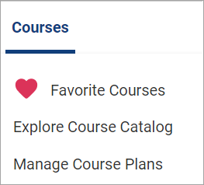

Explore the Course Catalog
Review your school’s course catalog to learn more about courses offered such as course corequisites and prerequisites.
- Select Courses and choose Explore Course Catalog.
- Optionally, lookup courses by:
- School Course Catalog
- Course Name or Keyword
- Subject Area
- Grade Level
- Select the course name or View to display course details.
- Select Favorite to add a course to your list of Favorite Courses.
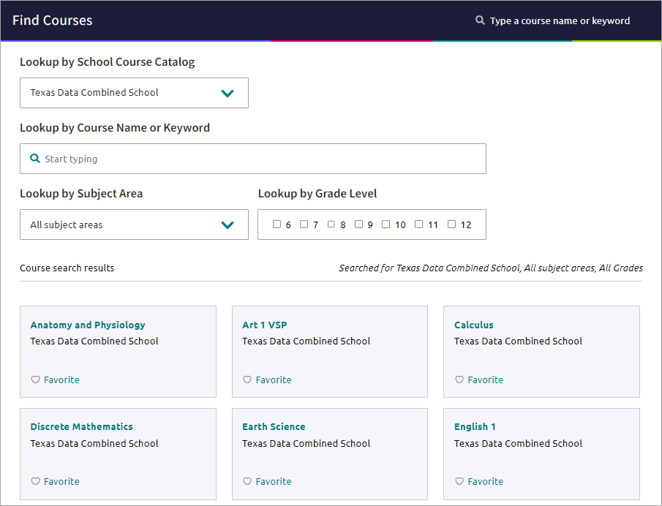

Favorite Courses
- Select Courses and choose Favorite Courses to display your list of interesting courses.
- Optionally, click Favorite to remove a course from your list.


Manage Course Plans
Use course plans to keep track of meeting graduation requirements and taking courses that align with your career interest.

Build a Course Plan
- Select Courses and choose Manage Course Plans.
- Click the add icon.
- Choose an option from the Select Your School list if available.
- Choose Select This Plan for a plan of study.
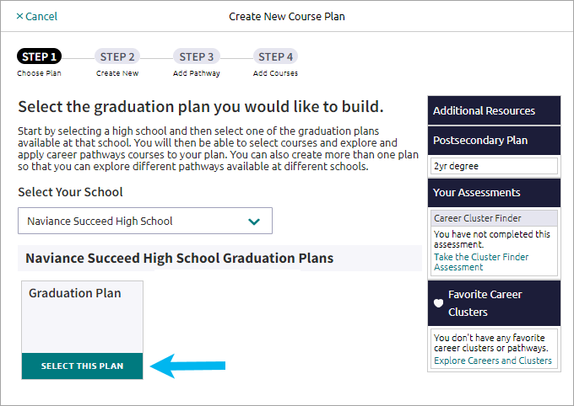

- Select Create a New Plan and then click Continue. Alternatively, select Copy from an Existing Plan to copy your course selections from an existing plan of study to a new plan of study.
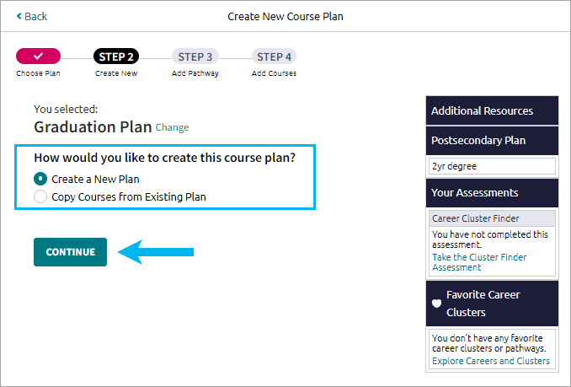
- Optionally, select a Cluster from the list, choose a related Pathway, and then click Add Selection and Continue to Your Plan. Alternatively, click Skip this Step if you do not want to select a cluster or pathway.
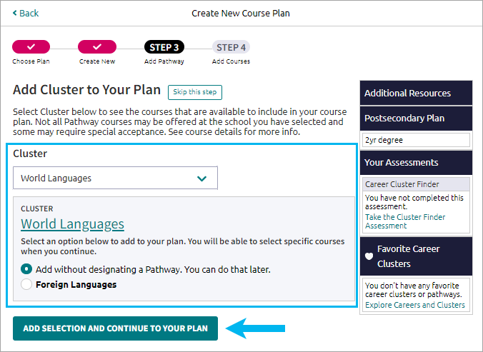

- From the course selection grid:
  - Review the Credits Required, In Plan, Still Needed, or Requirement alerts.
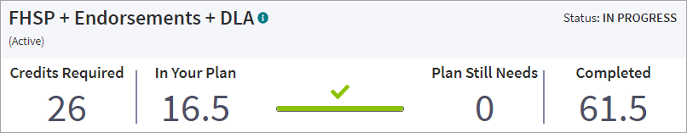
  - Review the credit summary for the selected requirement.
  - Select edit courses for a Requirement and then add courses to your plan until you have satisfied all required credits. Courses may display these notifications:
- In Plan - For an in-progress or completed course
- Credits earned - For a completed course
- Recommendation Required - For a course requiring a teacher or counselor recommendation
- Recommended by - For a course a teacher or counselor has recommended that you take
- Prerequisite Required - For a course where enrollment is dependent upon completion of another course
- Corequisite Required - For a course whose enrollment is dependent upon enrollment in another course
- Recover Credits - For a completed course with zero credits earned
  - Optionally:
- Review selected courses and their credit value or status.
- Click the trashcan icon to delete a selected course.
- Click the flag icon to display course alerts.
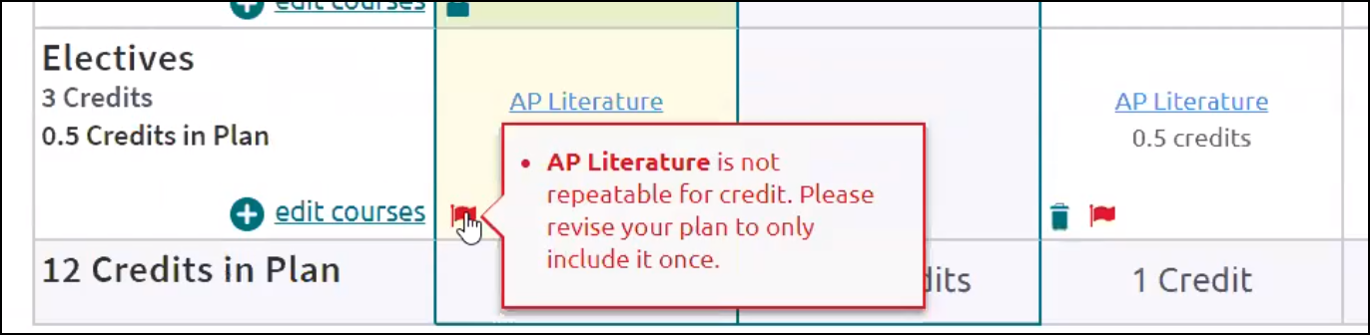
- Select edit courses, and then select Recovery Credits if a course displays zero credits complete.

- Click Check for Alerts to display information about course corequisites and prerequisites.
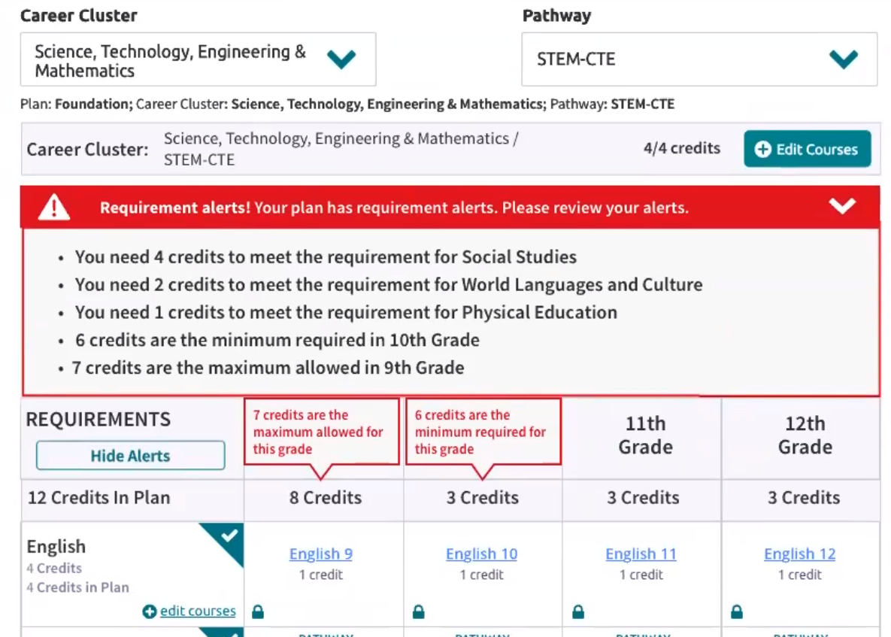
- Select a Cluster and a Pathway from the lists. You can select up to five pathways.
    - Click Add Courses to choose courses that fulfill the selected Cluster.
    - Select Add to choose courses that fulfill the selected Cluster.
- Review Additional Resources.
  - If available, select Submit For Approval after all course plan requirements. You can no longer edit a submitted course plan.
  - Optionally, click Print to download a PDF copy of your course plan.

Edit a Course Plan
- Select Courses, and then select Manage Course Plans.
- Choose the course plan to edit. Approved course plans may be locked for editing.
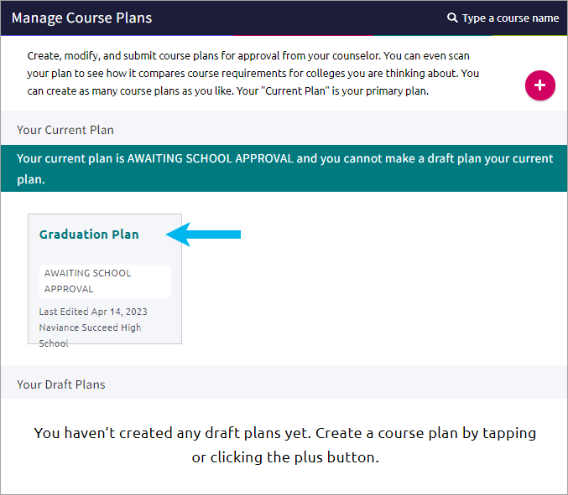
- Select edit courses for a Requirement or a course name to update your course selection.
- Optionally:
- Review selected courses and their credit value or status.
- Click the trashcan icon to delete a selected course.
- Click the flag icon to display course alerts.
- Select edit courses, and then select Recovery Credits if a course displays 0 credits complete.
- Click Check for Alerts to display information about course corequisites and prerequisites.
- Select a Cluster and a Pathway from the lists. You can select up to five pathways.
- Click Add Courses to choose courses that fulfill the selected Cluster.
- Select Add to choose courses that fulfill the selected Cluster.
- Review Additional Resources.

Delete a Course Plan
- Select Courses, and then select Manage Course Plans.
- Click Remove for the selected course plan.
- Click Delete.

