Refresh the country list of OLR Registration

- Log-in to Via Forms.
- Click Manage Schemas under the Admin icon
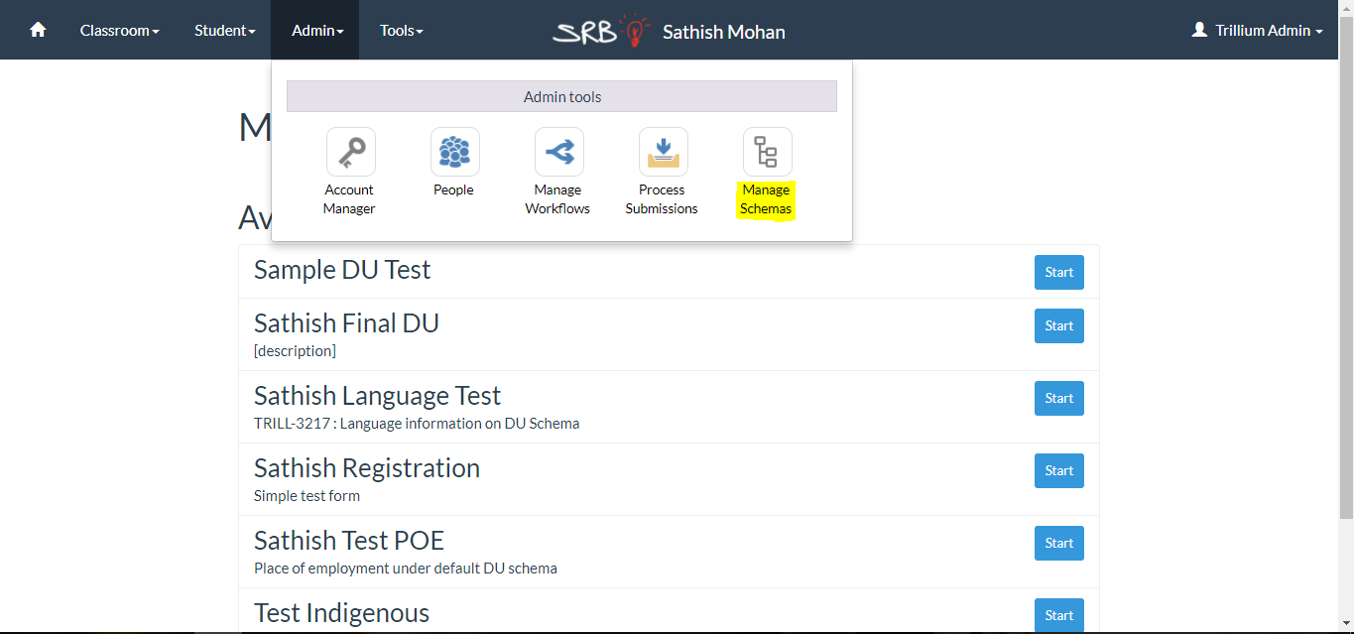

- Click the green Edit icon next to the schema for which you wish to update the country list. (eg. Sample Gender OLR schema)
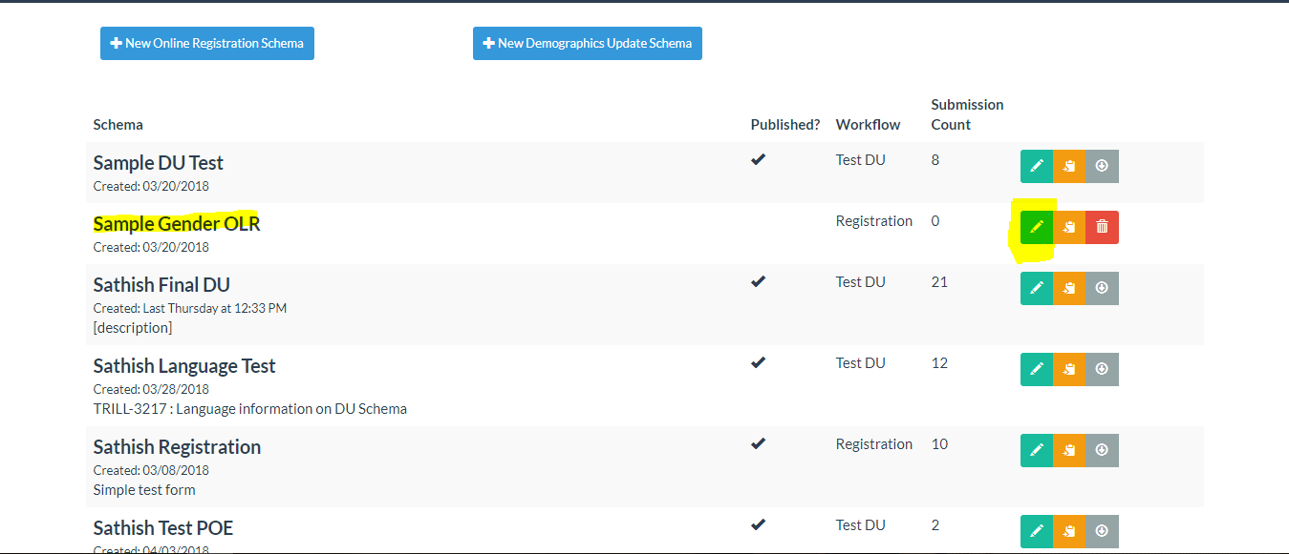

- Find the country fields and click on them. You’ll see the field options side panel open for the field.
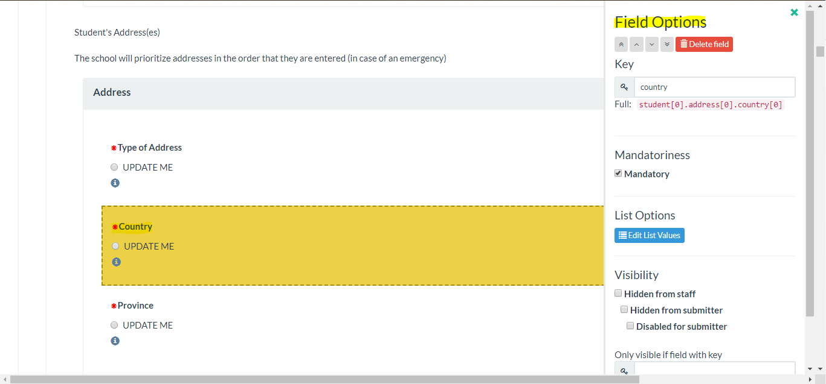

- Click the blue Edit list Values button. You’ll see this pop-up:
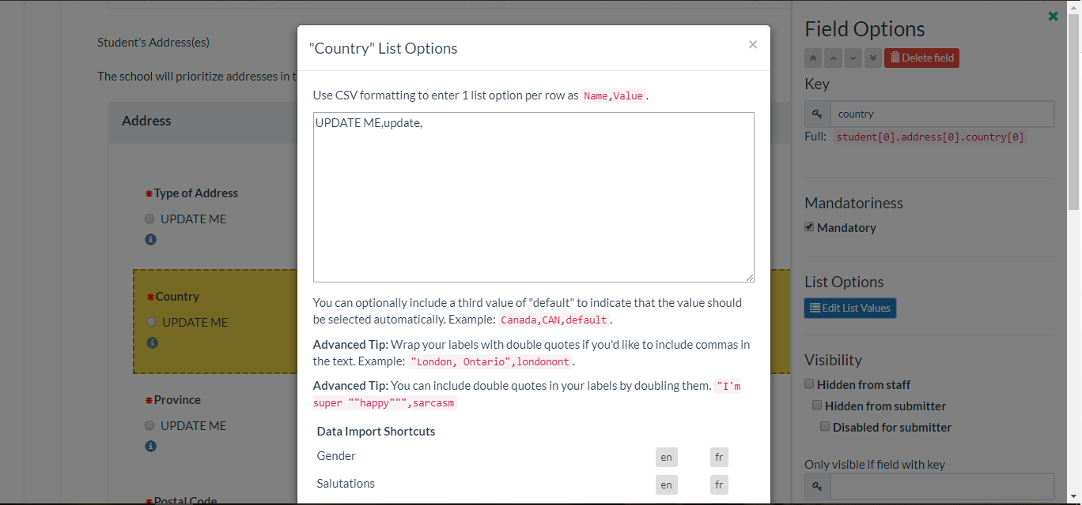

- Click Country data import to refresh the data.
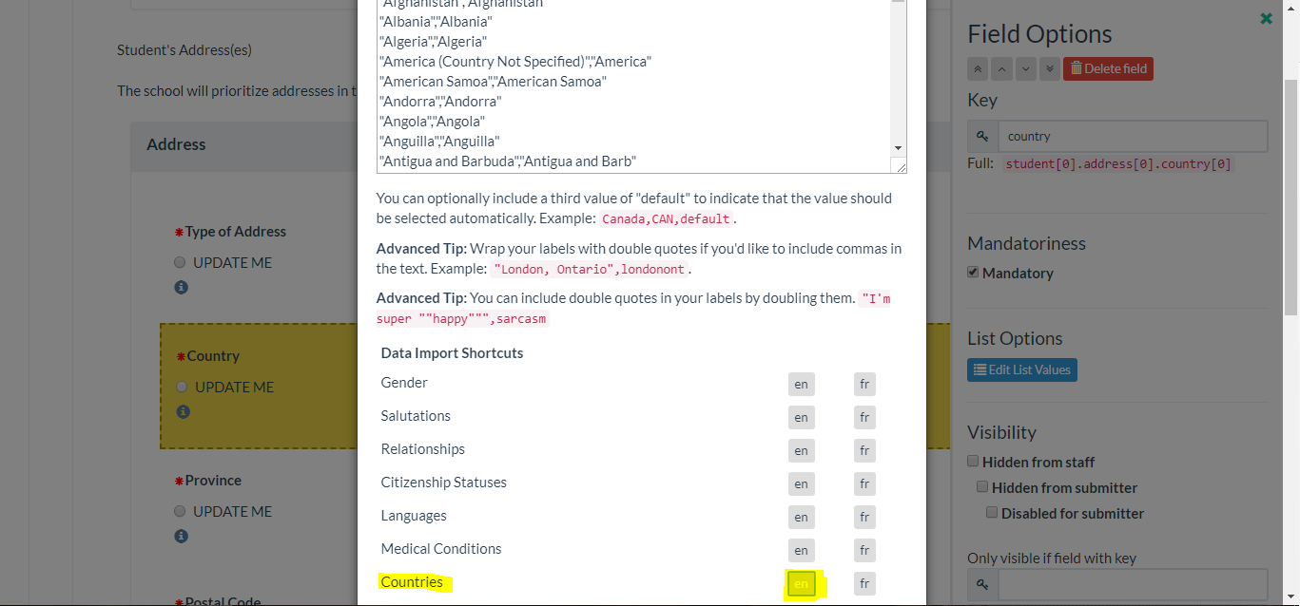

- Scroll down and click Apply Changes.
- Repeat Steps 5 to 7 for all the country fields in the schema.

