#### 



Online Registration

Version 1.50.10

Overview

March 2017

This document is furnished under license from

SRB Education Solutions Inc.

and may be used or copied only in accordance

with the terms and conditions of such license.

The information contained herein is

subject to change without notice.

COPYRIGHT © 2017 SRB Education Solutions Inc.

*A member of StarDyne Technologies.*



SRB Education Solutions Inc.

200 Town Centre Blvd. Suite 400

Markham, Ontario L3R 8G5

Support: 1-877-772-7878

General: 1-877-772-4685

Fax: 905-943-7713

Table of Contents

1 Document Tracking History 3

2 Introduction and Overview 4

3 Administrator Guide 5

3.1 Initial Setup 5

3.1.1 Security Tasks 5

3.2 Address Validation using StreetPerfect 5

3.3 Schools Accessibility 6

3.4 Core Trillium User profile setup 8

4 Trillium Web Online Registration 9

4.1 Login 9

4.2 Student Registration 9

4.2.1 Student Detail 10

4.2.2 Registration Detail 11

4.2.3 Funding 13

4.2.4 Conditional fields in Student Registration 15

4.2.5 Search School BSID 24

4.2.6 Customized Parent form fields 26

4.2.7 Register Student 38

5 Student Demographic Update 39

5.1 Add, Delete and Update Student and Contact Address 39

5.1.1 Address Insert 39

5.1.2 Address Update 39

5.1.3 Address Delete 39

5.2 Add, Delete and Update Student and Contact Phones/Emails 39

5.2.1 Phone/Email Insert 39

5.2.2 Phone/Email Delete 39

5.2.3 Phone/Email Update 40

5.2.4 Phone Critical Fields 40

5.2.5 Email Critical Fields 40

5.3 Add, Delete and Update Contact Demographic Information 40

5.3.1 Contact Insert 40

5.3.2 Contact Update 40

5.3.3 Contact Delete 40

5.3.4 Priority of the Contact/Address/Phone/Email 41

5.3.5 Update Contact’s various flags 41

6 Error Handling 42

# Document Tracking History

|  |  |  |
| --- | --- | --- |
| Action Taken | Action Taken By | Date |
| Initial version | SandeepS | August 2015 |
| Revision version | JaneZ | October 2015 |
| Revision for release 1.20.00 | SandeepS | December 2015 |
| Revision for release 1.30.00 | SandeepS | March 2016 |
| Revision for release 1.30.00 | MargaritaS | March 2016 |
| Revision for release 1.40.00 | SandeepS | August 2016 |
| Revision for release 1.50.10 | SandeepS | March 2017 |

# Introduction and Overview

The Trillium Online Registration system provides a facility to register a new student in Trillium database. The application will accept student data, validate it and then update the system with the data.

A new solution works with Submission forms where parents can fill the form online instead of paper form and submit it for the registration.

The application will have an ability to work with other applications/products to register a student.

The consumer system will invoke the application with student data. The authorized school board user will have an access to a screen before student registration where they can provide the office related registration information. The application will validate the information provided then and register the student at selected school.

# Administrator Guide

## Initial Setup

Trillium's Online Registration is used with the Online Registration (via Fusion). A license key is required in order to access the product. Once the web application and Core Trillium have been installed, the administrator or his designate will need to create and/or update user accounts with the appropriate security tasks necessary to access this functionality.

Note: User accounts and security privileges are done via Core Trillium’s security functions.

### Security Tasks

The following security tasks give access to the TWebOLR module pages.

|  |  |  |
| --- | --- | --- |
| **Security Task** | **Screen/Page Access** | **Module Name** |
| Online Registration | Allow to access Trillium Online Registration page | TWebOLR |

## Address Validation using StreetPerfect

The Student and Contact’s address by default validated against Trillium validation tables before updating the student details in Trillium database.

There is an option to validate these addresses using StreetPerfect (Address Accuracy Software for Canadian Addresses).

Listed are the steps needs to be followed if StreetPerfect needs to be used for Address validation.

* The StreetPerfect (third party software) server and client library are installed in client environment and accessible from the server where twebolr/DU is deployed.
* The application context file needs to be updated with a new parameter which identifies the StreetPerect Web service URL.

<Parameter name="address.server.url" override="false" value="${streetperfect_webservice_url}"/>

* There are two preferences in SchoolAdmin->Student Maintenance (one for board and one for school), which needs to be on and off respectively to use the street perfect validation.

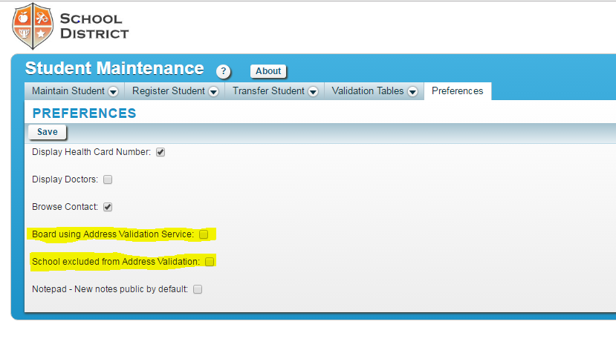

**Board using Address Validation Service** – This preference should be checked if StreetPerfect Address validation service is required to be used.

**School excluded from Address Validation** – This preference should be unchecked for StreetPerfect. This is school based preference and if it is checked for a school, the StreetPerfect will not be used for that particular school with Trillium Online Registration.

**Note:** The StreetPerfect setting must be completed on Via end as well to be used for Online Registration.

## Schools Accessibility

The user’s security profile determines the list of available schools at any date.

(Users’ security profiles and privileges are done via Core Trillium security module).

The profile might be synchronized with staff assignment data. A special flag allows adding and excluding some users to (from) the synchronization process by resetting the “Synchronize” default value in Core Trillium. By default, the "Synchronize" field for Board and Admin Users is always disabled and unchecked. The "Synchronize" field for Regular users is always enabled and checked by default.

If the profile is not synchronized, the start and end date of the profile will need to be maintained manually on an individual basis.

For synchronized users access to schools is determined by the “Start Date”, “End Date”, and “System Access Start Date” in staff assignment. The System Access Start Date is used to guarantee the user access to the application outside of the staff assignment dates.

User will be granted access to future assignments if the assignment start date is the same as the school start date once the school year becomes current.

User will be granted uninterrupted access to the system including access to the future assignments, if he/she has continuous staff assignments, in the current and future years.

## Core Trillium User profile setup

The user profile in core trillium must have the school assigned and must have All Classes flag checked to view the submissions for the assigned schools.

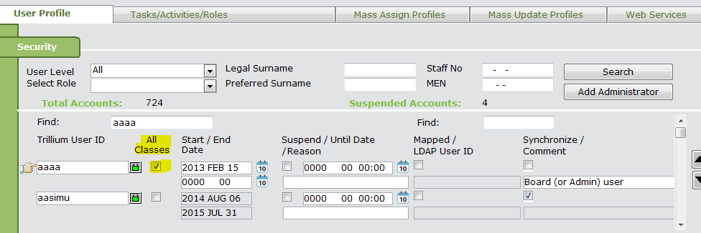

# Trillium Web Online Registration

## Login

The application can be used by Secretary/School Staff only through Online Registration product.

When Secretary/School Staff will click on Migrate button in the Online Registration application, TWebOLR Student Registration page will be launched. The user is authenticated using SSO (Single Sign On).

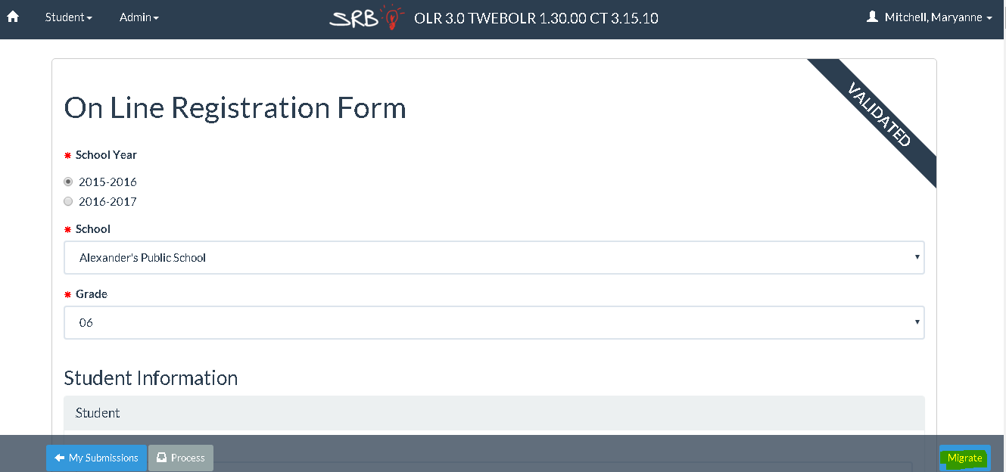

## Student Registration

The application allow user to update mandatory and optional fields which are required for a new student registration.

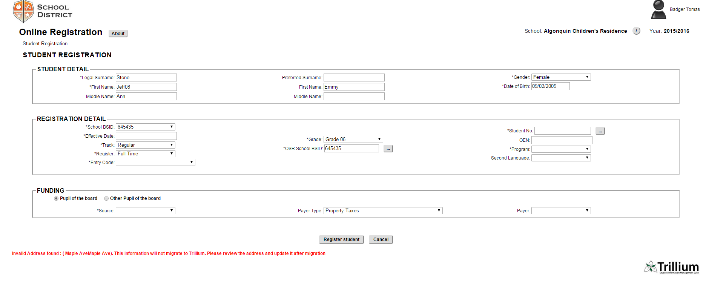

### Student Detail

The student registration page allows updating the student basic detail. The student basic detail is populated from the Online Registration’s Submission file. The Secretary/School Staff can update the values if required.



**Legal Surname**: This field is mandatory and has value as per Submission detail. The maximum length allowed is 40 characters.

If the submission detail have surname longer than 40 characters, a warning message will be displayed under the field and the value will be truncated at the time of registration.

**First Name**: This field is mandatory and has value as per Submission detail. The maximum length allowed is 20 characters.

If the submission detail have first name longer than 20 characters, a warning message will be displayed under the field and the value will be truncated at the time of registration.

**Middle Name**: This field is optional and has value as per Submission detail. The maximum length allowed is 20 characters.

If the submission detail have middle name longer than 20 characters, a warning message will be displayed under the field and the value will be truncated at the time of registration.

**Preferred Surname:** This field is optional and has value as per Submission detail. The **Legal** **Surname** value will be used in case if this field is empty. The maximum length allowed is 40 characters.

If the submission detail have surname longer than 40 characters, a warning message will be displayed under the field and the value will be truncated at the time of registration.

**First Name:** This field is optional and has value as per Submission detail. The **Legal** **First Name** value will be used in case if this field is empty. The maximum length allowed is 20 characters.

If the submission detail have first name longer than 20 characters, a warning message will be displayed under the field and the value will be truncated at the time of registration.

**Middle Name:** This field is optional and has value as per Submission detail. The maximum length allowed is 20 characters.

If the submission detail have middle name longer than 20 characters, a warning message will be displayed under the field and the value will be truncated at the time of registration.

**Gender:** This field is mandatory and has value selected as per Submission detail. It is a drop down.

**Date of Birth:** This is a mandatory and has value selected as per Submission detail. The format must be DD/MM/YYYY. The date must be less than today’s date.

### Registration Detail

The student registration page allows Secretary/School Staff to enter/update the detail required to register a student in Trillium. The few fields are populated from the Online Registration’s Submission file. The Secretary/School Staff can update the values if required.

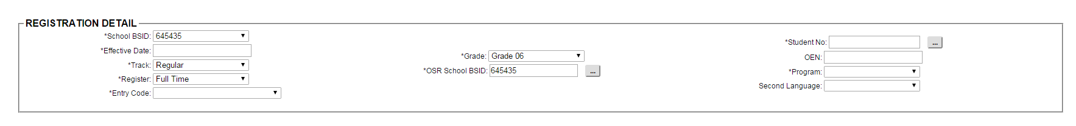

**School BSID**: This field is mandatory and has value as per selected school. This will have a drop down in case the selected school has more than one BSID.

**Effective Date**: This field is mandatory and this date will be used as start date for student registration. The value must follow the following rules:

* Must be in the format DD/MM/YYYY
* Must be within the selected school year
* Must be an attendance taking day
* Must be within the start and end date for the selected program

**Track**: This field is mandatory. It has a drop down populated with values selected from database as per selected school and school year.

**Register:** This field is mandatory. It has a drop down populated with values selected from database as per selected school.

**Entry Code:** This field is mandatory and has a drop down populated from validation table **Entry Types**.

**Grade:** This field is mandatory and has value selected as per Submission detail. It has a drop down populated from database as per selected school.

**OSR School BSID:** This field is mandatory and has default value same as of School BSID. The user can change the value by clicking the button next to the field which will open a search window. Refer to **Section 4.2.5** for Search School BSID functionality.

**Student No:** This field is mandatory. There is button next to the field to auto generate the available student number. The student number must be of 9 digits with a format xxx-xxx-xxx. It must be unique.

**OEN:** This field is optional. The value must be unique and validated against the Ministry rules. It must be of 9 digits with a format xxx-xxx-xxx.

**Program:** This field is mandatory and has value selected as per selected grade. It has a drop down populated from database as per grade selection. The drop down will be populated every time when grade value is changed. The field is disabled if there is nothing selected for **Grade**.

**Second Language:** This field is optional. The default selected value is as per the school preference in core trillium. It has a drop down value as per system defined table fs_fsl_programs.

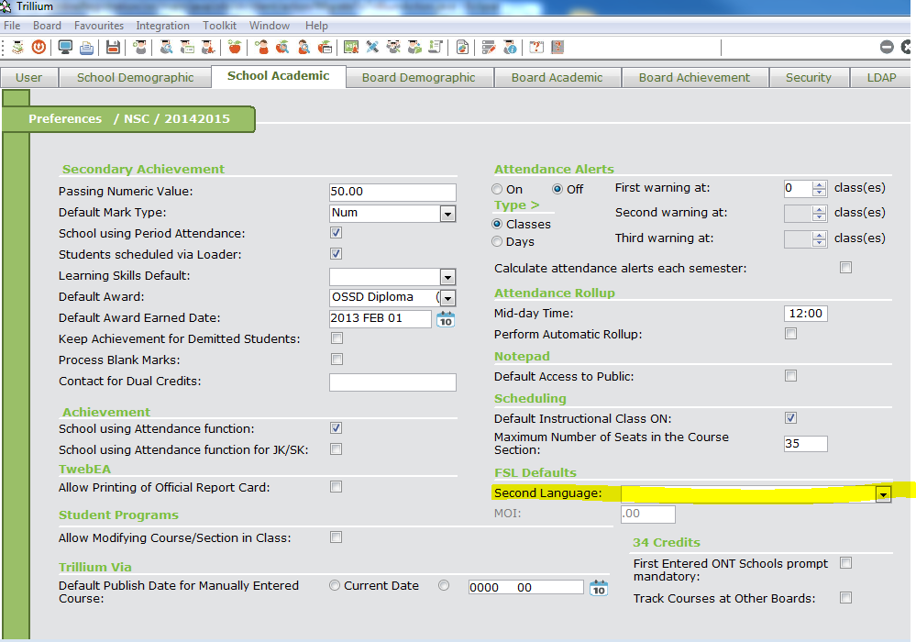

### Funding

The student registration page allows Secretary/School Staff updating the funding details about the student.



**Funding Type**: This field is mandatory. It has only two fixed values **Pupil of the Board** and **Other Pupil of the Board** as radio buttons. The default one selected is as per the school preference in core trillium.

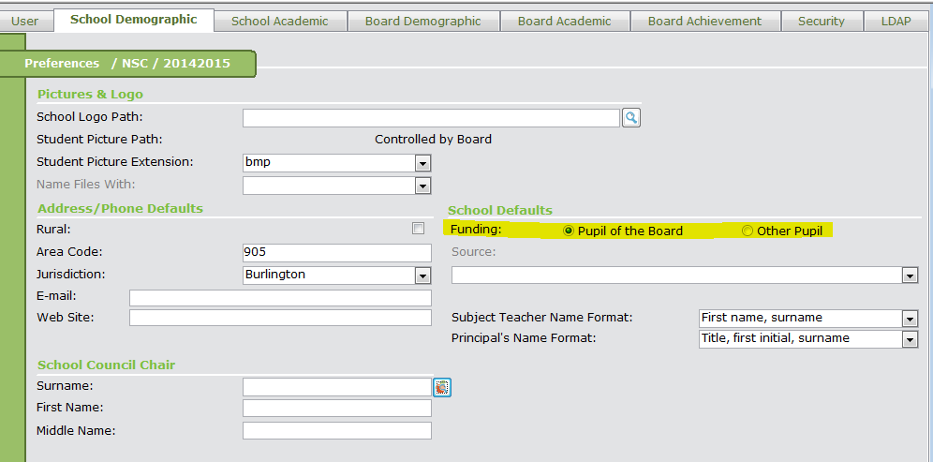

**Source**: This field is mandatory if the selected funding type is **Other Pupil of the Board** otherwise it is disabled. It has a drop down populated from system defined validation table **Funding Source**. The default selected value is as per the school preference in core trillium.

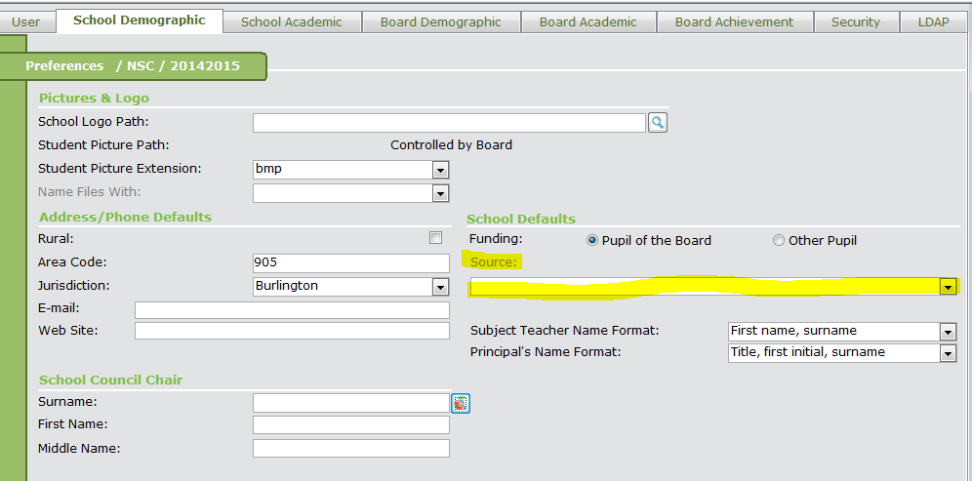

**Payer Type**: This field is optional. It has a drop down populated from system defined validation table **Organization Types** where Display for Funding flag is checked if selected funding type is **Other Pupil of the Board.**

Otherwise, the drop down displays a list having **Person** and **Property Taxes** as value with **Property Taxes** as default selected value.

**Payer**: This field is optional. It has a drop down populated with values selected from database as per selected payer type when payer type is other than **school**. In case of school as a selected payer type, there is a button next to the field which is used to search the school BSID. Refer to **Section 4.2.5** for Search School BSID functionality.

A warning message will be displayed before migration if the selected payer type is person. The

user needs to update payer after registration manually.

**Message at the home screen**

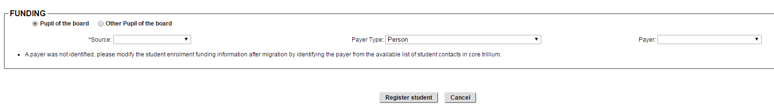

### Conditional fields in Student Registration

There are few fields on the screen which are conditional. These fields are mandatory and will be visible on the form based on what values user selected for the dependent fields.

#### Fields based on Entry Code selection

The application has a list of Ministry Defined entry codes. Each entry code selected has a different set of fields which are mandatory.

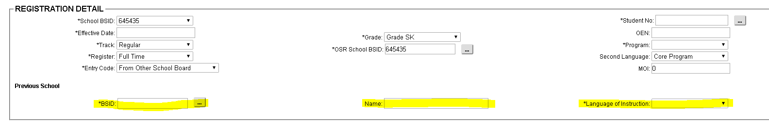

**BSID**: This field is mandatory and visible when selected entry code has **School mandatory** flag checked. This field will be visible as a read only with a value if **prompt** flag is not checked. The BSID text box will have a value as per **value** selected in CT Validation Table screen for table **Entry Types**. There will be a button next to the field which is used to search the school BSID if the prompt flag is checked. Refer to **Section 4.2.5** for Search School BSID functionality.

**Name**: This field is read only and visible only when BSID field is visible on screen. It will display the board/school name as per selected BSID.

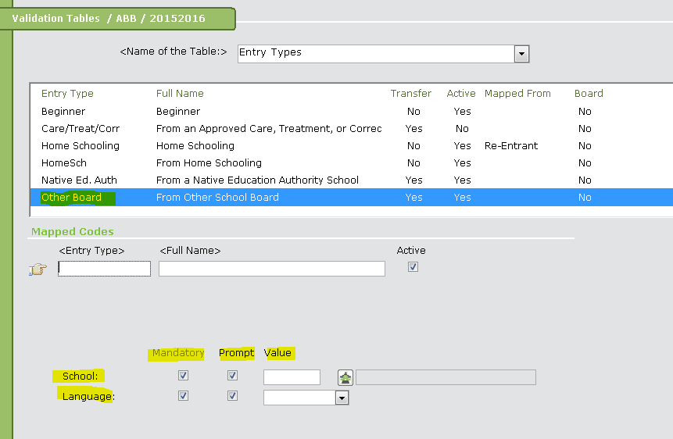

**Language of**

**Instruction**: This field is mandatory and visible when selected entry code has **Language** **mandatory** flag checked in CT as per above screen shot. This field will be visible as a read only with a value if **prompt** flag is not checked. The Language text box will have a value as per **value** selected in CT Validation Table screen for table **Entry Types**. If the **prompt** flag is checked, this field has a drop down populated from system defined validation table **Languages** based on the official language flag checked.

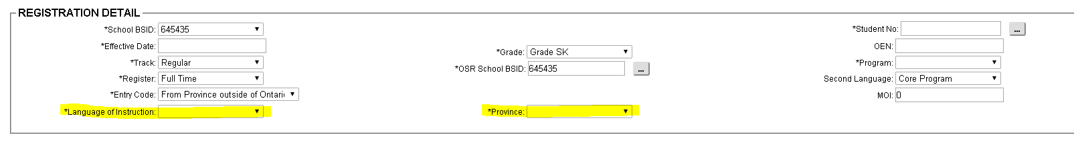

**Province**: This field is mandatory and visible when selected entry code has **Province** **mandatory** flag checked in CT as per below screen shot. This field will be visible as a read only with a value if **prompt** flag is not checked. The Province text box will have a value as per **value** selected in CT Validation Table screen for table **Entry Types**. If the **prompt** flag is checked, this field has a drop down populated from validation table **Province/State**. The drop down list will not include the default province as per board preference in core trillium.

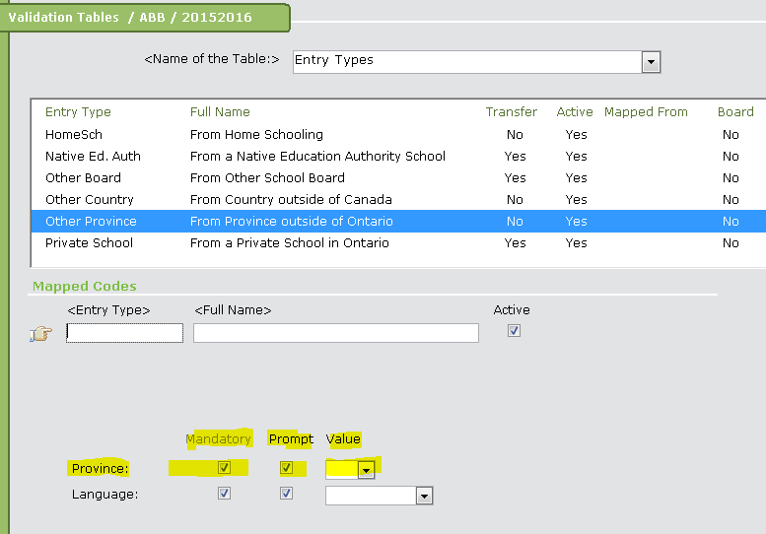

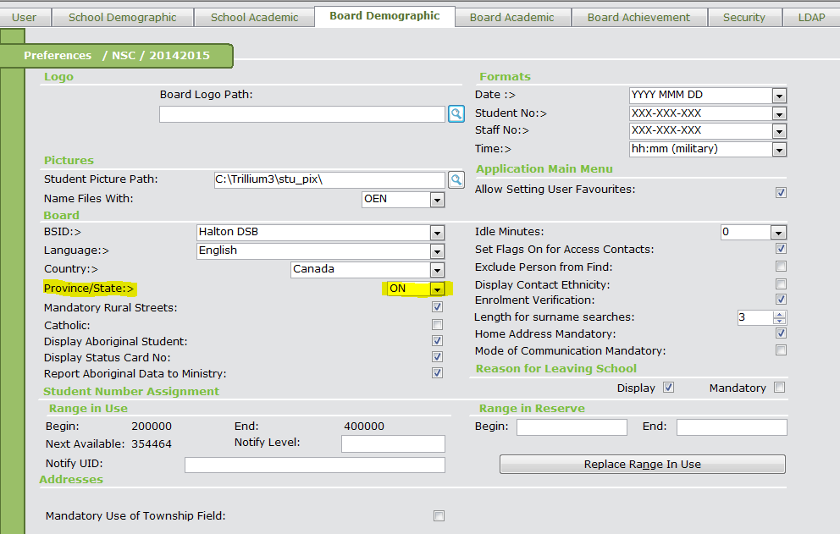

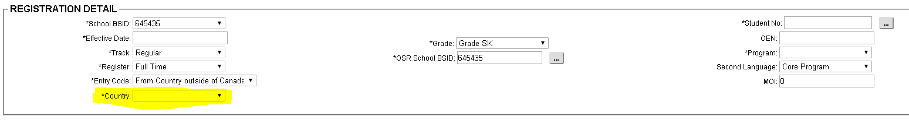

**Country**: This field is mandatory and visible when selected entry code has **Country** **mandatory** flag checked in CT as per below screen shot. This field will be visible as a read only with a value if **prompt** flag is not checked. The Country text box will have a value as per **value** selected in CT Validation Table screen for table **Entry Types**. If the **prompt** flag is checked, It has a drop down populated from system defined validation table **Countries**. The drop down list will not include the default country as per board preference in core trillium.

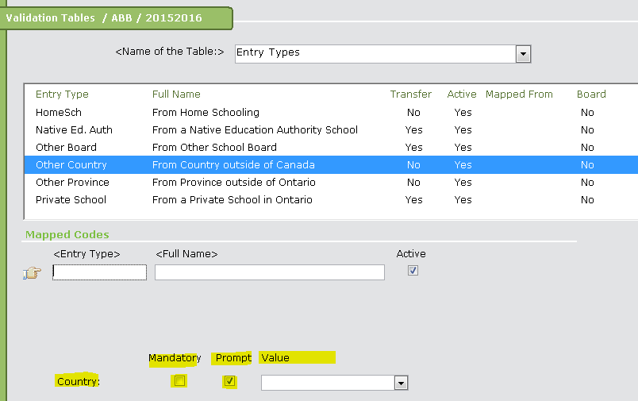

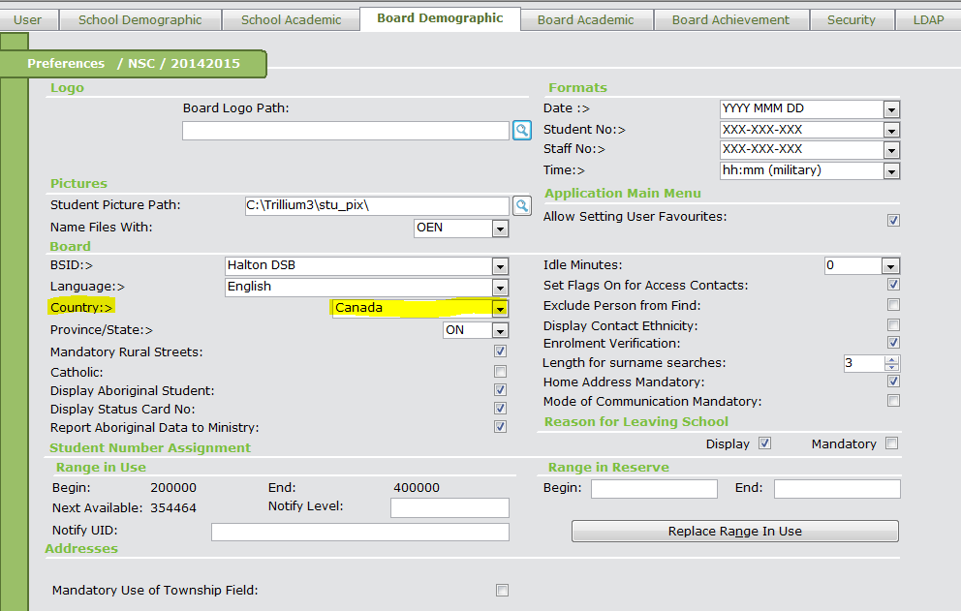

#### Fields based on School Type

##### School Type is Elementary

The application will display following field if the school type is elementary.

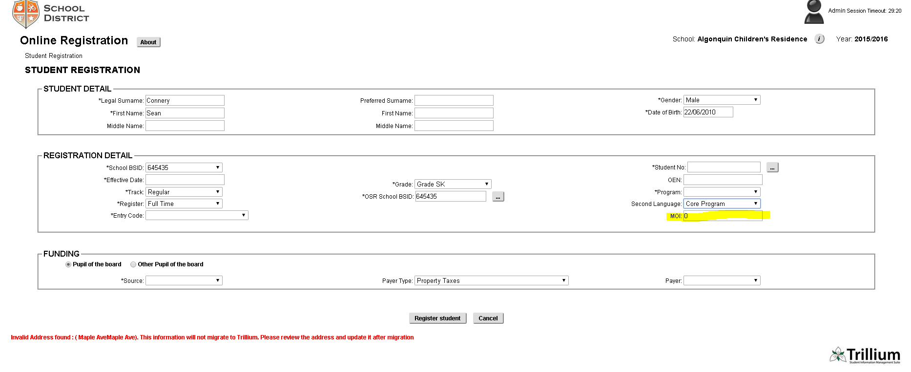

**MOI**: This field is mandatory if the **Second Language** field is not empty or the selected value for Second Language is not **Exempted**. The field default value is as per the school preference in Core Trillium. The default value will be zero (0) if there is no value specified in preference. The value will be validated against Ministry rules.

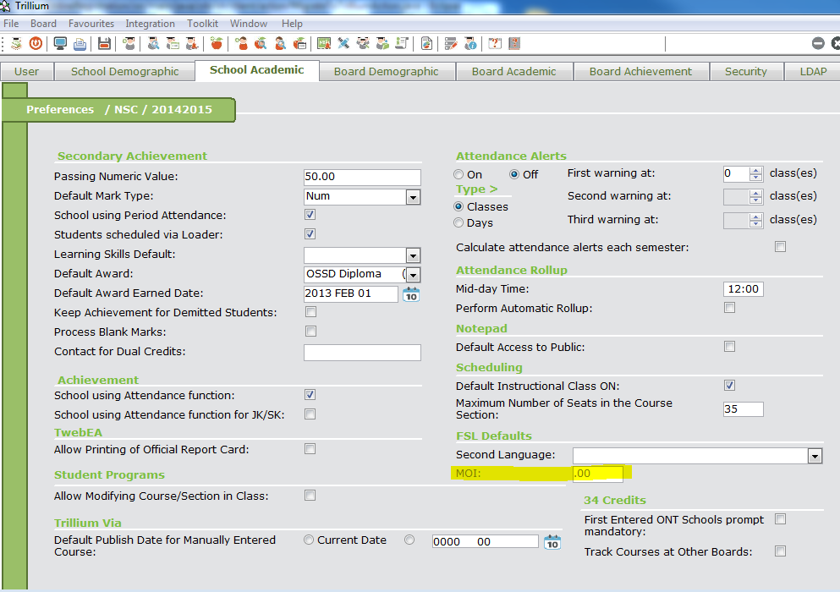

**MEQ**: This field is visible only for Elementary French school boards. This field is mandatory if the **Second Language** field is not empty and the selected value has a flag combined_program_flag_10 checked in database table fs_fsl_programs. The field default value is as per the school preference in Core Trillium. The value will be validated against Ministry rules.

##### School Type is Secondary

The application will display following field if the school type is secondary.

**Award**: It has a drop down populated from validation table **Awards**. It displays all awards having active flag checked and of type Diploma. It will not display any SHSM awards. The default selected value for the drop down is as per Core Trillium > School Setup > Preference > School Academic > Default Award field.

#### Fields based on Grade

There are fields on the screen which are based on the grade selected.

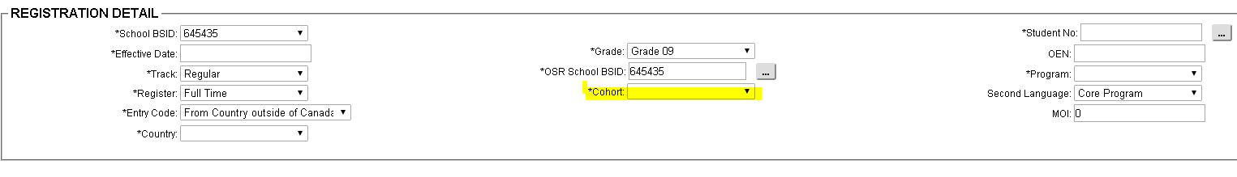

**Cohort**: This field is mandatory and visible only for grade 9 and up. This field displays a drop down list of last ten school years as per selected school. This field also allow user to enter a new value for Cohort if it is missing in the drop down. The value will be validated against the rule:

* it must be of 8 characters
* first 4 digits + 1 = last 4 digits
* e.g: 20122013

**First Entered**

**ONT Sec. Schools**

**After:** This field is mandatory and visible only for grade 9 and up and if the school preference is setup in Core trillium. It has drop down list with two values as **Yes** and **No**.

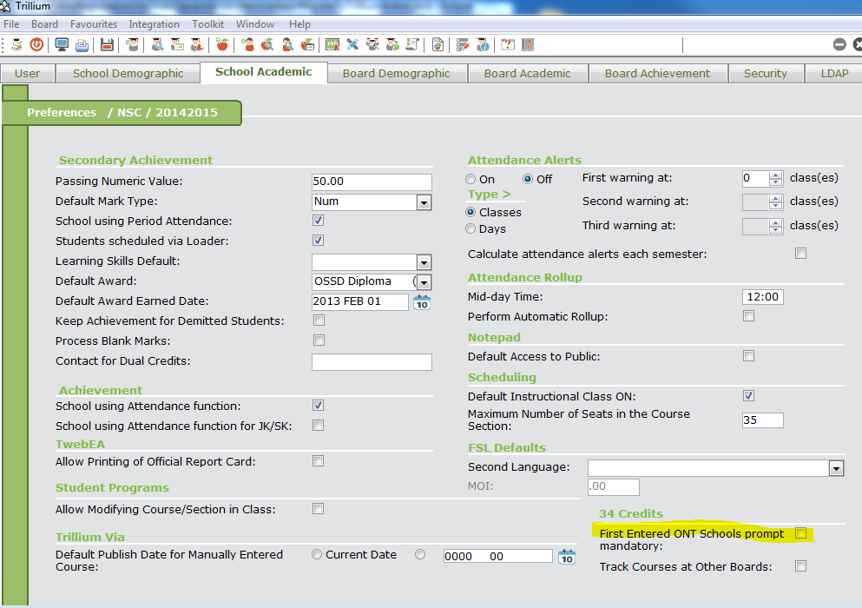

#### Fields based on Program

There are fields on the screen which are based on the grade selected.

**International**

**Language**: This field is optional and visible only if the selected value for **Program** has **International Language flag** checked in CT validation table screen. It has a drop down list of values as per system defined validation table **Languages.**

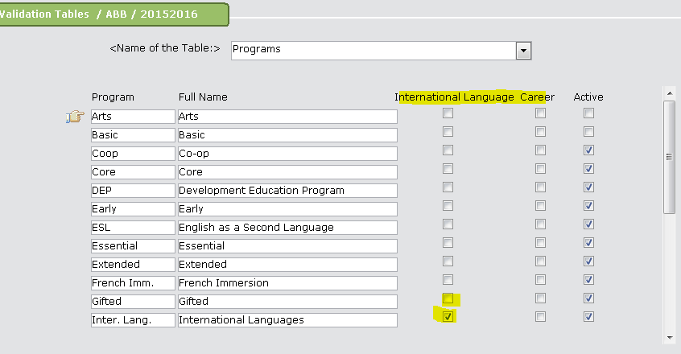

### Search School BSID

The application has a functionality to search for the school BSID using school name and other criteria.

This functionality is used in this application from a button next to three fields: **OSR School BSID**, **Previous School BSID and Payer (**when selected Payer type is **School).**

When user clicks the button, a new popup window will appear:

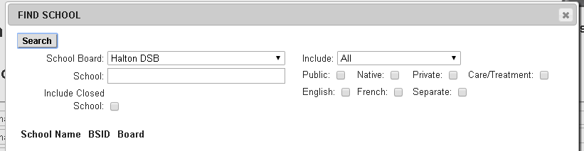

**School Board**: This field has a drop down which display the list of school boards depending upon from where we clicked this button and what is the value selected for entry code drop down as:

|  |  |  |  |
| --- | --- | --- | --- |
| **Sr.No** | **Source** | **Entry Codes** | **School Board** |
| 1 | From OSR School BSID | Any Value | List having only current school board |
| 2 | From Previous School – BSID | This School Board | List having only current school board |
| 3 | Other School Board | List of all school boards |
| 4 | From Payer | This School Board | List having only current school board |
| 5 | Any other value | List of all school boards |

**School**: This field is text box where user can type in the school name. The searched school list will contain the school having entered school name.

**Include Closed**

**School**: This field is a checkbox which will specify in search criteria whether to include closed schools or not in the searched list.

**Include**: It has a drop down list of school types populated from the validation table **School Types**. User can select either one school type or select the option **ALL.** This value will be used as a search criteria.

**Search Attributes**: This is a group of checkboxes which will specify to include the schools with a specific attribute. The various attributes are:

* **Public**
* **Native**
* **Private**
* **Care/Treatment**
* **English**
* **French**
* **Separate**

**Search**: When user click the search button, the entered fields will be used as search criteria and a below table will be populated as:

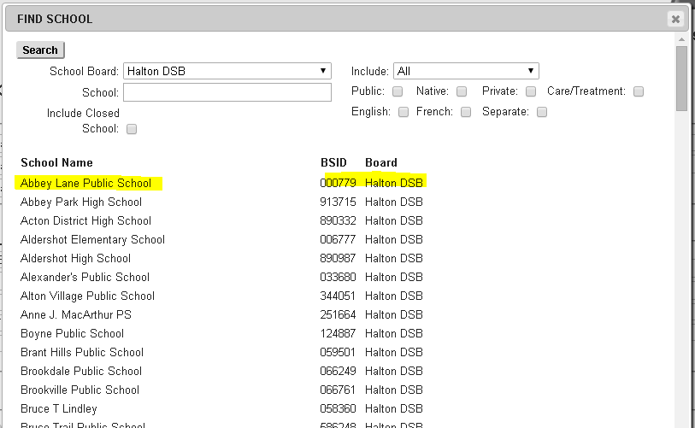

User can click on the row to select the BSID. The popup will be closed after clicking the row and the BSID will be used to populate the source field e.g: **OSR School BSID.**

### Customized Parent form fields

The parent form is customizable. So, each school can set up their own fields which are going to be visible to the parent. If fields are visible on the screen, it should be migrated to trillium with student registration. Below is the list of fields/section which can be migrated to trillium.

#### Address

The address data related to the student and contact will also be migrated to Trillium.

Here is the screenshot from the parent form. This data is not visible on the screen but will be validated and stored in the database with student registration.

The Parent can enter more than one address for student or/and the contacts. Each address will have a priority assigned to it based on the order in which the address will be provided for each person.

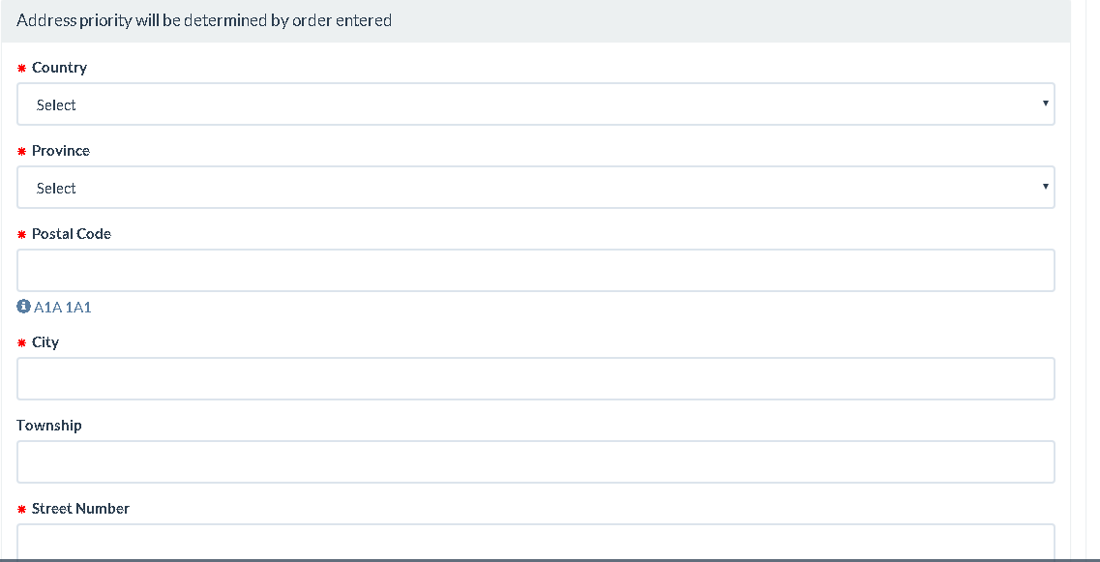

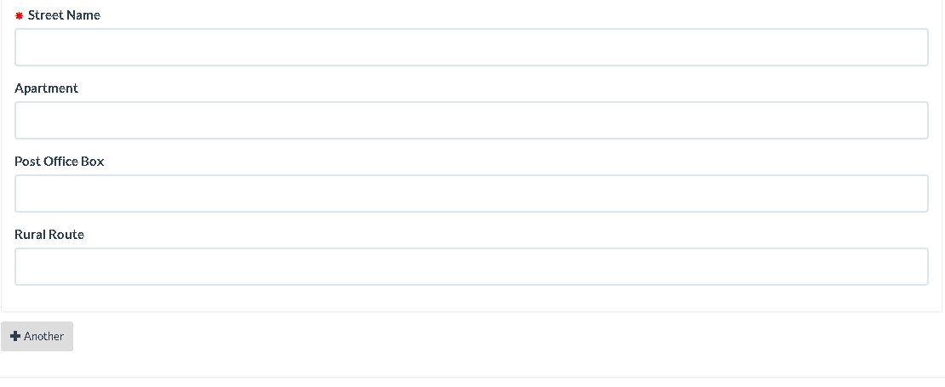

**Country**: This is mandatory for the address data. This field has an auto suggest drop down which start getting populated with matched countries (containing the typed characters) using system defined validation table **Countries** as user type the characters in the field.

**Province/State**: This is optional for the address data. This field has an auto suggest drop down which start getting populated with matched province (containing the typed characters and based on selected country) using system defined validation table **Province/State** as user type the characters in the field.

**Postal Code**: This is mandatory for the address data. This field is a text box where user can enter only valid formatted postal codes XYX-YXY where X is any alphabet and Y is any number.

**City**: This is mandatory for the address data. This field has an auto suggest drop down which start getting populated with matched city (containing the typed characters and based on selected country) using validation table **Jurisdiction/Streets** as user type the characters in the field.

**Township**: This is optional for the address data. This field has an auto suggest drop down which start getting populated with matched township (containing the typed characters and based on selected city) using validation table **Jurisdiction/Streets** as user type the characters in the field.

**Street Number**: This is mandatory for the address data. This field is text box where user can type in the street number.

**Street Name**: This is mandatory for the address data. This field has an auto suggest drop down which start getting populated with matched street name (containing the typed characters and based on selected city) using validation table **Jurisdiction/Streets** as user type the characters in the field.

**Apartment** This is optional for the address data. This field is text box where user can type in the apartment number.

**Post Office Box**: This is optional for the address data. This field is text box where user can type in the PO Box number.

**Rural Route**: This is optional for the address data. This field is text box where user can type in the RR number.

##### Address Validation

There are two ways to validate the address:

* Using StreetPerfect
* Using Trillium validation table

###### Address Validation Using Trillium Validation Tables

The listed validations will be done on the addresses before saving to trillium database if StreetPerfect is not enabled.

**Street Name**: The street name for each address (student and contact) will be validated against the Trillium validation table. If the street name is valid, the address will be migrated to Trillium with student registration. Otherwise, the address will be skipped and there will be a warning message on the home screen at the end and also on the Registration status screen.

**Address Priority** Application validate priority with following rules:

1. Priority can’t be null.

2. Must be unique with address type. (Expired address doesn't validated)

**Message at the home screen**



**Message at the Registration Status screen**

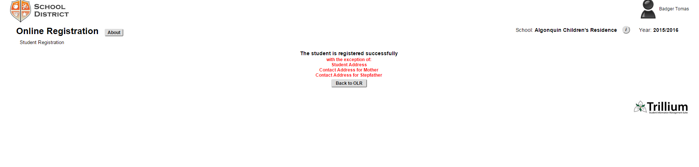

**Postal Code**: The postal code must be in valid format as XYX-YXY where X is any alphabet and Y is any number.

###### Address Validation Using StreetPerfect

The listed validations will be done on the addresses before saving to trillium database using StreetPerfect.

The board preference must be checked in Student Maintenance to use StreetPerfect.

**Address:** The complete address will be validated against StreetPerfect which includes:

* + - * Street Number
      * Street Name
      * Municipality/Jurisdiction/city
      * Province
      * Postal Code

If any of the above is wrong, the address is not a valid address.

**Street Name**: If the address is valid as per StreetPerfect and street name doesn’t exist in Trillium Validation tables, the Street Name will be added to Trillium Validation tables before saving student information to Trillium.

**City**: If the address is valid as per StreetPerfect and city doesn’t exist in Trillium Validation tables, the city will be added to Trillium Validation tables before saving student information to Trillium.

**Message at the home screen**

When address is not valid as per StreetPerfect validation.

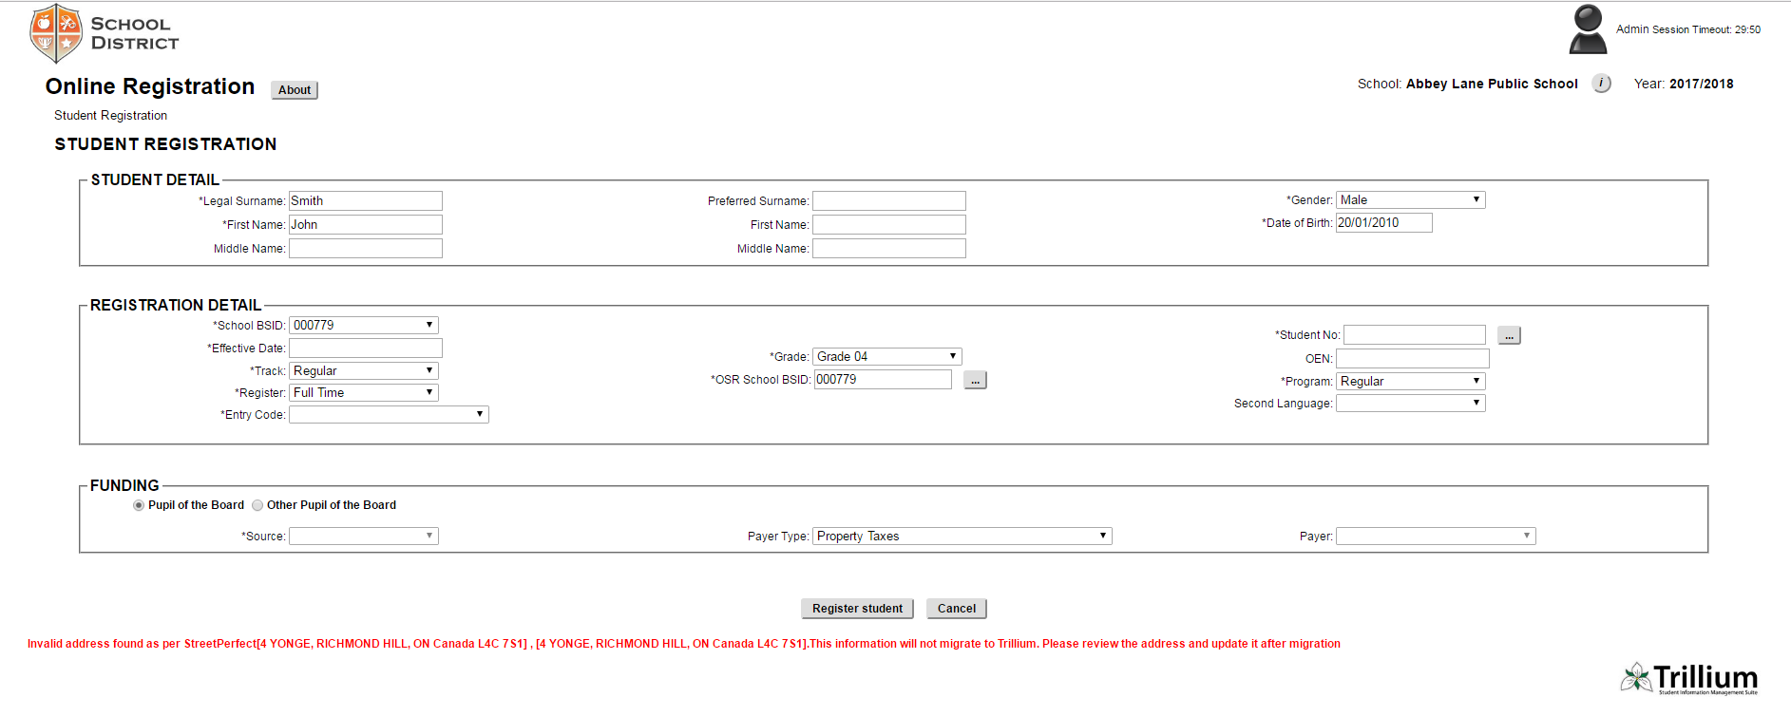

**Message at the Registration Status screen**



#### Contact

The student contact data will also be migrated to Trillium.

Here is the screenshot from the parent form. This data is not visible on the screen but will be validated and stored in the database with student registration.

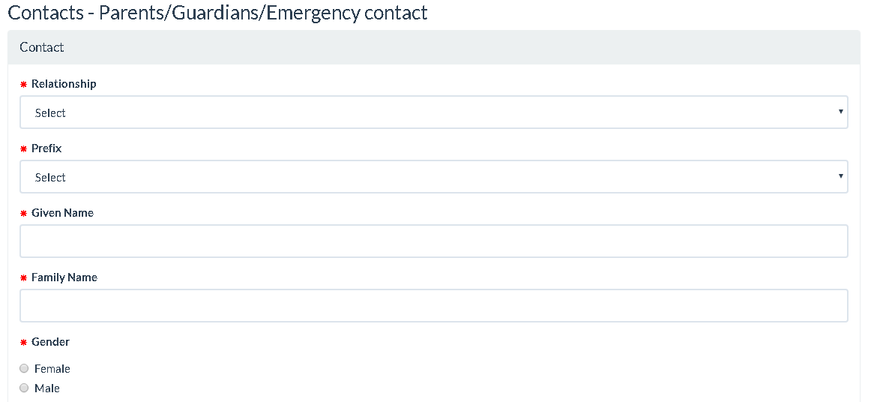

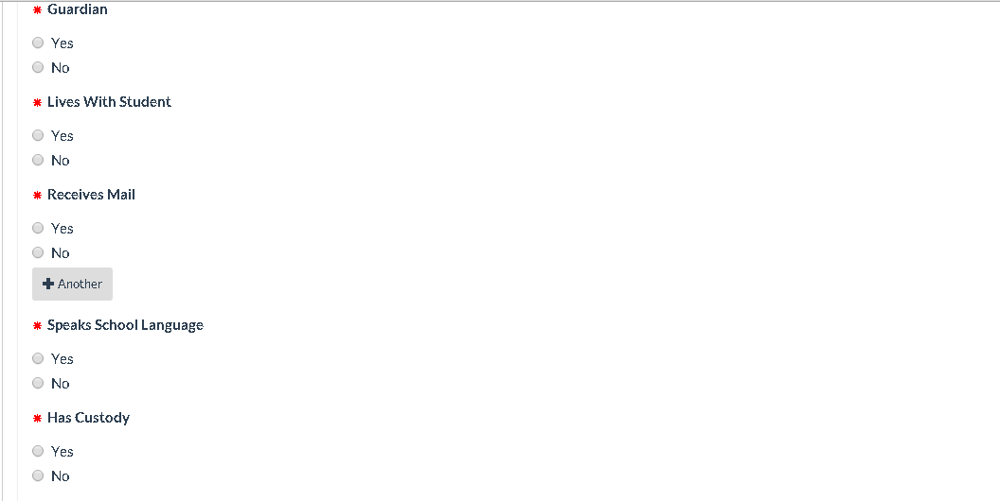

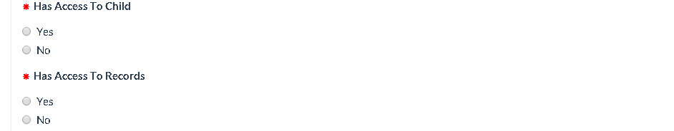

**Relationship**: This is mandatory field. This field has a drop down populated from validation table **Relationships**

**Prefix**: This is optional field. This field has a drop down populated from validation table **Salutations.**

**Given Name**: This is mandatory field. This field is a text box where user can enter the first name of the contact.

**Family Name**: This is mandatory field. This field is a text box where user can enter the last name of the contact.

**Gender**: This is mandatory field. It has two checkboxes **Male** and **Female**.

**Guardian**: This is mandatory field. It has two checkboxes **Yes** and **No**. It specify if the contact is a guardian to the student.

**Live with Student**: This is mandatory field. It has two checkboxes **Yes** and **No**. It specify if the contact lives with the student.

**Receives Mail**: This is mandatory field. It has two checkboxes **Yes** and **No**. It specify if the contact is going to receive mail for the student.

**Speaks School**

**Language**: This is mandatory field. It has two checkboxes **Yes** and **No**. It specify if the contact speaks school language.

**Has Access to Child**: This is mandatory field. It has two checkboxes **Yes** and **No**. It specify if the contact has access to the student.

**Has Custody**: This is mandatory field. It has two checkboxes **Yes** and **No**. It specify if the contact has custody for the student.

**Has Access to**

**Records**: This is mandatory field. It has two checkboxes **Yes** and **No**. It specify if the contact has access to student records.

**Priority For**

**Emergency**: This is mandatory field. It has checkboxes from number **1** to **4** and **N/A**. It specify the contact’s priority to inform in case of emergency for the student.

**Priority For**

**School Closure**: This is mandatory field. It has checkboxes from number **1** to **4** and **N/A**. It specify the contact’s priority to inform in case of school closure for the student.

**Place of**

**Employment**: This is optional field. This field is a text box where user can enter the contact’s place of employment.

**Telecom Fields**: There are few fields which are related to telecom data for the contact. Refer to section **4.2.8** for detail. **REALLY: 4.2.6.3**

**Address Fields**: There are few fields which are related to address data for the contact. Refer to section **4.2.6** for detail. **REALLY: 4.2.6.1**

##### Contact Validation

The listed validations will be done on the contact before saving to trillium database.

**Duplicate Contact**: The TWEBOLR will check if the duplicate contact exist before saving contact data to the Trillium database. This validation depends on the setting in core trillium. If the checkbox Exclude Person from Find is checked, the duplicate contact validation will be skipped and the new contact will be created in Trillium regardless of duplicate record.

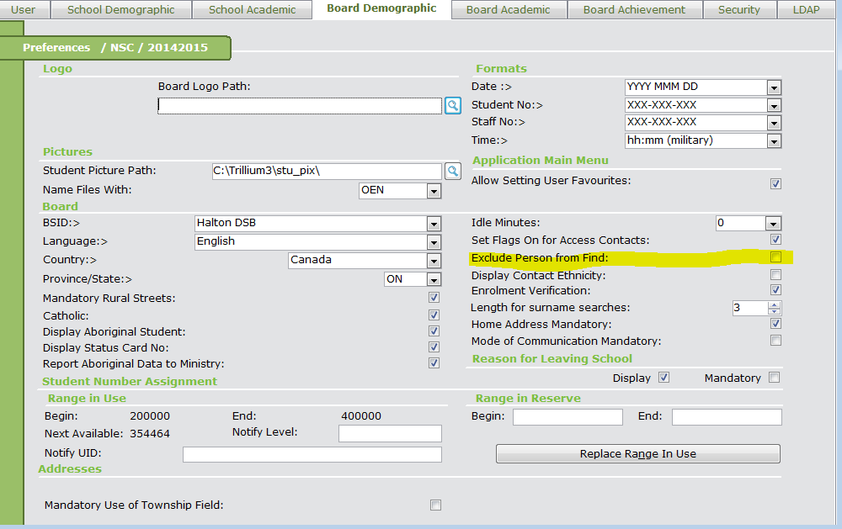

If this checkbox is unchecked, the application will look for the exact match for the contact with name and contact end date and home phone number or cell phone number. If there is an exact match, the existing contact will be used for the student in the Trillium. Otherwise, new record will be created.

#### Telecom Information

The telecom data related to the student and contact will also be migrated to Trillium.

Here is the screenshot from the parent form. This data is not visible on the screen but will be validated and stored in the database with student registration.

The Parent can enter more than one telecom information for student or/and the contacts. Each phone number will have a priority assigned to it based on the order in which the phone will be provided for each person.

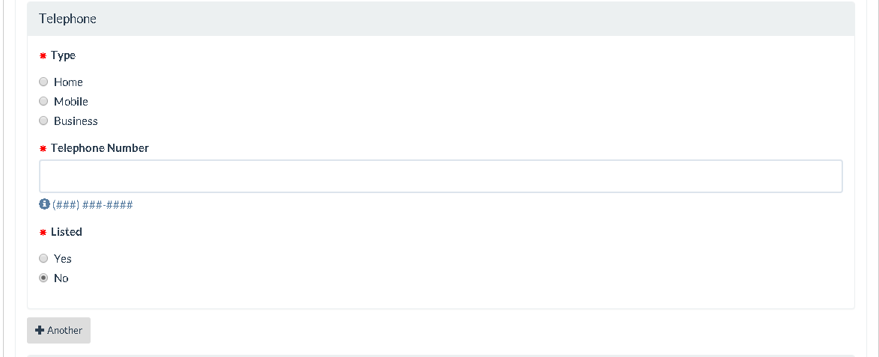

**Type**: This is mandatory field. This field is a set of radio button which specify type of the phone number.

**Telephone Number:** This is mandatory field. This field is text box where user can type in the phone number.

**Listed**: This is mandatory field. This field is a set of radio buttons which specify if the phone number is listed or not.

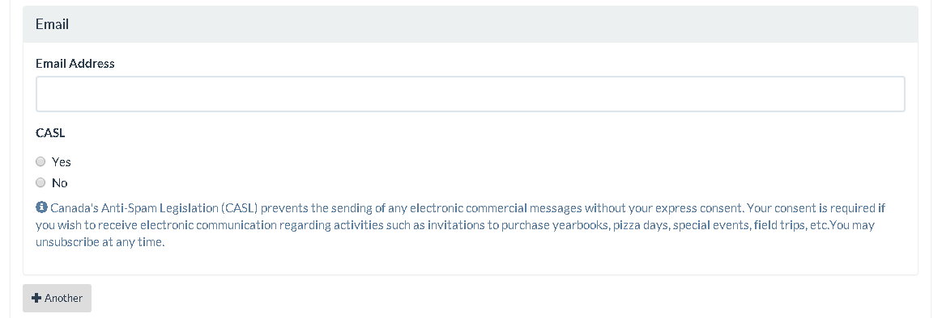

**Email Address**: This is optional field. This field is text box where user can type in the valid email address.

**CASL**: This is optional field. This field has two radio buttons **Yes** and **No**.

#### Medical Information

The medical data related to the student will also be migrated to Trillium.

Here is the screenshot from the parent form. This data is not visible on the screen but will be validated and stored in the database with student registration.

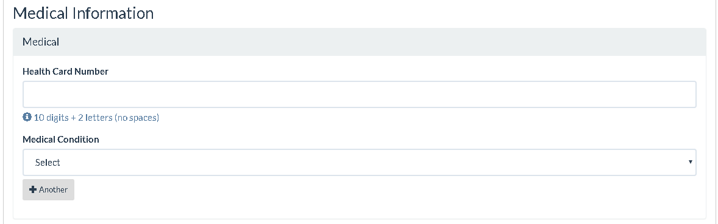

**Health Card**

**Number**: This is optional field. This field is a text box where student health card number with version can be entered.

**Medical Condition**: This is optional field. This field is a drop down which is going to display the various medical conditions.

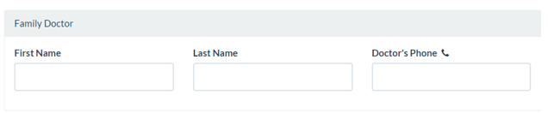

**First Name**: This is optional field. This field is a text box where doctor’s first name can be entered for the student.

**Last Name**: This is optional field. This field is a text box where doctor’s last name can be entered for the student.

**Doctor’s phone**: This is optional field. This field is a text box where doctor’s phone number can be entered for the student.

##### Doctor Validation

The listed validations will be done on the doctor information before saving to trillium database.

**Doctor Exist**: The TWEBOLR will check if the doctor exist in validation table **Doctors** before saving data to the Trillium database. If the doctor exists based on the exact match for name and phone number, the student record will be inserted with the reference to the doctor. Otherwise, doctor information will be skipped in the registration process. The registration status message will include if the doctor is skipped.

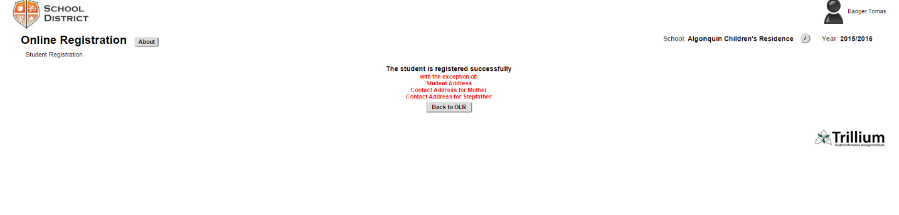

### Register Student

There are two buttons on the screen as:

**Register Student**: When user click this button, the registration process get started which updated data in trillium for:

* Student Detail
* Registration Details
* Enrollment Details
* Address Details
* Contact Details
* Telecom Details
* Medical Details

After validating the data. The registration status screen will appear with the status.

**Cancel**: When user click this button, the migration process is cancelled and control goes back to the Online Registration portal – submission detail page.

# Student Demographic Update

It allows parents to update student and contact Information stored in Trillium. Here's what's available in the first phase of implementation:

## Add, Delete and Update Student and Contact Address

### Address Insert

* Search to learn whether the address to be inserted exists.
* If the address exists, then link the address to the person, i.e. insert a person-address relationship in the table with today as start date and null end date.
* If the address does not exist, insert the address in the DB and then link the address to the person.

### Address Update

* Set the end date of the existing personal-address to yesterday. The rest of this process is the same as Address Insert.

### Address Delete

* Set the end date of the personal-address relationship to yesterday in the DB. The address is not deleted.

## Add, Delete and Update Student and Contact Phones/Emails

### Phone/Email Insert

* Insert the new phone/email in the DB with today as start date and null end date.

### Phone/Email Delete

* Set the end date of the existing phone/email to yesterday in the DB. The deleted data is still in the DB without being removed.

### Phone/Email Update

* If any critical field (listed below) is changed, set the end date of the existing phone/email to yesterday. Then insert the new phone/email with today as the start date and null end date.
* If the changed fields are NOT critical, the existing phone/email will be updated directly in the DB. The start/end date continue using their existing values without being changed.

### Phone Critical Fields

* Area Code
* Phone Number
* Extension Number

### Email Critical Fields

* Email Address

## Add, Delete and Update Contact Demographic Information

### Contact Insert

* Add a new contact person in the DB with start date of today and null end date.

### Contact Update

* Update the existing contact fields in the DB without changing the start/end date.

### Contact Delete

* Set the end date of the contact to yesterday in the DB. The deleted contact is still kept without being removed.

**Note:** The right way to replace an existing contact with a new one is to delete the existing contact and then insert the new contact. We do not recommend replacing the existing contact with the new one.

### Priority of the Contact/Address/Phone/Email

All Priority fields are populated and transferred from the Submission forms. TWebOLR will validate if there are any priority conflictions. If any conflict is found, TWebOLR will display an exception page. The Priority is an attribute of the entity. It will be inserted, updated or deleted along with the entity.

### Update Contact’s various flags

The Contact flags below are going to be populated and transferred from the Submission forms. TWebOLR will validate these and if any conflict is found, it will display an exception page.

* Is this contact a guardian for the child?
* Does this contact live with the child?
* Does this contact speak the school's language?
* Does this contact receive mail from the school?
* Does this contact have custody of the child?
* Does this contact have access to the child's school records?
* Does this contact have access to the child?

# Error Handling

The application will shows some predefined error messages as per the validation check. Here is the table which explains the error messages and related condition.

|  |  |  |
| --- | --- | --- |
| Sr. No | Error Message | Meaning |
| 1 | School name selected for registration is not yet setup in Trillium | If the selected school in Submission Details is not assigned to the user in Core Trillium. |
| 2 | School Year or Year Track for registration is not yet setup in Trillium | If the selected school year in Submission detail is not setup in core trillium for the selected school.  OR  If the tracks is not yet setup in core trillium for the selected school. |
| 3 | School grade for registration is not yet setup in Trillium | If the grades are not yet setup in core trillium for the selected school. |
| 4 | The selected grade is not assigned to a program | If there is no program defined for the selected grade in Core Trillium. |
| 5 | Registration process failed. Student is already registered in database. | There is an exact match for the legal name or preferred name, date of birth and gender with a student number in database. |
| 6 | The session has expired. You have been logged out | The user session is expired. The session is ideal for more than specified session timeout. |