**Refresh the country list of OLR Registration**

1. Log-in to Via Forms.
2. **Click *Manage Schemas*** under the Admin icon

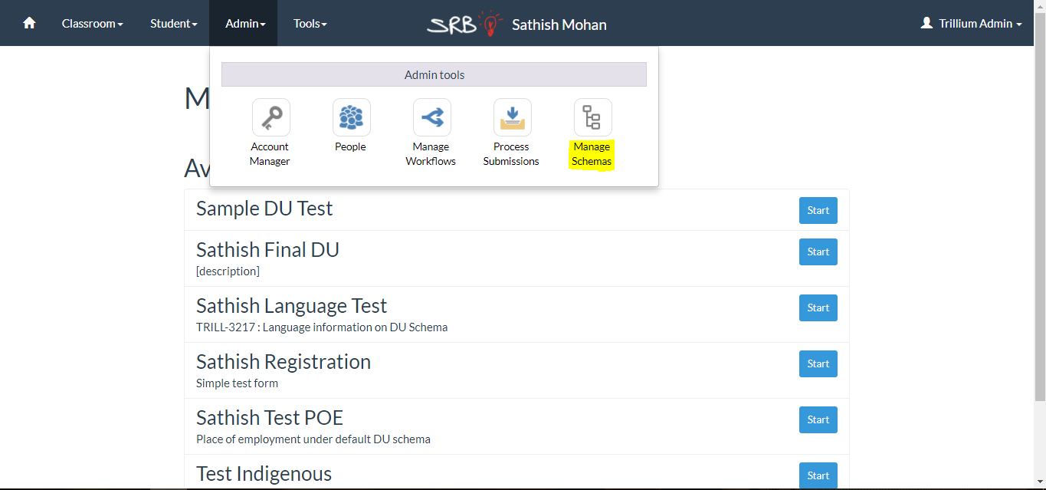

1. Click the green **Edit** icon next to the schema for which you wish to update the country list. *(eg. Sample Gender OLR schema)*

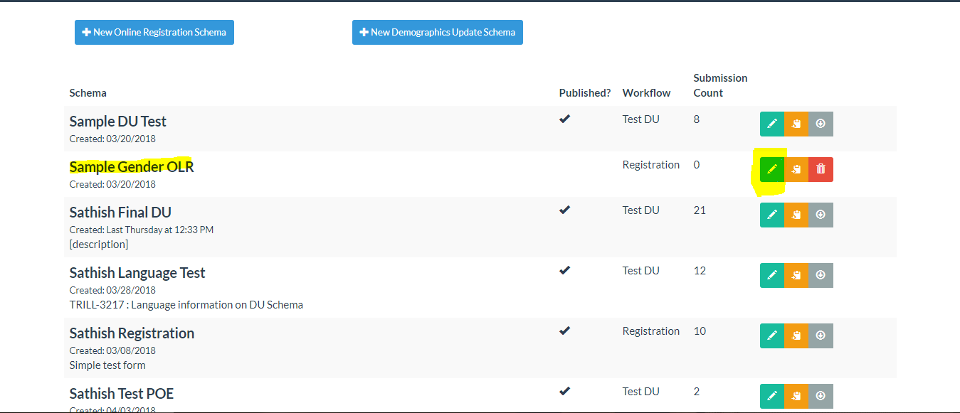

1. Find the country fields and click on them. You’ll see the field options side panel open for the field.

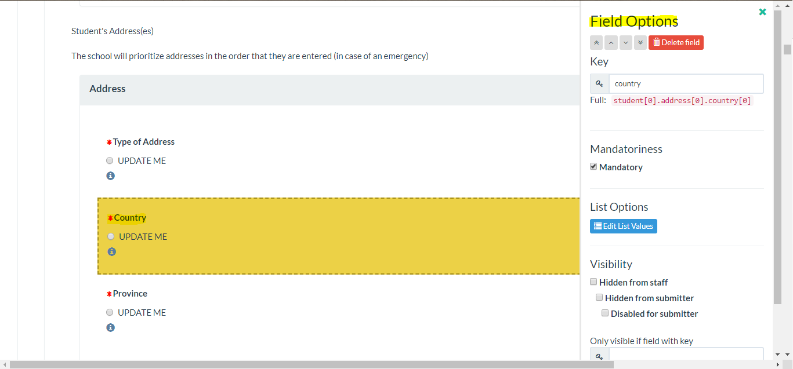

1. **Click** the blue ***Edit list Values*** button. You’ll see this pop-up:

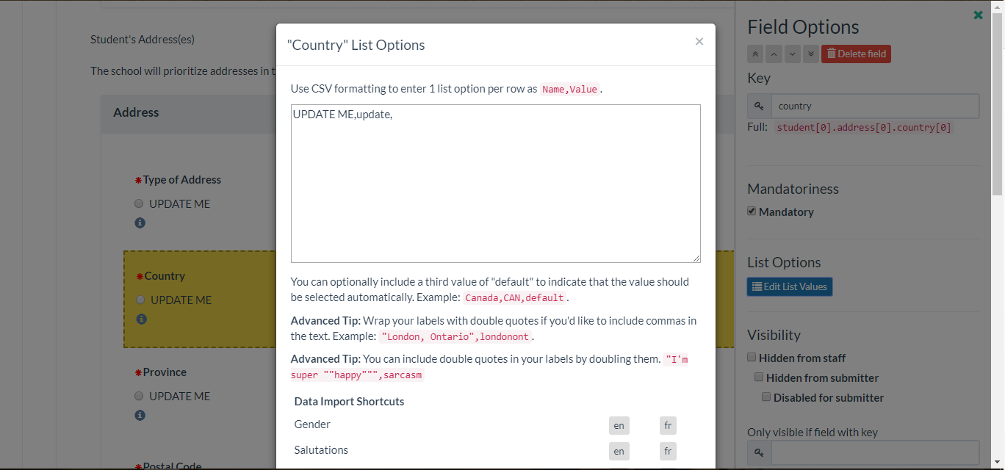

1. **Click *Country data import*** to refresh the data.

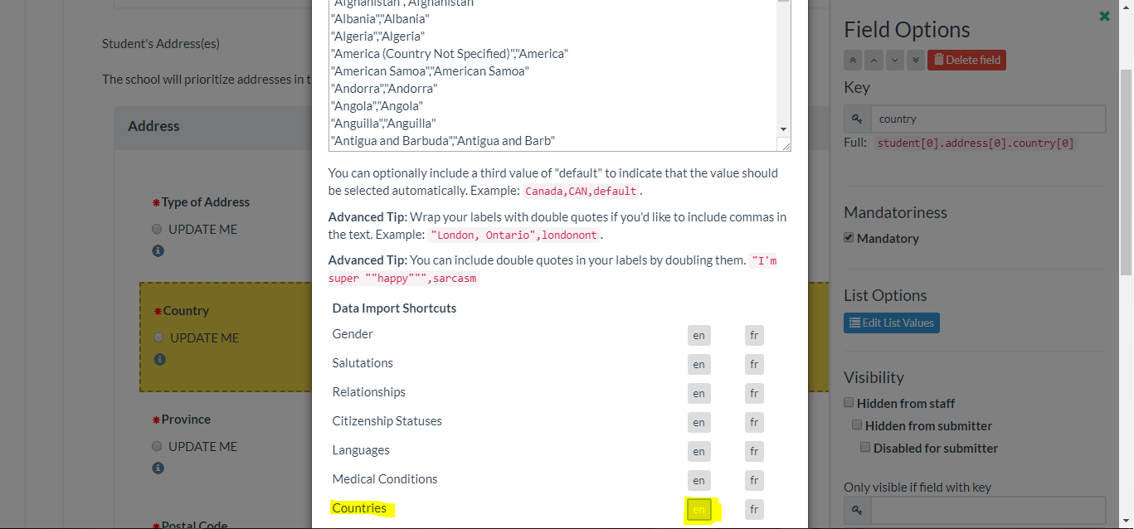

1. Scroll down and **click *Apply Changes***.
2. Repeat Steps 5 to 7 for all the country fields in the schema.