The College Application Process

Reference Guide

Overview
To get started with college applications in Naviance Student, build an application list, and request transcripts and teacher letters of recommendation. After you build an application list and request documents, track document submission status and update application details.

Build an Application List
You can build an application list by:
- Moving colleges from your Colleges I'm Thinking About list to your Colleges I'm Applying to list.
- Add colleges to your Colleges I'm Applying to list. As you add colleges to your application list, you can also request transcripts.

Move Colleges to Your Colleges I'm Applying to List
- Select Colleges and then select Colleges I'm Thinking About.
- Select the colleges you want to move to your application list.
- Select Move to Application List.
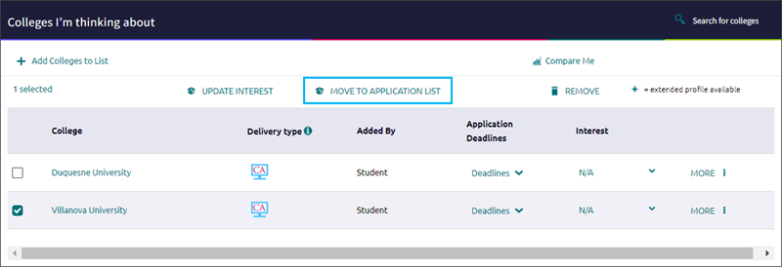
- From Step 1, answer the questions, indicate if you have submitted your application to the college, and then click Add Applications.
- Alternatively, click Add and Request Transcripts. Select the transcript type to request and click Request and Finish.

Add Colleges to Your Colleges I'm Applying to List and Request Transcripts
- Select Colleges and then select Colleges I'm Applying To.
- Click Add.
- Enter the name of the college to which you are applying and select it from the list.
- Select an App Type from the list.
- Optionally, indicate how you'll submit your application, if you have submitted your application, and if you plan to submit SAT or ACT scores with your application.
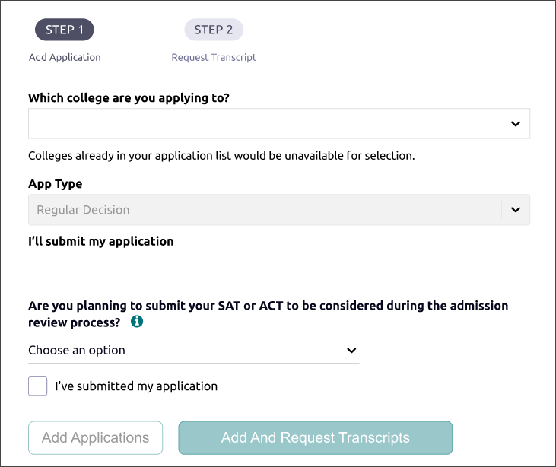
- Click Add Applications.
- Alternatively, click Add and Request Transcripts. Select the transcript type to request and click Request and Finish.

Request Transcripts
Request transcripts as you add a college to your list of Colleges I'm Applying To.
- Select Colleges and then select Colleges I'm Applying To.
- Select Request Transcripts.
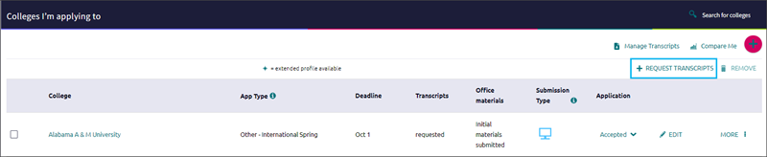
- Select the type of transcript you are requesting, select a college from your application list, or enter a college name, and then click Request and Finish.
Alternatively, use:
- Request Transcript to request transcripts for colleges to which you are applying.
- Manage Transcripts to request college, scholarship, or other transcripts.

Request Teacher Letters of Recommendation
- Select Colleges and then select Letters of Recommendation from Apply to College.
- Click Add Request.
- Select a teacher from the list.
- Select All Colleges or specific colleges to invite a teacher to write a letter and send it to only the colleges that you have specified. You cannot request a letter of recommendation if you have already requested the maximum number allowed by the institution.
- Optionally, select General Request to invite a teacher to write a letter and send it to any college that you add to Colleges I'm Applying To list.
- Enter a personal note of up to 3000 characters. Share information that you want the teacher to highlight in their letter.
- Click Add Request.
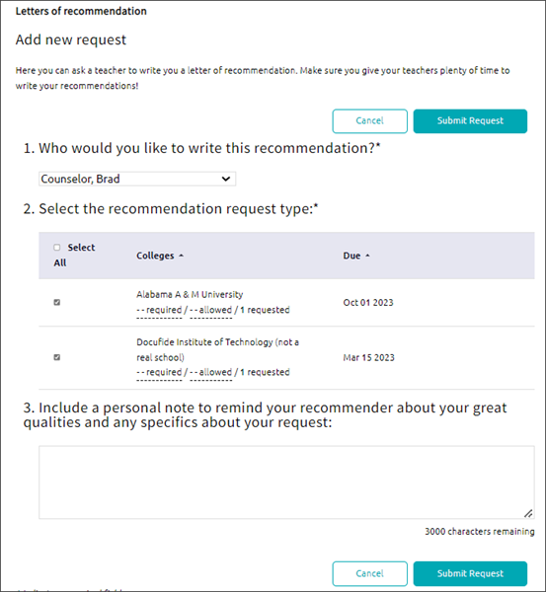

Track Document Submission Status

Application Materials
Select Colleges and then select Colleges I'm Applying To. From Transcripts, review the status of your transcript request, either requested or submitted. From Office Materials, review the status of your initial, midyear, or final application materials, either pending or submitted.

Transcripts
Select Colleges and then select Manage Transcripts. Review the status or submission date for your initial, midyear, and final transcript.

Letters of Recommendation
Select Colleges and then select Letters of Recommendation from Apply to College and review the status of each request.
Hover over the status for each request to review details such as submission date and more.

Update Application Details
Update your application details such as app type, interest, result, and more.
- Select Colleges and then select Colleges I'm Applying To.
- Choose Edit for the college to update.
- Update the details.
- Click Update Applications.

