Letters of Recommendation Quick Guide

Key Features
- Access the Letters of Recommendation page in Naviance Student by selecting Colleges and choosing Letters of Recommendation.
- From Letters of Recommendation:
  - Review the number of requests required, allowed, and requested for colleges in your Colleges I'm Applying To list.
  - Select specific colleges and specific teachers for whom you want to write a recommendation. The page displays a notification if the college does not allow letters of recommendation (LORs), or if you have already requested the maximum number of LORs allowed by the college.
  - Make a general request if you do not have any colleges in your list of Colleges I’m Applying To or if you do not have a preference for which teachers will send a recommendation to each college.
  - Review the status of all requests.
  - Review the submission date and time for each requested LOR as well as the date and time of each status change and the person who made the change.
- You cannot request more than the maximum number of LORs allowed by the college when requesting letters for specific colleges.
- When you delete an application, the corresponding LOR request is automatically removed from the LOR status page. If you restore the application, the request repopulates your list of requests.

Request Information
Column Title | Description
Recommendation For | The college or university where the LOR will be sent.
Deadline | The application deadline for the way you are applying, such as ED, EA, and RD.
Recommender | The teacher whom you requested to write the LOR.
Status | The status of the LOR request:  Requested: You requested the LOR  In Progress: The teacher wrote the LOR  Submitted: A high school staff member sent the LOR to the requested colleges.  Canceled: Either you, the teacher, or the counselor canceled the request.
Cancel Request | You can cancel an LOR request if the status is Requested. For any other status, you will see a message to contact the teacher or your counselor for help.

Request a Letter of Recommendation
- Select Colleges and choose Letters of Recommendation from Apply to College.
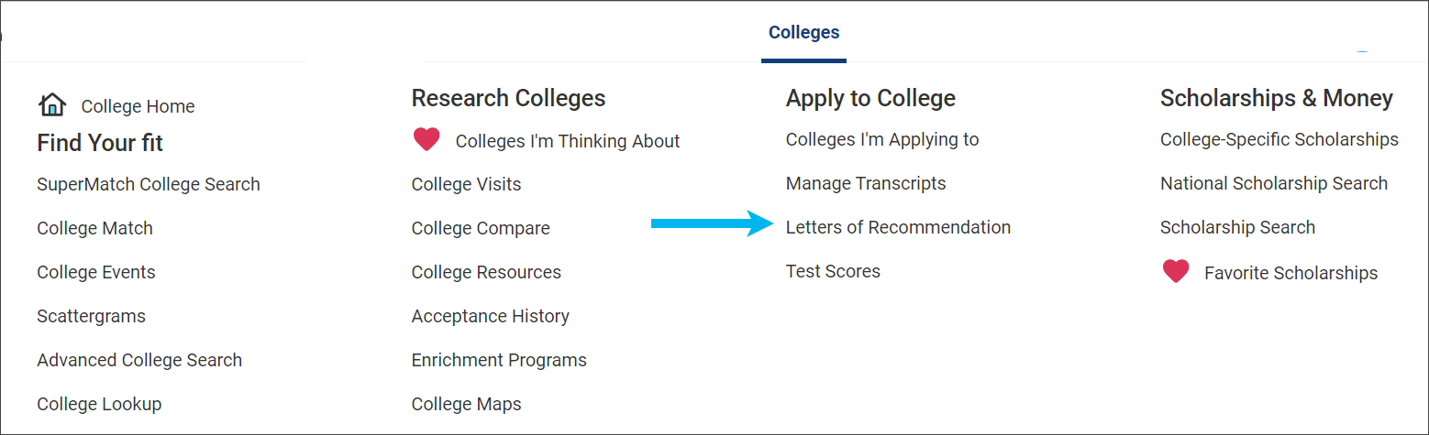
- Click Add Request.

- Select a teacher from the list. If a teacher is not listed, let your counselor know.
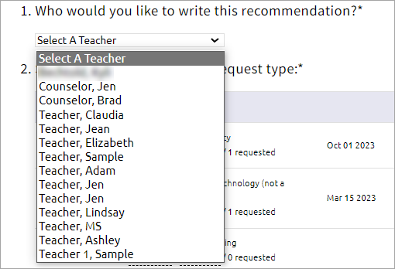
- Select General request or Specific request.


- If you selected Specific request, select all colleges or individual colleges.
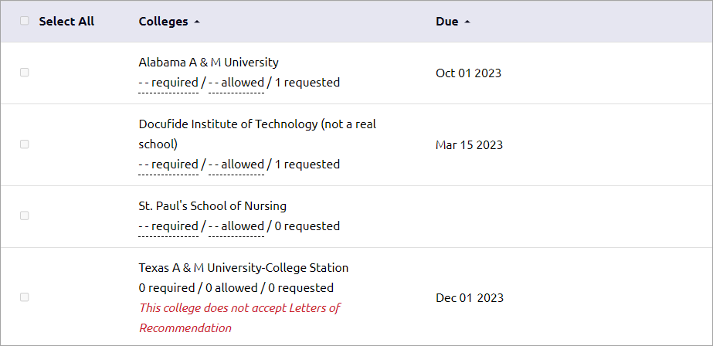
- Enter a personal for the recommender listing your great qualities and any specifics about your request.

- Click Submit Request.


