Common App Account Matching Quick Guide
Start this process on or after August 1.

- Go to www.commonapp.org, click Create an account, and then select First year student.
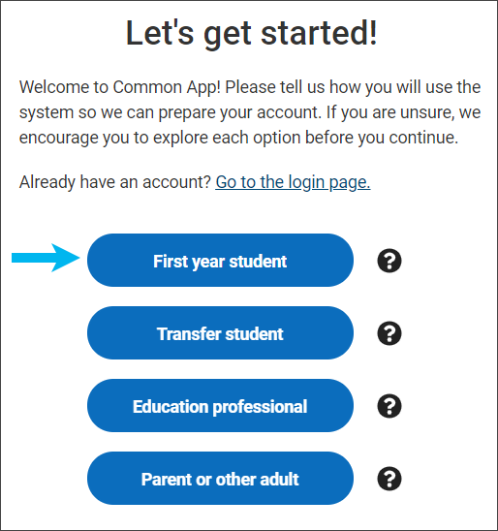
  - Before you can match your Common App account in Naviance Student, you must set up your Common App account.
  - Students applying to college must create an account for a First-year student, even if their parents or guardians have already created an account for Parent or other adult.

- Follow the prompts to set up your account credentials and create your account.
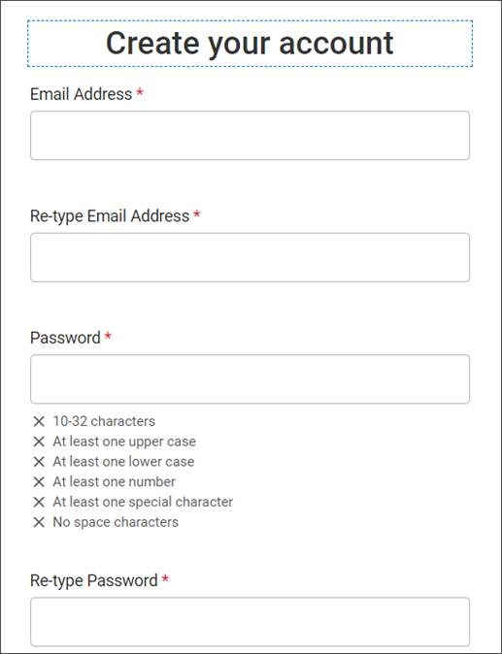

- Review the dashboard. Your CAID number is at the top of the page.
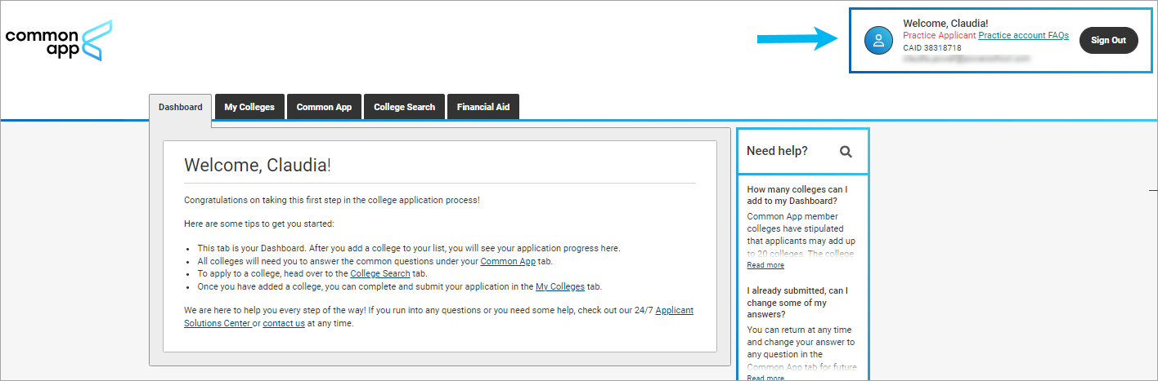
- Select Common App and enter information for all sections in the side navigation. Make sure you select the correct school’s name in the Education section. Many high schools have similar names.
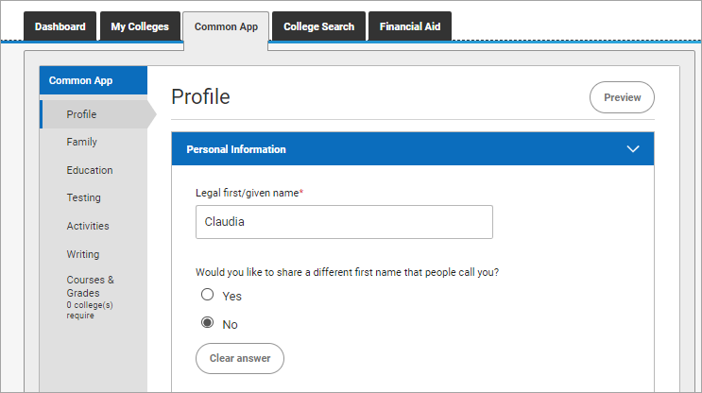

- Select College Search and add at least one college. You cannot complete the FERPA release without having at least one college on your list.
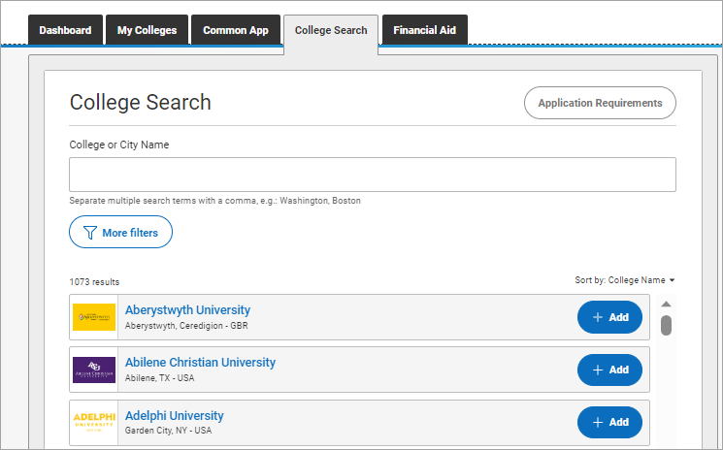
- Select My Colleges to review the contact information, deadlines, and more for each college on your list.
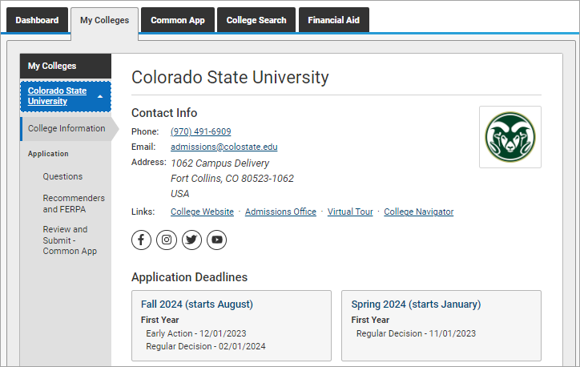

- From Application on My Colleges:
  - Select Recommenders and FERPA and complete the FERPA release authorization.
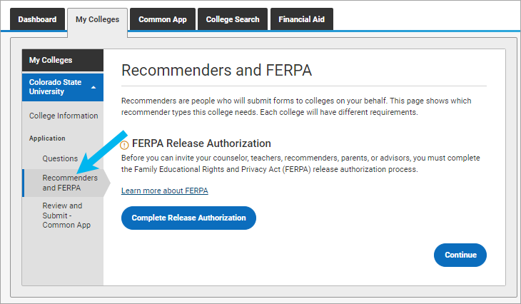
  - Review the Recommenders and FERPA Information. You will invite counselors and teachers from Naviance Student. Download PDF forms from here if needed.
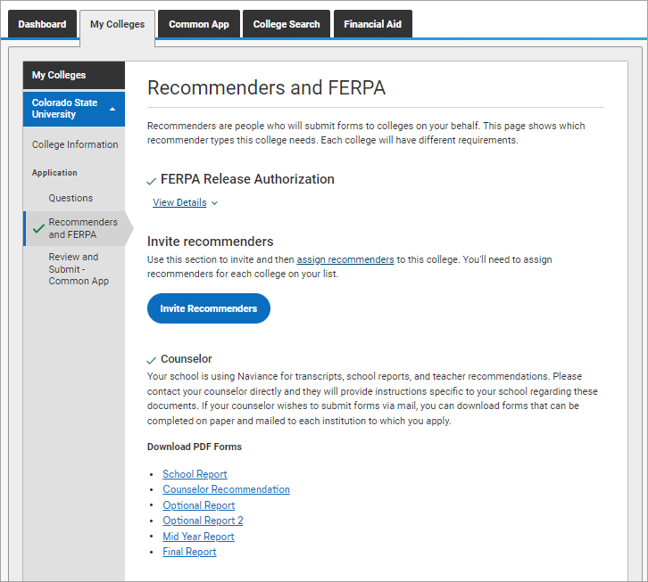
- Log in to Naviance Student, select Colleges and choose Colleges I’m Applying To.
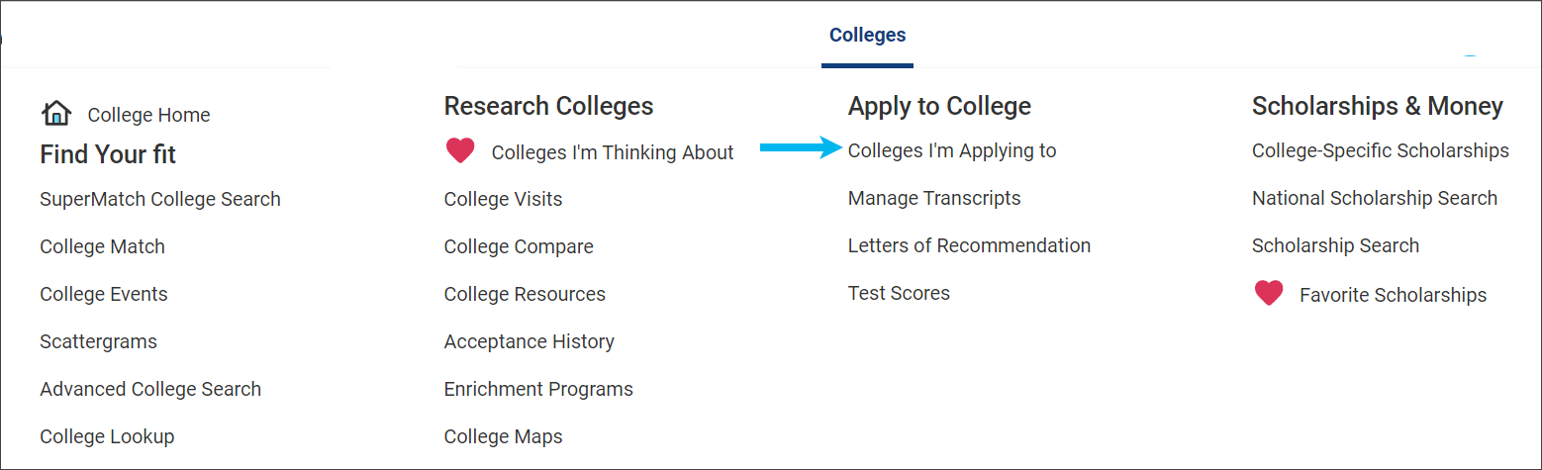
- Click Match Accounts.
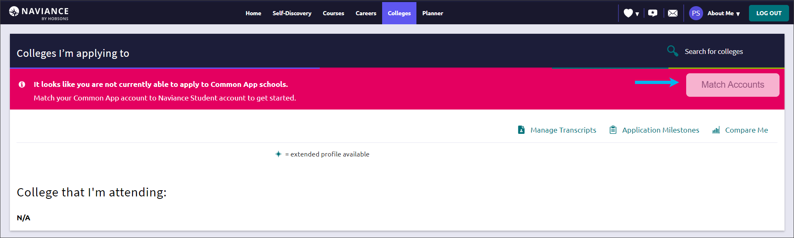
- Sign in to your Common App account with the email and password you used to create your Common App account.
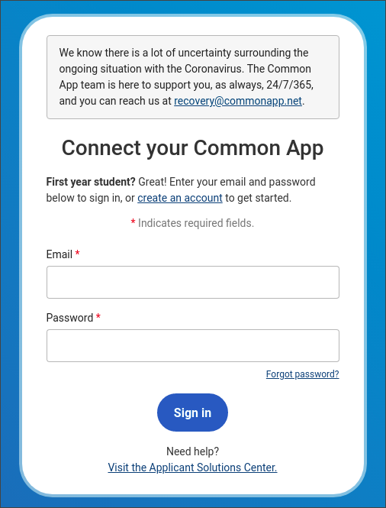

- Review the information, select I agree, and then click Connect to match your accounts.
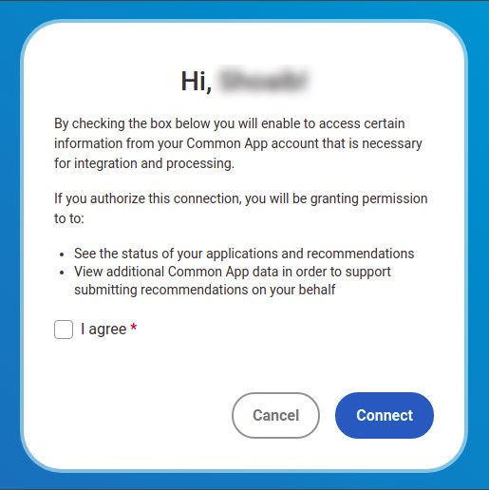
  - Colleges from your Common App account are automatically added to your Colleges I’m Applying To list in Naviance Student.
  - Request transcripts for your Common App colleges according to your high school’s instructions.

