Naviance Test Prep Quick Guide
Naviance Test Prep incorporates lessons, flashcards, practice questions, and tests to assess your strengths and areas for improvement and to determine your skill profile. These results and the test date create a personalized study plan that guides you through the course.

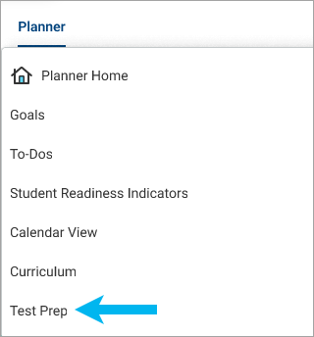
Access Naviance Test Prep
Select Planner and choose Naviance Test Prep. A new browser tab or window displays your Test Prep course.

If you have more than one Naviance Test Prep course, select the course from the drop-down list in the navigation toolbar.
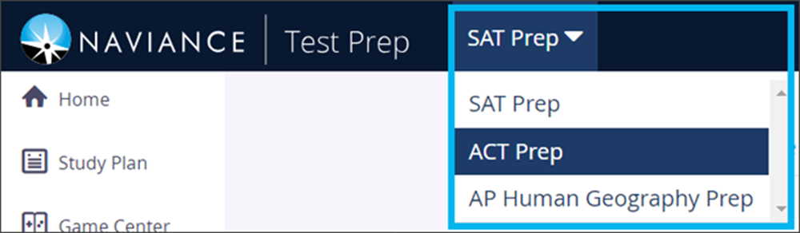

Get Started
When logging in to Naviance Test Prep for the first time, you must choose your test date. According to the test date, Naviance creates a custom Study Plan that guides you through the course and ensures you cover all the material by your test date.
- Select Planner and choose Naviance Test Prep.
- Choose your test or end date from the calendar and click Update.
- Click Get Started from the dashboard to launch the lesson. Depending on the course, you may be asked to take a diagnostic test so Test Prep can analyze your strengths and areas for improvement.
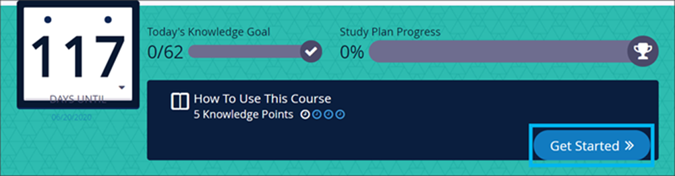

Use Test Prep Features

Messages and Notifications
From the navigation toolbar, review Messages and Notifications for:
- In-app messages
- Activity in a followed discussion topic
- Unlocked achievements

Dashboard
Review the Test Prep Dashboard for an overview of your individualized study plan, including your personal progress and performance information.

From the dashboard, review your:
- Performance over time
- Strengths and weaknesses
- Student status
- Top game scores
- Achievements

Achievements
Unlock achievements when you reach milestones, such as answering a question correctly within ten seconds, creating 50 bookmarks, or replying to a public discussion.

Study Plan
Follow the Study Plan to cover the course material efficiently.
- Study plans include individual study tasks, including lessons, flashcards, practice questions, and tests.
- Study tasks are worth Knowledge Points determined by the task length, difficulty, and importance.
- Daily Knowledge Goals display the number of points you must complete each day to finish the course on time.
- The study plan automatically readjusts if you miss a day or complete more than the daily goal.
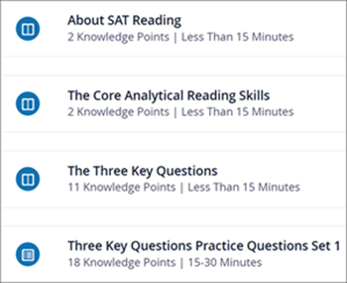

Game Center
Use the Game Center options to help you learn the flashcard content faster and improve your memory retention.
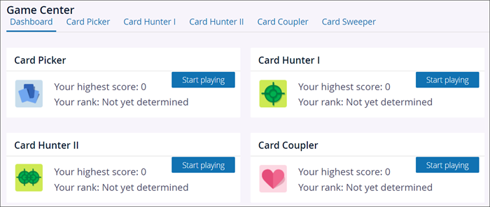

Flashcards
Use Flashcards to review key terms and concepts for the test.
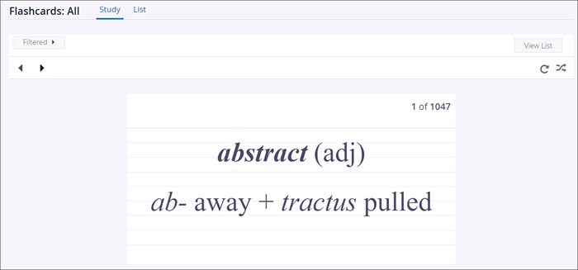

Practice Questions
Use Practice Questions to test your knowledge of specific categories and concepts.
- Complete as many or as few questions at a time.
- Review questions after answering them or at the end of a session.
- Reset practice questions to try them again.

Tests
Simulate a real test experience by taking a practice exam. The full-length exams have sections and breaks that mock the real-life exam.

Allow enough time to complete the entire exam without having to pause it.

