Naviance Curriculum Quick Guide

# Overview

The Naviance College, Career, and Life Readiness Curriculum is a series of interactive lessons that equip you with the knowledge and skills to succeed in your post-secondary goals.

Lessons fall into six categories:

* Self-Discovery
* Success Skills
* Support Network
* Career Planning
* College Planning
* Financial Planning

# Access Curriculum Lessons

To access Naviance Curriculum lessons, select Planner and then choose **Curriculum**.

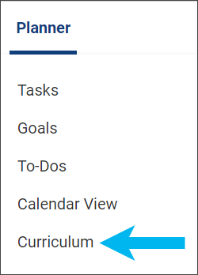

Your Current Lessons page displays the lessons assigned by your school or district. From Your Current Lessons:

* Review your overall progress in completing your assigned lessons.
* Filter lessons by theme.
* Display results of completed lessons.
* Review or edit lessons.
* Note lessons with a video icon.
* Note the theme icon included on each lesson tile.
* Select **Past Lessons** from Lesson Progress to display lessons completed in previous years.

# Complete a Curriculum Lesson

1. Select **Planner** and then choose **Curriculum**.
2. Optionally, from the Curriculum homepage, filter lessons by theme.
3. From the lesson tile, click **Get Started**.

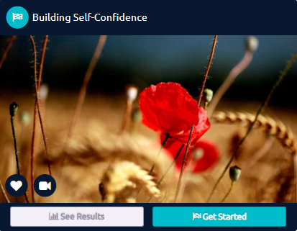

1. Review the information and follow the instructions.
2. Click the arrow to advance through each page of the lesson.
3. Create an action item. Enter the **Action Item** description, select a priority level and due date, and then click **Next**. (You can navigate to **My** **Planner** in Naviance and select **To-Dos** to display or edit the action items created in Curriculum lessons.)

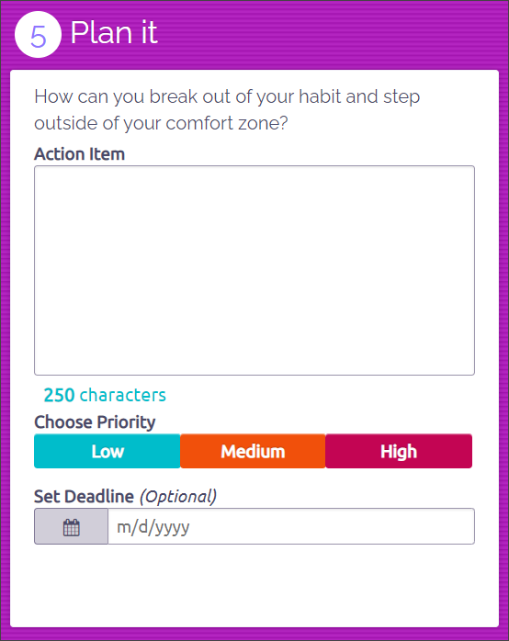

1. Optionally:
   1. Review the progress bar.
   2. Return to a previous page in the lesson.
2. Click **Turn In My Work**. You must click **Turn In My Work** to save your progress. Otherwise, your lesson progress is not saved.

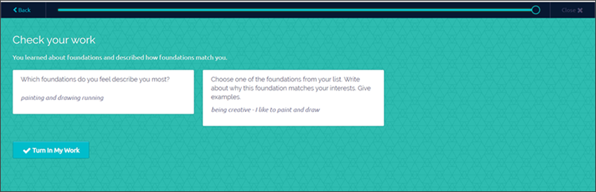

# Manage Your Plans

1. From the Naviance Curriculum home page, select **Plans**.
2. Optionally, search for any action items to complete.
3. After completing an action item, select the corresponding checkbox to indicate completion. The progress bar updates to reflect your completion level.

Plans page with option to select item for completion


1. Select **Lessons** to return to the Naviance Curriculum home page.

# Review Overall Lesson Progress

From the Curriculum home page, review your **Lesson Progress** for the completion progress of the lessons you are assigned.

Lesson progress
