Letters of Recommendation Quick Guide

# Key Features

* Access the Letters of Recommendation page in Naviance Student by selecting Colleges and choosing Letters of Recommendation.
* From Letters of Recommendation:
  + Review the number of requests required, allowed, and requested for colleges in your Colleges I'm Applying To list.
  + Select specific colleges and specific teachers for whom you want to write a recommendation.  The page displays a notification if the college does not allow letters of recommendation (LORs), or if you have already requested the maximum number of LORs allowed by the college.
  + Make a general request if you do not have any colleges in your list of Colleges I’m Applying To or if you do not have a preference for which teachers will send a recommendation to each college.
  + Review the status of all requests.
  + Review the submission date and time for each requested LOR as well as the date and time of each status change and the person who made the change.
* You cannot request more than the maximum number of LORs allowed by the college when requesting letters for specific colleges.
* When you delete an application, the corresponding LOR request is automatically removed from the LOR status page. If you restore the application, the request repopulates your list of requests.

## Request Information

|  |  |
| --- | --- |
| **Column Title** | **Description** |
| Recommendation For | The college or university where the LOR will be sent. |
| Deadline | The application deadline for the way you are applying, such as ED, EA, and RD. |
| Recommender | The teacher whom you requested to write the LOR. |
| Status | The status of the LOR request:  **Requested**: You requested the LOR  **In Progress**: The teacher wrote the LOR  **Submitted**: A high school staff member sent the LOR to the requested colleges.  **Canceled**: Either you, the teacher, or the counselor canceled the request. |
| Cancel Request | You can cancel an LOR request if the status is **Requested**. For any other status, you will see a message to contact the teacher or your counselor for help. |

# Request a Letter of Recommendation

1. Select **Colleges** and choose **Letters of Recommendation** from Apply to College.

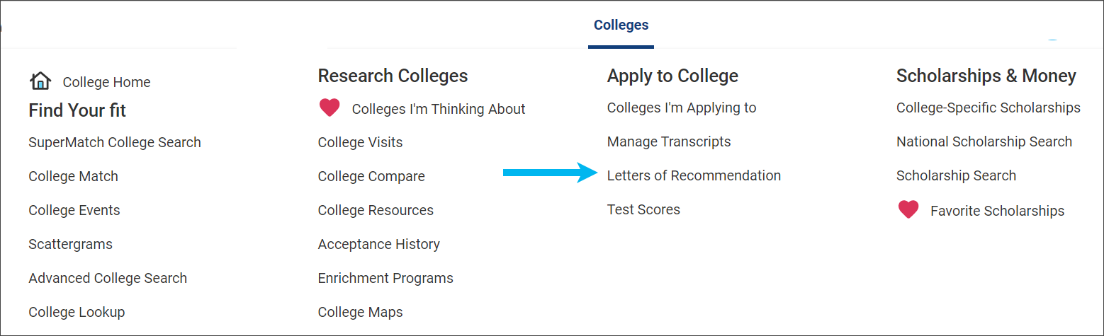

1. Click **Add Request**.

A screenshot of the Add Request button.

1. Select a teacher from the list. If a teacher is not listed, let your counselor know.

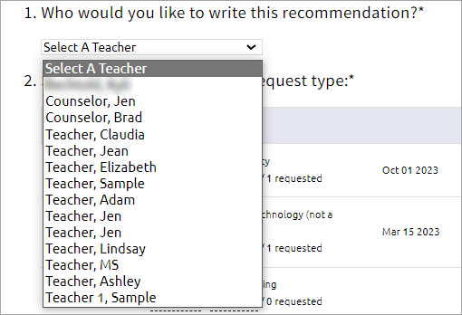

1. Select **General request** or **Specific request**.

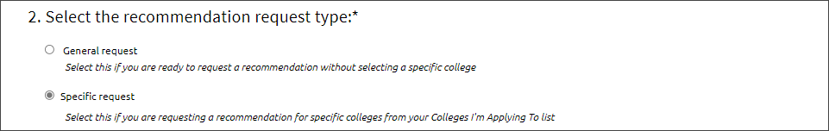

1. If you selected **Specific reques**t, select all colleges or individual colleges.

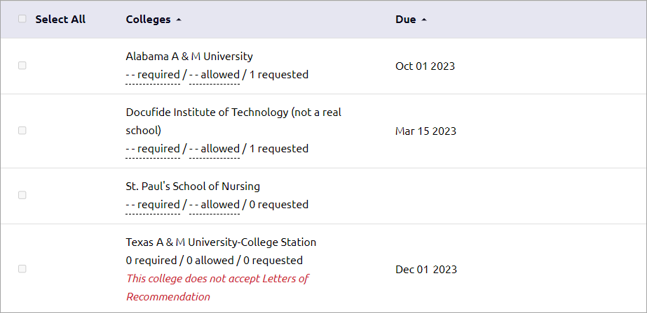

1. Enter a personal for the recommender listing your great qualities and any specifics about your request.



1. Click **Submit Request**.

A screenshot of the Submit Request button