Common App Account Matching Quick Guide

Start this process on or after August 1.

1. Go to [www.commonapp.org](http://www.commonapp.org), click **Create an account**, and then select **First year student**.

A picture calling out the First year student option.

* + Before you can match your Common App account in Naviance Student, you must set up your Common App account.
  + Students applying to college must create an account for a First-year student, even if their parents or guardians have already created an account for Parent or other adult.

1. Follow the prompts to set up your account credentials and create your account.

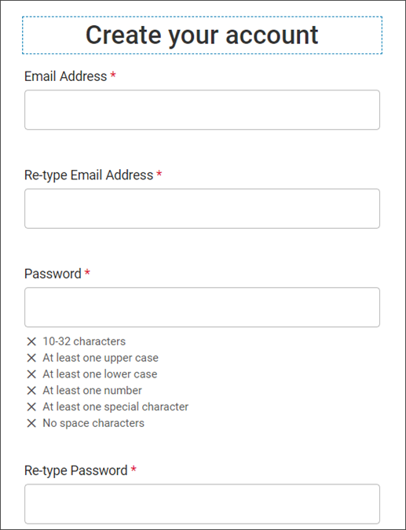

1. Review the dashboard. Your CAID number is at the top of the page.

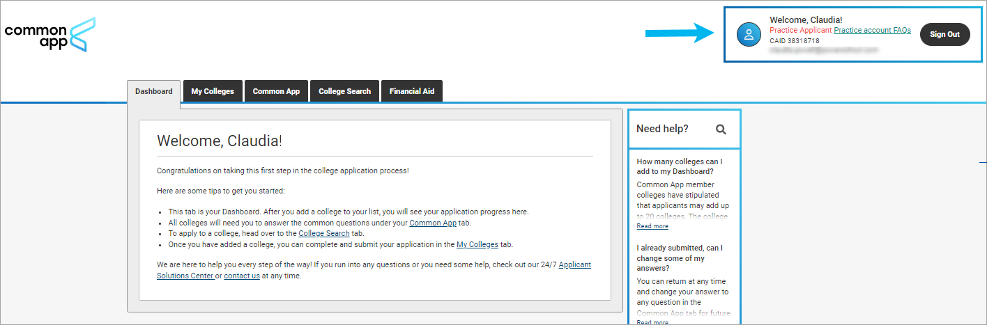

1. Select **Common App** and enter information for all sections in the side navigation. Make sure you select the correct school’s name in the Education section. Many high schools have similar names.

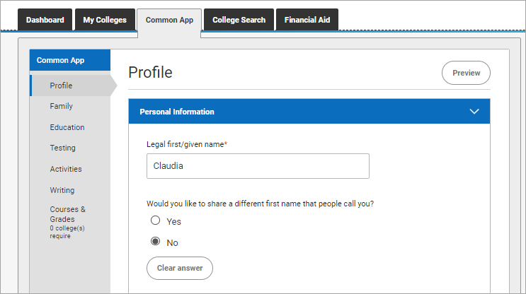

1. Select **College Search** and add at least one college. You cannot complete the FERPA release without having at least one college on your list.

A screenshot of the College Search page. 


1. Select **My Colleges** to review the contact information, deadlines, and more for each college on your list.

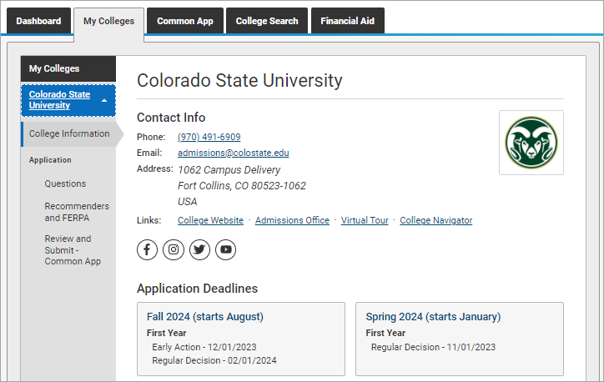

1. From Application on My Colleges:
   1. Select **Recommenders and FERPA** and complete the FERPA release authorization.

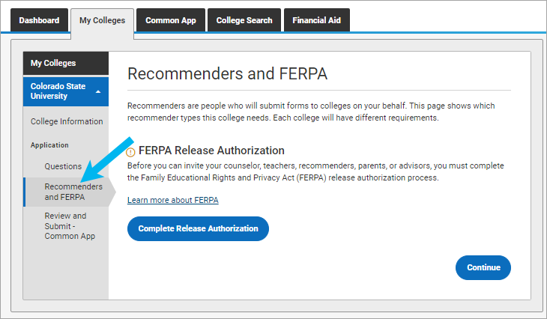

* 1. Review the Recommenders and FERPA Information. You will invite counselors and teachers from Naviance Student. Download PDF forms from here if needed.

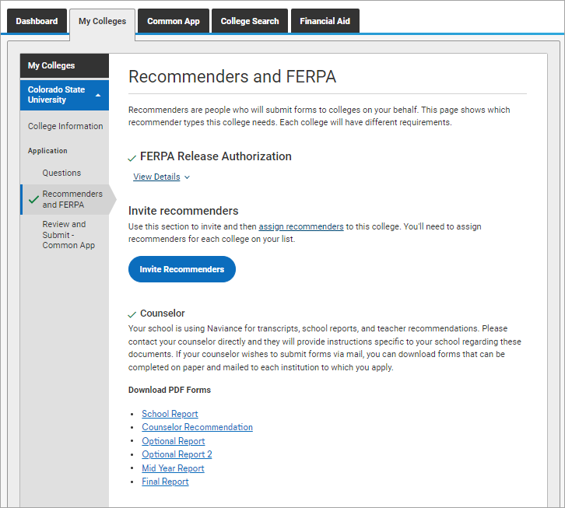

1. Log in to Naviance Student, select **Colleges** and choose **Colleges I’m Applying To**.

1. Click **Match Accounts**.

1. Sign in to your Common App account with the email and password you used to create your Common App account.

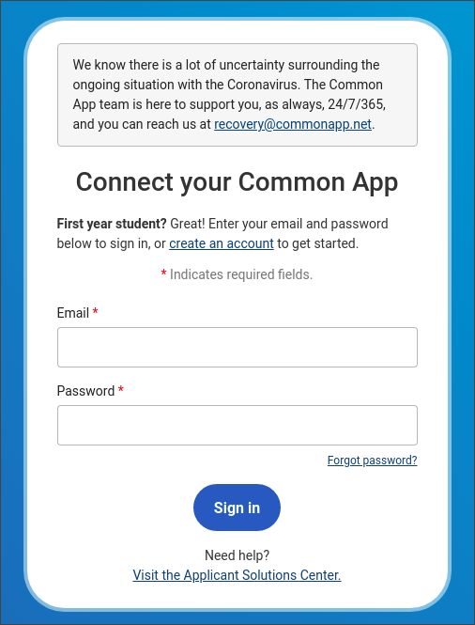

1. Review the information, select I agree, and then click **Connect** to match your accounts.

A pscreenshot of the Connect Common App account screen.

* + Colleges from your Common App account are automatically added to your Colleges I’m Applying To list in Naviance Student.
  + Request transcripts for your Common App colleges according to your high school’s instructions.