Success Planning Reference Guide

# Overview

Use the Planner features to:

* Review past and upcoming tasks and to-dos.
* Manage assigned tasks from your school or district.
* Create and manage goals.
* Create and manage to-do list items, including those created in Naviance Curriculum.

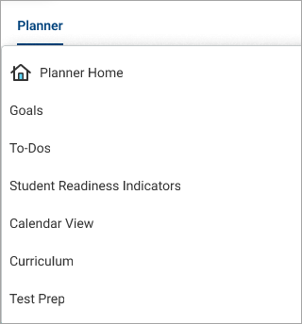

You can also access Test Prep, Curriculum, Student Readiness Indicators, and X2VOL from the Planner menu if available at your school.

From the Naviance Student homepage:

* Review **Tasks from My School** for those with an upcoming due date. By default, Naviance displays three upcoming tasks or to-dos. Click **See All in My Planner** for a complete list.
* Check **Messages** for reminders about an upcoming task due date if your school sends deadline reminders.

# Tasks

1. Select **Planner** and then select **Tasks**.
2. From **My Tasks**, review:
   * Tasks you Need to Work On
   * Tasks you've Completed
   * Overdue
   * Tasks for Future Grades
3. Select a task name to display the task details.
4. Optionally, from the task details:
   * Select the link to be redirected to the task activity.
   * Click **Raise Hand** to ask your counselor or teacher a question about the task.
   * Enter a Comment and then click **Add Comment** to share a comment with your counselor, teacher, parents, and guardians.
   * Click **Define your next to-do** to add a to-do list item to help you stay on track and reach your goal.
   * Click **Mark as Done** if your school has instructed you to mark the task complete manually.
   * Download a document.
   * Attach a file related to the task. The file must be 10MB or less. Naviance supports the following file types:
     + PPTX, PPT, XLSX, XLS, DOCX, DOC
     + MP4, WMV, MOV
     + WAV, MP3
     + JPG, PNG, GIF
     + PDF
     + ZIP
   * Naviance does not support MAC documents.

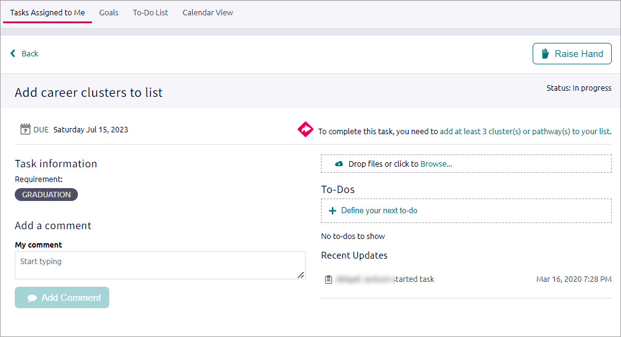

# Goals

Create goals for yourself and keep track of your progress in achieving them.

## A screenshot of possible goal categoriesCreate a Goal

1. Select **Planner** and then select **Goals**.
2. Click **Add** and select a goal category.
3. Enter the information and then click **Add**.

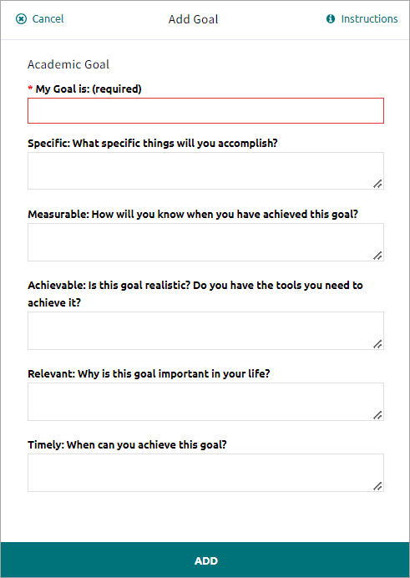

1. Optionally:
   * Enter a **Comment** and then click **Add Comment** to share the comment with your counselor, teacher, parent, and guardian.
   * Click **Define Your Next Step** and add a to-do list item to help you stay on track and reach your goal.

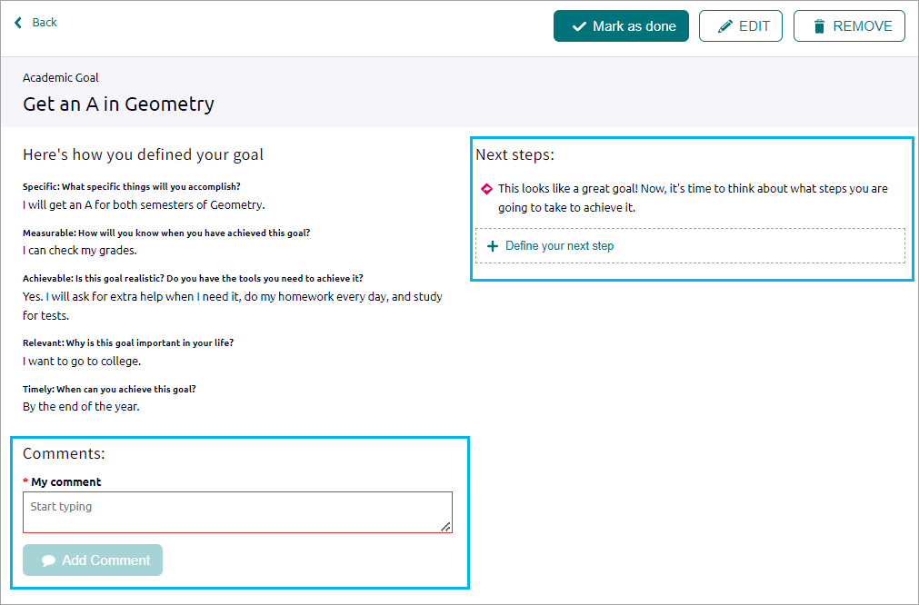

## Manage a Goal

1. Select **Planner** and then select **Goals** to display any goal categories.
2. Optionally:
   * Click the **comment** icon, enter a comment, and then click **Add** to share it with your counselor.
   * Click the **edit** icon, edit the goal details, and then click **Save**.
   * Click the **delete** icon and then click **Delete**.
   * Click the goal name and then click **Mark as Done**.

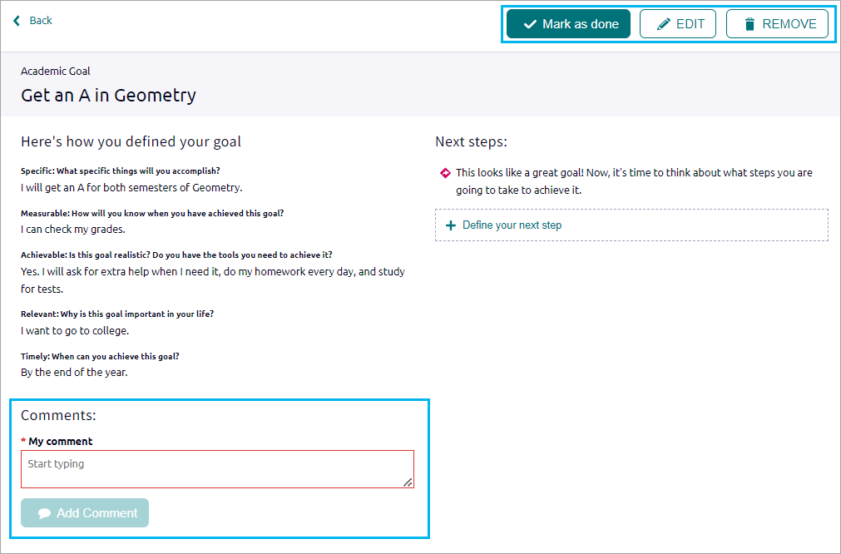

# A screenshot an Add To-Do cardTo-Dos

Use the To-Do feature to add and manage action items to complete.

1. Select **Planner** and then select **To-Dos**.
2. Click **add**.
3. Enter the details and then click **Add**.

After creating to-dos, use the sort and filter options to organize your to-do list.

You can also review any to-do list items created in Naviance Curriculum lessons.

# Calendar View

Use the calendar feature to display upcoming due dates for to-dos and tasks in a calendar.