# Approving Course Plans Quick Guide

Parents and guardians can approve their student's course plans if required by the school or district.

1. Navigate to **Courses**, and then select **Manage Course Plans**.

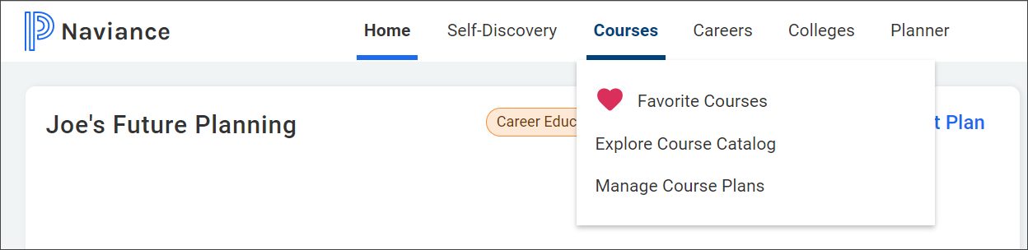

1. Select the course plan that displays **Awaiting Parent Approval**.

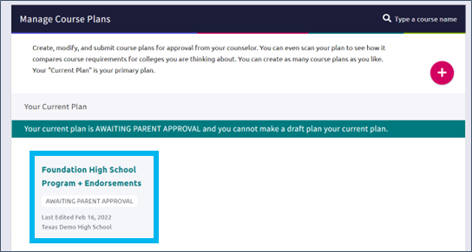

1. Review the course plan.
2. Enter your Full name to sign, and then click **I Approve This Plan**. If you do not approve the course plan, discuss your student's course selections with their counselor.

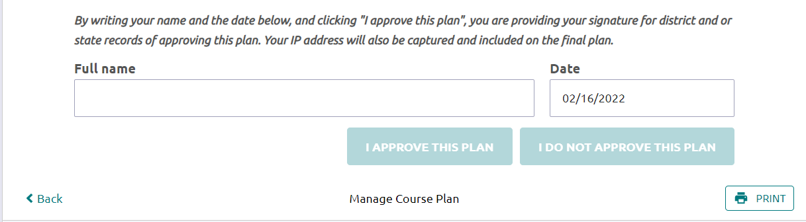

1. To display a copy of the course plan, click **Documents Shared With Me** from the confirmation banner, select **Course Plans**, and then click **View**for the selected course plan.

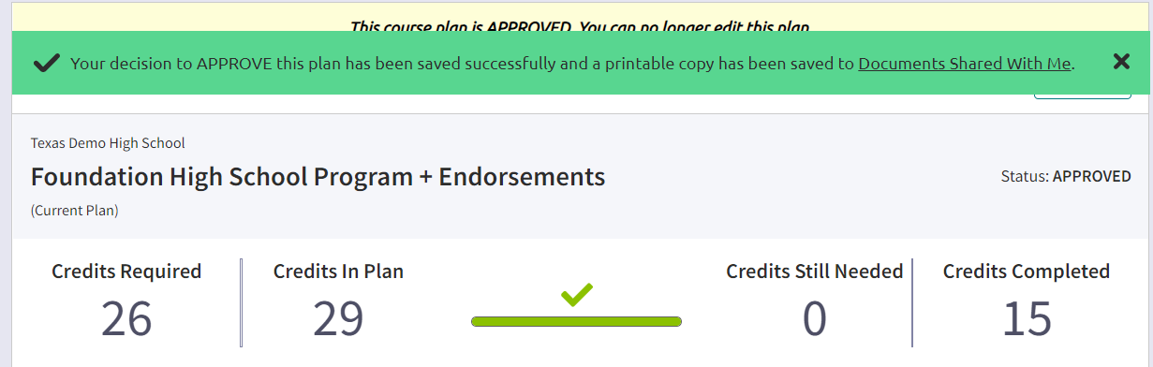

1. If the confirmation banner is not available, click **Print**to print the course plan.

